# School Management System



Dha Lhamu Lama

00172890

Computing Project

Level 5 Diploma in Computing

Softwarica College of IT and E-Commerce

Dilli Bazar, Kathmandu

Nepal

# Abstract

The project includes the documentation where it explains all the design methodologies. It shows all the initial design phase to final design phase. It shows all the initial design approaches, design methods, analysis, milestones of the project and the project is working very good as required.

The project has major part which is called project management that includes detailed information about the methodology approaches, technical requirements, scheduling, milestones and the risk management. Similarly the other main part is of designing part which includes of use case, class diagram, data modelling, Activity diagram, sequence diagram. The documentation gives the clear explanation about the project and the user can be benefitted from this documentation.

# Acknowledgement

I am extremely thankful to my teachers for their encouragement, supervision and the guidance for the completion of this project. Without their help this project won't be good at this level so, I want to say thank you so much to my teachers especially Kiran Sir and Sudeep sir who gave valuable knowledge and ideas of the project.

Contents

School Management System 1

Abstract 2

Acknowledgement 2

Chapter 1: Introduction 8

Introduction of the project 8

Problem background to the system 8

Justification 9

Aim 9

Objective 9

Overview of the project 10

Chapter 2: Analysis 10

Introduction to analysis 10

Need for analysis 10

Object oriented analysis 10

Pitfalls and merits of your project 10

Requirement 11

Requirement prioritization 11

NLA 13

Initial class diagram 13

Use case 15

Architecture 16

1. Methodology used: 16

2. **Design Pattern***:* 17

3. System Architecture: 19

Chapter 3: Design 20

Dynamic modelling 20

Sequence diagram 20

Activity diagram 22

Structural modelling 25

Class diagram (final class diagram) 25

DFD or Context diagram 25

Database modelling ER 26

ER Diagram 26

Data dictionary 27

UI modelling (prototype) 31

Chapter 4: Implementation 39

Language used 39

Development process 39

Chapter 5: Testing 40

White Box Testing: 40

Unit Testing: 40

Black Box Testing 41

Unit Testing 42

Test log 42

Chapter 6: Other project issues Risk Management 60

Risk management 60

Configuration management 62

Scheduling 62

Future work 63

User manual 63

Limitation 74

Chapter 7: Conclusion 74

Conclusion of the project 74

Chapter 8: Reference and bibliography 74

Chapter 9: Appendix 74

List of tables

Table 1: Pitfalls and Merits of the project 11

Table 2: Requirement being priotitized 13

Table 3: Student data dictionary 28

Table 4: Teacher data dictionary 28

Table 5: Class data dictionary 28

Table 6: Payment data dictionary 29

Table 7: Class_schedule data dictionary 29

Table 8: Attendance data dictionary 29

Table 9: Assignment data dictionary 30

Table 10: Events data dictionary 30

Table 11: Subjects data dictionary 30

Table 12: Transportation data dictionery 31

List of Figures

Figure 1: Initial class diagram 15

Figure 2: Use Case for school management system 17

Figure 3: Waterfall module 18

Figure 4: Design Pattern 19

Figure 5: 3 tier system architecture 20

Figure 6: Admin Sequence Diagram 22

Figure 7: Student registration Sequence Diagram 22

Figure 8: User Registration 24

Figure 9: Teacher Activity Diagram 25

Figure 10: Exam Activity Diagram 25

Figure 11: Final Class Diagram 26

Figure 12: Context Diagram for school management system 27

Figure 13: ER Diagram 28

Figure 14: User Login Form (Prototype) 33

Figure 15: Admin Dashboard (Prototype) 34

Figure 16: Teacher Registration Form (Prototype) 35

Figure 17: Student Registration Form (Prototype) 36

Figure 18: Parent Registration Form (Prototype) 38

Figure 19: Admin Login Form 44

Figure 20: Admin Dashboard 45

Figure 21: Admin unsuccessful login 45

Figure 22: Teacher Registration Form 47

Figure 23: Registration for Teacher Approval 48

Figure 24: Teacher Login 49

Figure 25: Teacher Dashboard 50

Figure 26: Teacher login with wrong email_id or password 51

Figure 27: Teacher login unsuccessful 52

Figure 28:Student registration form 53

Figure 29: Student approval 54

Figure 30: Student Login successful 54

Figure 31: Student dashboard 55

Figure 32: Student login by wrong password 56

Figure 33: Unsuccessful Login by Student 57

Figure 34: Previous emaid_id of Teacher 58

Figure 35: New email_id of Teacher 59

Figure 36: Updated email_id of Teacher by admin 60

Figure 37: Risk management chart 61

Figure 38: Risk management1 62

Figure 39: Risk Management2 62

Figure 40: Gantt chart 63

Figure 41: Gantt Chart1 64

Figure 42: Teacher Sign up Form 66

Figure 43: Student sign up form 67

Figure 44: Parent sign up form 68

Figure 45: Login form for users 69

Figure 46: Admin Login form 70

Figure 47: Dashboard of Admin 71

Figure 48: student name before changing 72

Figure 49: Student name renamed 73

Figure 50: Student name renamed1 73

Figure 51: Student name modified successfully 74

Figure 52: Student name being modified 74

Figure 53: Files from the Laravel project 76

Figure 54: Database in MYSQL 77

Figure 55: Database in MYSQL1 77

Figure 56: models files in Laravel 78

Figure 57: Controllers 79

Figure 58: Controllers1 80

Figure 59: Views files 80

Figure 60: Admin and User UI Login Form 81

Figure 61: Dashboard for the system 81

Figure 62: Teachers list 82

Figure 63: Teacher Registration Form 83

Figure 64: Student Registration Form 84

Figure 65: Parent Registration Form 85

Figure 66: List of Students 86

Figure 67: Name of the classes 87

Figure 68: List of Subject UI design 87

Figure 69: AccountSettingsController 88

Figure 70: AccountSettingsController1 89

Figure 71: AccountSettingsController2 89

Figure 72: AccountSettingsController3 90

Figure 73: Adminscontroller.php 90

Figure 74: Adminscontroller.php 91

Figure 75: Adminscontroller.php 91

Figure 76: TeachersController.php 92

Figure 77: TeachersController.php1 93

Figure 78: TeachersController.php2 93

Figure 79: TeachersController.php3 94

Figure 80: TeachersController.php4 94

Figure 81: TeachersController.php5 95

Figure 82: TeachersController.php6 95

Figure 83: TeachersController.php7 96

Figure 84: TeachersController.php8 96

Figure 85: TeachersController.php9 97

Figure 86: TeachersController.php10 97

Figure 87: TeachersController.php11 98

Figure 88: TeachersController.php12 98

Figure 89: LoginController.php 99

Figure 90: LoginController.php1 100

Figure 91: LoginController.php2 100

Figure 92: LoginController.php3 101

Figure 93: LoginController.php4 101

Figure 94: LoginController.php5 102

Figure 95: LoginController.php6 103

Figure 96: LoginController.php7 103

Figure 97: ClassesController.php 104

Figure 98: ClassesController.php1 105

Figure 99: ClassesController.php2 105

Figure 100: ClassesController.php3 106

Figure 101: DashboardControllers.php 106

Figure 102: DashboardControllers.php1 107

Figure 103: DashboardControllers.php2 107

Figure 104: DashboardControllers.php3 108

Figure 105: DashboardControllers.php4 108

Figure 106: DashboardControllers.php5 109

Figure 107: DashboardControllers.php6 109

Figure 108: DashboardControllers.php7 110

Figure 109: DashboardControllers.php8 110

Figure 110: DashboardControllers.php9 111

Figure 111: StudentsController.php 111

Figure 112: StudentsController.php1 112

Figure 113: StudentsController.php2 112

Figure 114: StudentsController.php3 113

Figure 115: StudentsController.php4 113

Figure 116: StudentsController.php5 114

Figure 117: StudentsController.php6 114

Figure 118: StudentsController.php7 115

Figure 119: StudentsController.php8 115

Figure 120: StudentsController.php9 116

Figure 121: StudentsController.php10 116

Figure 122: StudentsController.php11 117

Figure 123: StudentsController.php12 117

Figure 124: StudentsController.php13 118

Figure 125: StudentsController.php14 118

Figure 126: StudentsController.php15 119

Figure 127: StudentsController.php16 119

Figure 128: StudentsController.php17 120

Figure 129: StudentsController.php18 120

Figure 130: SubjetcsController.php 121

Figure 131: SubjetcsController.php1 122

Figure 132: SubjetcsController.php2 122

Figure 133: ParentsController.php 123

Figure 134: ParentsController.php1 124

Figure 135: ParentsController.php2 125

Figure 136: ParentsController.php3 126

Figure 137: ParentsController.php4 127

Figure 138: ParentsController.php5 128

Figure 139: ParentsController.php6 129

Figure 140: ParentsController.php6 130

Figure 141: ParentsController.php7 131

Figure 142: ParentsController.php8 132

Figure 143: ParentsController.php9 133

Figure 144: ParentsController.php10 134

Figure 145: AssignmnetsController.php 135

Figure 146: AssignmnetsController.php 1 136

Figure 147: AssignmnetsController.php2 137

Figure 148: AssignmnetsController.php3 138

Figure 149: AssignmnetsController.php4 139

Figure 150: ClassScheduleController.php 140

Figure 151: ClassScheduleController.php1 141

Figure 152: ClassScheduleController.php2 142

Figure 153: ClassScheduleController.php4 143

Figure 154: ClassScheduleController.php5 144

Figure 155: ClassScheduleController.php6 144

Figure 156: Assignmnets.php 145

Figure 157: attendance.php 145

Figure 158: Classes.php 145

Figure 159: classSchedule.php 145

Figure 160: events.php 146

Figure 161: examlists.php 146

Figure 162: gradelevels.php 146

Figure 163: User.php 147

Figure 164: User.php1 148

Figure 165: User.php2 149

Figure 166: subject.php 149

Figure 167: newsboard 149

Figure 168: payments.php 150

Figure 169: staticpages.php 150

Figure 170: register.php from view 151

Figure 171: register.php from view 1 152

Figure 172: register.php from view 2 153

Figure 173: register.php from view 4 154

Figure 174: register.php from view 5 155

Figure 175: register.php from view 6 156

Figure 176: register.php from view 7 157

Figure 177: register.php from view 8 158

Figure 178: register.php from view 9 159

Figure 179: Login code from view 160

Figure 180: Login code from view1 161

Figure 181: Login code from view2 162

# Chapter 1: Introduction

## Introduction of the project

School management system is a software that handles the database of school where all the activities of the school are included. This software is made mainly for school management system with the purpose of providing a nice website where administration, student, teacher, parents can easily access the information and find their details which makes very easy for the school instead of not having website. The admin job is to handle all the school management system that includes the registration of teacher, student, parent, allocation of class and assign the subject for the teacher and notify the events and holidays to the students and parents. So to get access in this website, the users have to be registered and only be able to see the website of the school. After getting registered, the teacher can easily be able to give homework or assignment to the student, give exams and do the result of the student. The students can see their information and be able to give exams and see their result. The parents can see their child performance and get notified the events, news and holidays of the school.

## Problem background to the system

* The school management has no record system in database, they are using record book for all the activities which is waste of money and also not safe since it can be damaged by air, water and dust.
* Difficult in finding the record of students and the teachers.
* Time consuming since searching each student in the record book is difficult.
* School was facing the problem in recording the attendances and the report in and fees
* There was not clear idea of how many students are enrolled every year.

## Justification

Our company is running with good prestige and has served numerous companies and schools with many projects. The project is done since many schools are not implementing the latest technical methods of using the system. Since schools are having difficulty in managing the schools management. The project is introduced and it has to be done to overcome the problem faced by the schools and we can create the project by understanding and researching the requirements of the schools and after the project is ready, we have to understand whether the project is user friendly and good to use to the schools or not.

## Aim

The main aim is to meet the requirements of the users for their benefit as well as for the school management system. The required analysis of data of students, teachers, fees, salary etc. can be possible by making software in the computer where one can access easily and get the required answers wanted by them.

## Objective

The main objectives of developing this software is

### (a) Record Keeping

* It maintains the data of all the student and teacher in database system.
* It maintains the personal record as well as the academic record of the student.
* It maintains student fee record and dues record.
* Teacher personal record and salary record are also store in the software.
* It also manages class record, subject record, examination record.

### (b) Reports Generating

Reports are the essential outcomes of school management system (SMS).Reports includes the given points

* Attendance of the students
* Results of the student
* Submitted due reports
* Teacher Experience reports
* Examination report

## Overview of the project

The overall project is working efficiently as wanted by client or school management. As it contains all the featured and the objectives of the school.

# Chapter 2: Analysis

## Introduction to analysis

Analysis is really important and is one of the main first part of waterfall model to identify the problem and with the analysis is possible to meet the requirement of the project. School requirements are well analyzed.

## Need for analysis

To meet the requirement of the project. School requirements are well analyzed.

## Object oriented analysis

Object-oriented analysis is a process that groups items that interact with one another, typically by class, data or behavior, to create a model that accurately represents the intended purpose of the system as a whole.

## Pitfalls and merits of your project

Pitfalls: There are some pitfalls of this project that is defined in the given table below.

Merits: The project has good merit which has been very useful to the admin and user and is explained below the table.

|  |  |
| --- | --- |
| Pitfalls | Merits |
| Need to have internet to access the system. | Users can be notified by admin for events, holidays and schedule. |
| Only approved users can view the page | Students can easily view their information and get updated if necessary |
| There is no online payment system. | Students can do online exams as well |

Table 1: Pitfalls and Merits of the project

## Requirement

Functional and non-functional requirement for School Management System

Functional requirement:Functional requirements are those which are related to the technical functionality of the system

Non-functional requirement: It is a requirement that specifies criteria that can be used to judge the operation of a system in particular conditions, rather than specific behaviors.

## Requirement prioritization

Requirement prioritized are explained clearly on the table below.

|  |  |  |  |
| --- | --- | --- | --- |
| Functional(F)/Non-functional(NF) | Requirements | MoSCoW | Description |
| F(R1) | Login and Registration System | M | Security is possible with this system since only approved one can visit the page. |
| F(R2) | Sending and view message | M | It is one of the effective way to keep teacher student parent and teacher in contact when is necessary. |
| F(R3) | Attendance | S | Attendance can be added and viewed from normal existing system but if is added in this system student report generation can be made. |
| F(R4) | Inserting students result of each subject | C | Having final detailed report is important but result system is not that important. |
| F(R5) | Calendar | S | Events are managed in the timetable where date is very important so calendar is very important to have. |
| F(R6) | CRUD function | C | Admin can update delete insert and retrieve the data of the student, teacher classes courses etc. which is important. |
| F(R7) | Routines | M | Routines enable users to guide the timeline of the schedule of the school. |
| F(R8) | Results | M | Results is the outcome of the exams done by the student, so it is one of the main function of the school. |
| F(R9) | Notifications sending | M | Best communication means |
| F(R10) | Exam | M | This is one of the main function of the school that allows student involve in exams so that they can get their results from what they can be able to do. |
| NF(R11) | Security | S | Data security must be always prioritized so, security measures should be followed. |
| NF(R12) | performance | M | Performance is one of the main feature of this application. So performance is prioritized. |
| NF(R13) | Scalability | M | Increase in data and new technology system needs to be flexible and changeable |
| NF(R14) | Maintainability | M | Although project can't be 100%okay , there are always chances of having bugs and errors so system should be manageable to be out of bugs and errors |
| NF(R15) | Usability | M | Whole system should be usable for the good performance. |

Table 2: Requirement[prioritization](https://www.google.com/search?rlz=1C1CHBF_enNP761NP761&q=prioritization&spell=1&sa=X&ved=0ahUKEwiapqG6p-PhAhUMqI8KHTiRCBUQkeECCCcoAA)

## NLA

After deep analysis of the system, I have chosen the following classes

* Registration
* Admin
* Teacher
* Student
* Parent
* Class
* Subject

All above mention classes have effect on this system

## Initial class diagram

Class diagram is a static diagram. It represents the static view of an application. Class diagram shows a collection of classes, interfaces, associations, collaborations, and constraints. It is also known as a structural diagram. Initial class diagram is drawn in the analysis phase for the class identification.

Justifications of the use of initial class diagram

The Class Diagram is for modeling the static view of an application. It is forward and reverse engineering. Class diagrams are the only diagrams which can be directly mapped with object-oriented languages and thus widely used at the time of construction. It describes the responsibilities of a system.

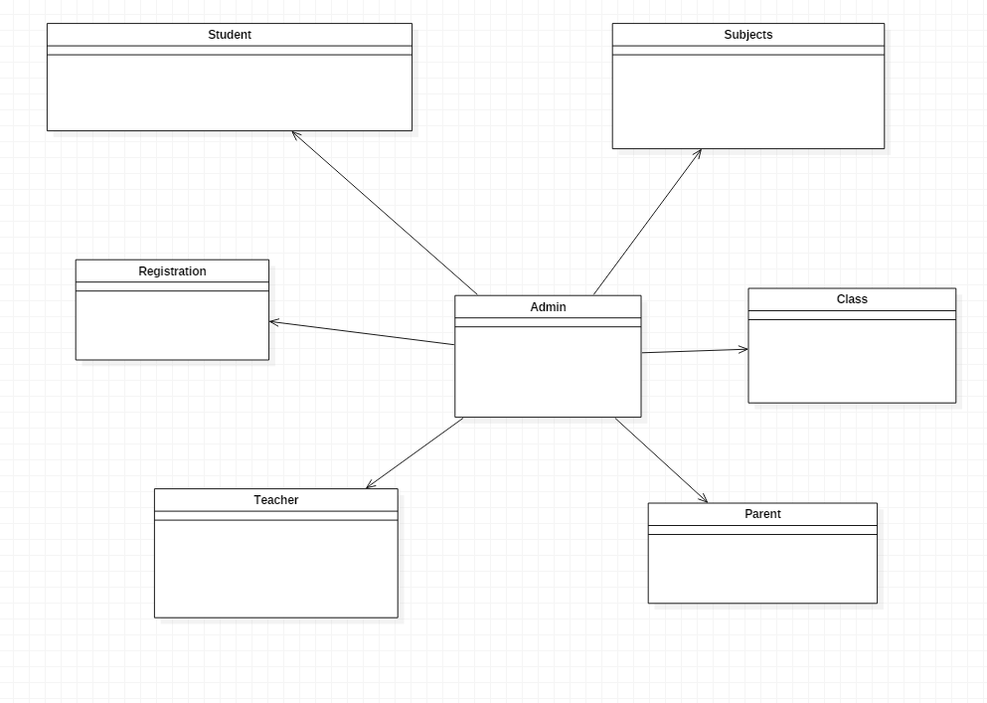

Figure 1: Initial class diagram

**Pros**

* Class diagram are simple and fast to read.
* It gives you a sense of orientation.
* They provide detailed insight into the structure of our systems.

**Cons**

* They do not have dynamic model.
* It shows only collaboration among the elements of the static view.

## Use case

A **use case diagram** is a representation of a user's interaction with the system that shows the relationship between the user and the different use cases in which the user is involved. To build the use case diagram, a set of specialized symbols and connectors are to be used.

**Justifications of the use of use case**

The use case diagram describes a set of actions that some system can perform in collaboration with one or more external users of the system, gather the requirements of a system, identifies and clarifies the relationships between and among the actors and the use cases and identifies the external and internal factors influencing the system.

**Pros**

* It helps to collect the functional requirements of a system.
* It can serve as the basis for the estimating, scheduling and validating effort.
* It can also collect additional behavior that can improve system robustness.

**Cons**

* They do not capture the non-functional requirements easily.
* Difficult to manage scenario.
* It has poor identification of structure and flow.

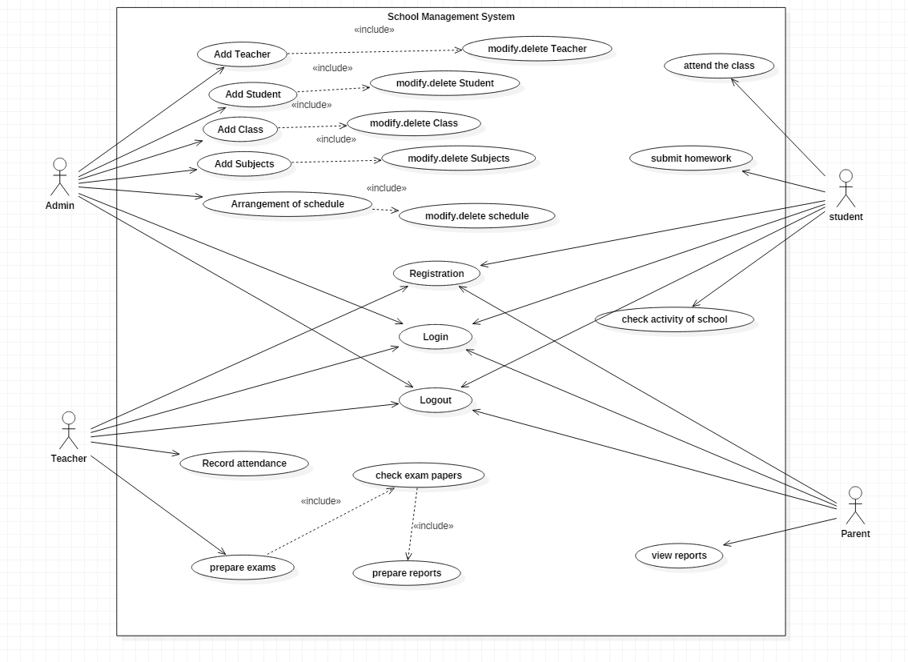

Figure 2: Use Case for school management system

## Architecture

### Methodology used

For the development of this project, I have chosen Waterfall Model method. It is very simple to understand and use. In this model, each phase must be completed before thenext phase can begin and there is no overlapping in the phases. **Hence, I chose this method because** Waterfall model works well where requirements are very well understood.

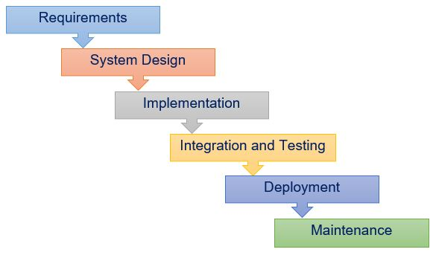

Figure 3: Waterfall module

Waterfall is of six stage which are Requirement Analysis, Design, Implementation, Testing, Deployment and Maintenance.

Requirement Analysis is the step where I have analyzed the Functional and Non-Functional requirements with their MoSCoW Prioritization. After completing the requirements analysis, I have done design of models such as use case diagrams, class diagrams, E-R diagrams, activity diagrams, sequence diagrams and Prototype. In this phase, the tools I have used are Star UML, Visio, Visual paradigm and Balsamiq.

After the completing the analyzing the requirement, Design steps starts where I have started designing the user interface with HTML5, Bootstrap4 and Javascript.

Implementation phase is the time where I started the code using PHP language on Laravel and Sympony framework. The tools that I have used in this phase are XAMPP and Sublime editor.

### Design Pattern used

For my project I will be working on MVC (Model-View-Controller) design pattern using PHP (Laravel+Sympony) framework. Model to represent an objects, view to represent the visualization of the data that model contains and controller to control the data flow into model object and updates the view whenever data changes. The MVC pattern with the given framework functions as shown below

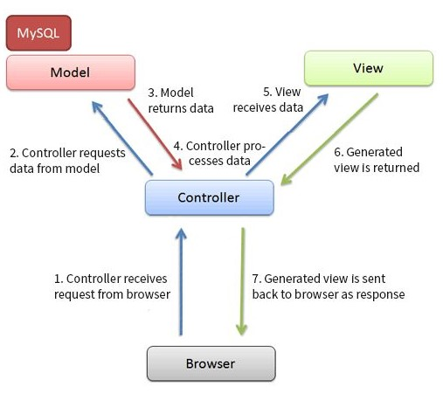

Fig: Design pattrem

Figure 4: Design Pattern

### System Architecture used

3-tier architect system is being used in my project where it separates the application into three major parts which are UI, Business Logic and Data

Fig 5: 3 tier system architecture

Figure 5: 3 tier system architecture

Storage.

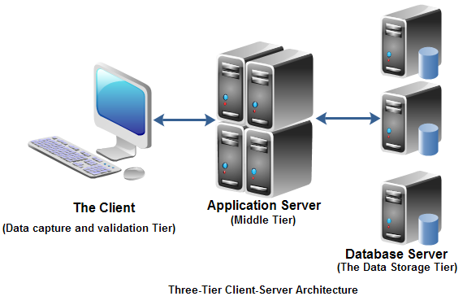Chapter 3: Design

# Chapter 3: Design

## Dynamic modelling

### Sequence diagram

Sequence Diagrams are interaction diagrams that detail how operations are carried out. Sequence Diagrams show elements as they interact over time and they are organized according to object (horizontally) and time (vertically). The sequence diagram is used primarily to show the interactions between objects in the sequential order that those interactions occur.

**Justifications of the use of Sequence Diagram**

Here, I have drawn sequence diagram to show the high-level interaction between active objects in a system, model the interaction between object instances within a collaboration that realizes a use case, the interaction between objects within a collaboration that realizes an operation and to show all the possible paths through the interaction.

**Pros**

* The sequence diagram may be used in object-oriented analysis to validate class diagrams against use cases, or to show the timing of interactions between entities within the system scope.

**Cons**

* A sequence diagram must be defined for each possible scenario. Strictly speaking, a sequence diagram requires a fully defined class model.

Admin Sequence Diagram

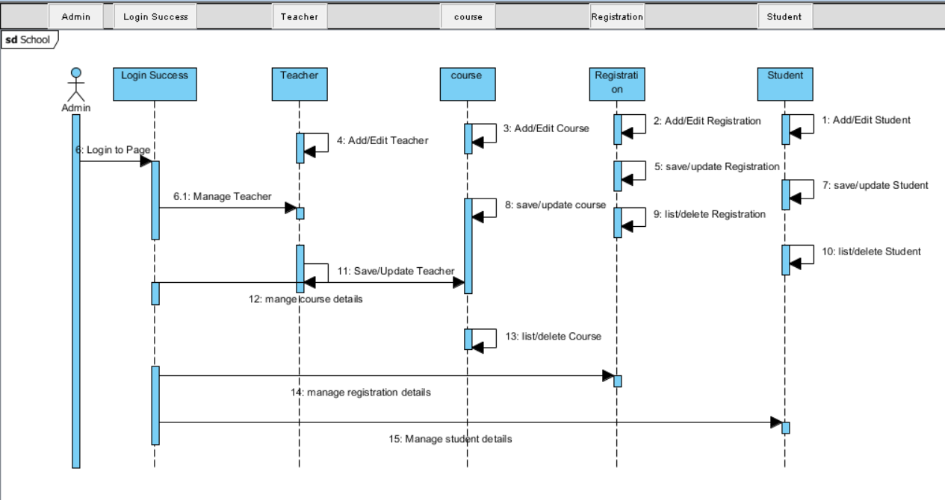

Figure 6: Admin Sequence Diagram

Student registration

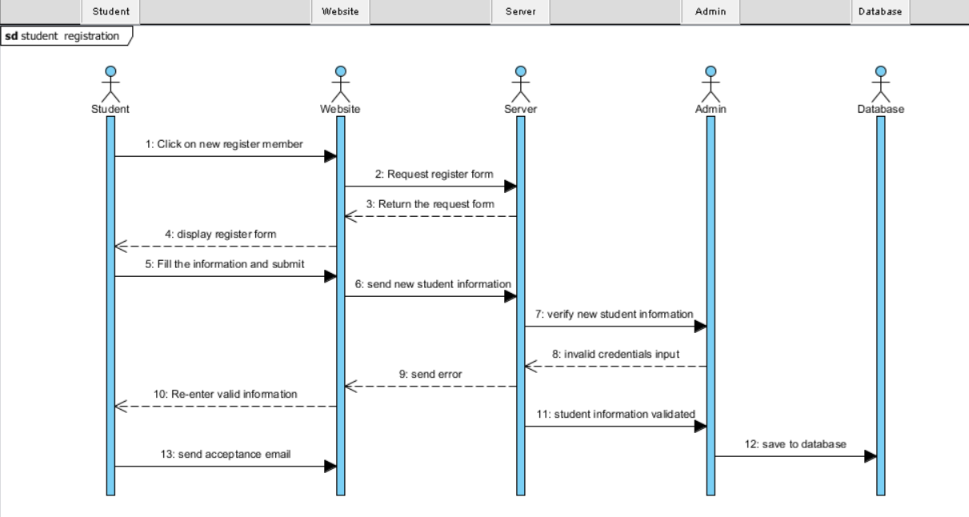

Figure 7: Student registration Sequence Diagram

### Activity diagram

An activity diagram is a graphical representation of an executed set of procedural system activities and considered a state chart diagram variation. Activity diagrams describe parallel and conditional activities, use cases and system functions at a detailed level.

**Justifications of the use of Activity Diagram**

Here, I have drawn activity diagram to show message flow from one activity to another. It captures the dynamic behavior of the system. It is also used to draw the activity flow of a system, to describe the sequence from one activity to another, and also to describe the parallel, branched and concurrent flow of the system.

**Pros**

* Since it is the most user-friendly diagram. So, generally regarded as an essential tool.
* It helps to display multiple conditions and actors within a work flow through the use of swim lanes.
* These diagrams are normally easily comprehensive for both analysts and stakeholder.

**Cons**

* These diagrams can lead the over complex which might affect the user-friendly nature.
* These diagrams do not give the detail about how object behave or collaborate.

User Registration

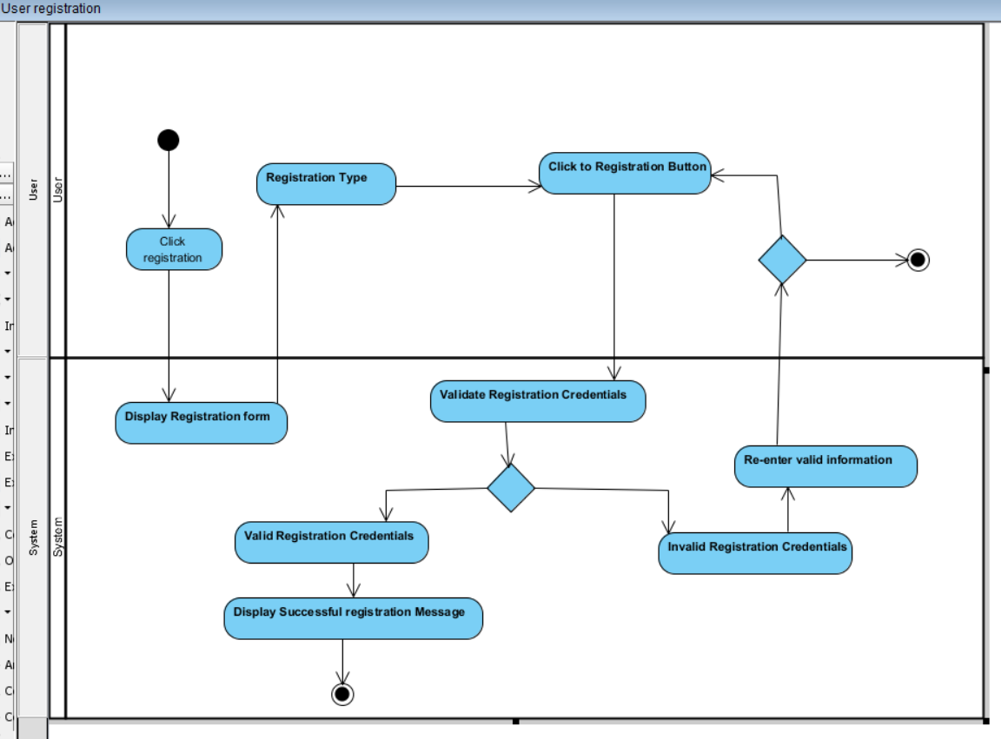

Figure 8: User Registration

Teacher Activity Diagram

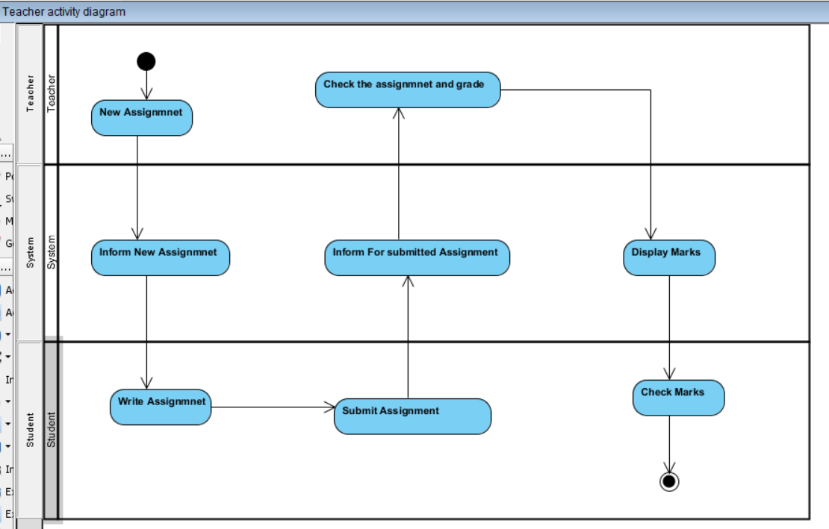

Figure 9: Teacher Activity Diagram

Exam Activity Diagram

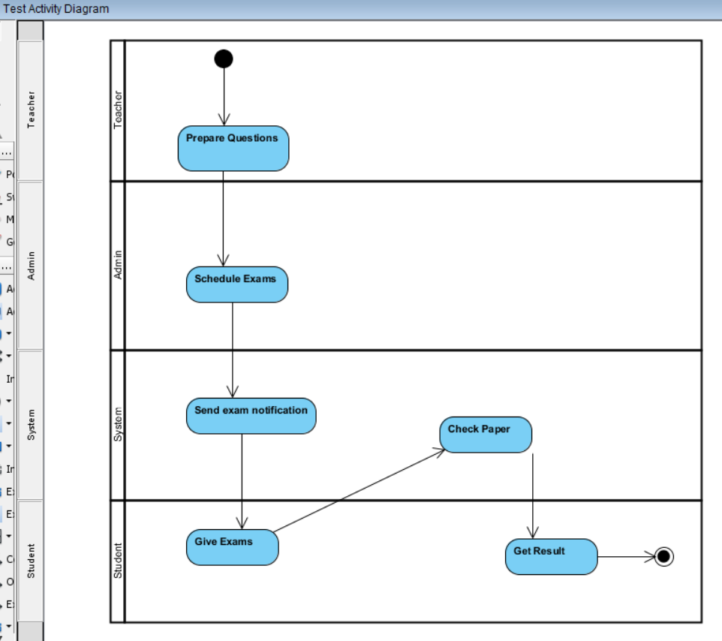

Figure : Exam Activity Diagram

## Structural modelling

### Class diagram (final class diagram)

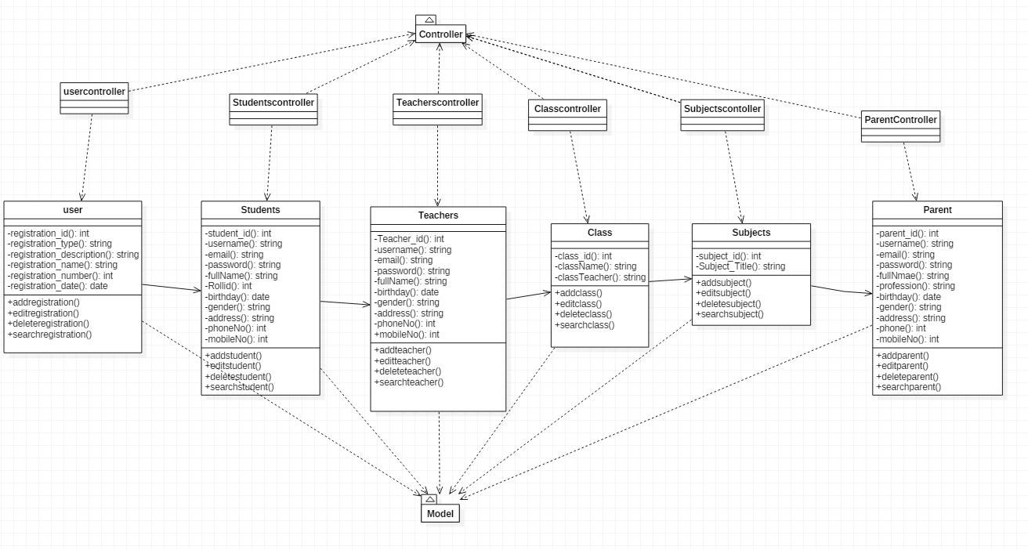

Figure 11: Final Class Diagram

#### Justification of the Final class diagram use

A class diagram is an illustration of the relationships and [source code](https://searchmicroservices.techtarget.com/definition/source-code) dependencies among classes in the Unified Modeling Language (UML). In this context, a [class](https://whatis.techtarget.com/definition/class) defines the [method](https://whatis.techtarget.com/definition/method)s and [variable](https://whatis.techtarget.com/definition/variable)s in an object, which is a specific entity in a program or the unit of code representing that entity. Class diagrams are useful in all forms of object-oriented programming (OOP). The concept is several years old but has been refined as OOP modeling paradigms have evolved.

## DFD or Context diagram

Context diagram is a diagram that defines the boundary between the system, or part of a system, and its environment that shows the entities which interact with it. It is also called high level view of system which is similar to a block diagram.

I have made context diagram which the main classes which are Registration management, Students management, Teacher management, Fees management, Transportation, Subjects management and class management which are under the control of school management system

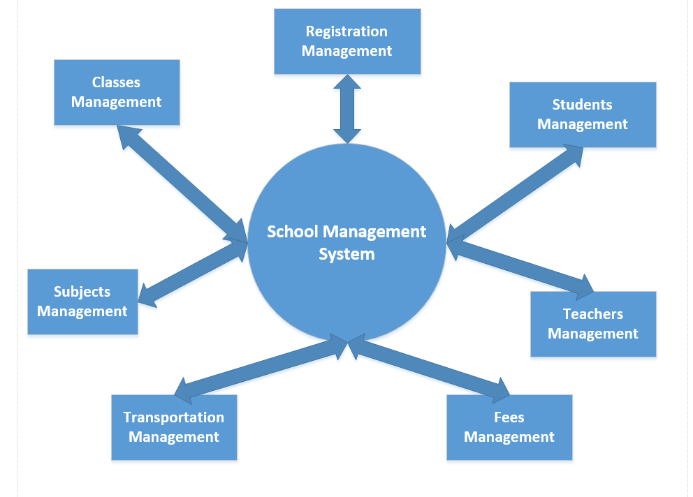.

Figure 12:Context Diagram for school management system

Context Diagram of School management System

## Database modelling ER

## 

## ER Diagram

An entity-relationshipdiagram(ERD) is a data modeling technique that graphically illustrates an information system's entities and the relationships between those entities. An ERD is a conceptual and representational model of data used to represent the entity framework infrastructure.

**Justifications of the use of ERD**

The ER Diagram is to visualize database design ideas, so we have a chance to identify the mistakes and design flaws, and to make correction before executing the changes in database. By visualizing a database schema with an ERD, we have a full picture of the entire database schema through which we can easily locate entities, view their attributes and to identify the relationships they have with others.

**Pros**

* It is very simple if we know relationship between entities and attributes.
* It is better visual representation.
* It is an effective communication tool for database designer.

**Cons**

* It has limited constraints and specification.
* Information can be hidden in ER model.
* It is difficult to show data manipulation in ER model.

ER diagram for School management System

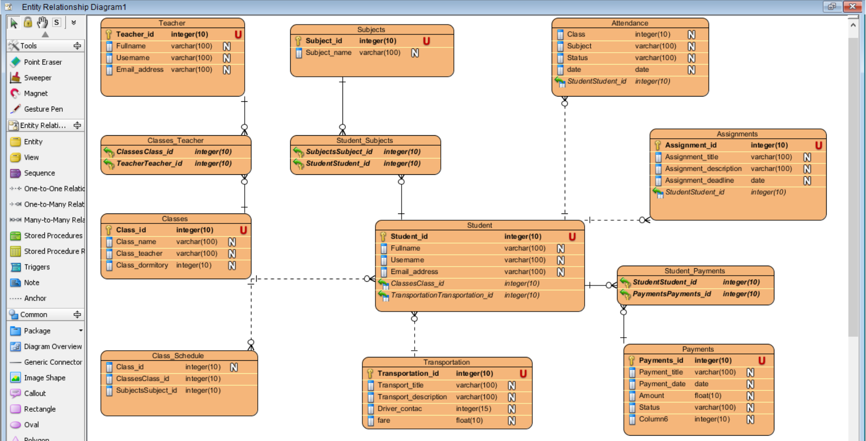

Figure 13: ER Diagram

## Data dictionary

Student_tbl

|  |  |  |  |  |  |
| --- | --- | --- | --- | --- | --- |
| Column name | Data type | Length | Null | Key | Constraint |
| Student_id | Integer | 10 | No | Primary key | pk_Student_id |
| Fullname | Varchar | 100 | Yes | - | - |
| Username | Varchar | 100 | Yes | - | - |
| Email_address | Varchar | 100 | Yes | - | - |

Table 3: Student data dictionary

Teacher_tbl

|  |  |  |  |  |
| --- | --- | --- | --- | --- |
| Data type | Length | Null | Key | Constraint |
| Integer | 10 | No | Primary key | pk_Teacher_id |
| Varchar | 100 | Yes | - | - |
| Varchar | 100 | Yes | - | - |
| Varchar | 100 | Yes | - | - |

Table 4: Teacher data dictionary

Class_tbl

|  |  |  |  |  |  |
| --- | --- | --- | --- | --- | --- |
| Column name | Data type | Length | Null | Key | Constraint |
| Class_id | Integer | 10 | No | Primary key | pk_Classes_id |
| Class_name | Varchar | 100 | Yes | - | - |
| Class_teacher | Varchar | 100 | Yes | - | - |
| Class_dormitory | Integer | 10 | Yes | - | - |

Table 5: Class data dictionary

Payment_tbl

|  |  |  |  |  |  |
| --- | --- | --- | --- | --- | --- |
| Column name | Data type | Length | Null | Key | Constraint |
| Payment_id | Integer | 10 | No | Primary key | pk_student_id |
| Payment_title | Varchar | 100 | Yes | - | - |
| Payment_date | Date |  | Yes | - | - |
| Amount | Float | 100 | Yes | - | - |
| Status | Varchar | 100 | Yes |  |  |

Table 6: Payment data dictionary

Class_schedule_tbl

|  |  |  |  |  |  |
| --- | --- | --- | --- | --- | --- |
| Column name | Data type | Length | Null | Key | Constraint |
| Class_id | Integer | 10 | Yes |  | Fk_class_id |
| Class_name | Varchar | 100 | Yes | - | - |

Table 7: Class_schedule data dictionary

Attendance_tbl

|  |  |  |  |  |  |
| --- | --- | --- | --- | --- | --- |
| Column name | Data type | Length | Null | Key | Constraint |
| Class | Integer | 10 | yes |  | Fk_Student_id |
| Subject | Varchar | 100 | Yes | - | - |
| Status | Varchar | 100 | Yes | - | - |
| Date | Date |  | Yes | - | - |

Table 8: Attendance data dictionary

Assignments_tbl

|  |  |  |  |  |  |
| --- | --- | --- | --- | --- | --- |
| Column name | Data type | Length | Null | Key | Constraint |
| Assignment_id | integer | 10 | No | Primary key | fk_student_id |
| Assignment_title | varchar | 100 | Yes | - | - |
| Assignment_description | varchar | 100 | Yes | - | - |
| Assignment_deadline | date |  | yes | - | - |

Table 9: Assignment data dictionary

Tbl_Events

|  |  |  |  |  |  |
| --- | --- | --- | --- | --- | --- |
| Column name | Data type | Length | Null | Key | Constraint |
| Event_id | Integer | 10 | No | Primary key | pk_student_id |
| Eventname/Place | Varchar | 100 | Yes | - | - |
| Event_description | Varchar | 100 | Yes | - | - |
| Event_for | Varchar | 100 | Yes | - | - |
| Date | Date |  |  |  |  |

Table 10: Events data dictionary

Subject_tbl

|  |  |  |  |  |  |
| --- | --- | --- | --- | --- | --- |
| Column name | Data type | Length | Null | Key | Constraint |
| Subject_id | Integer | 10 | No | Primary key | pk_Subject_id |
| Subject_name | Varchar | 100 | Yes | - | - |

Table 11: Subjects data dictionary

Transportation_tbl

|  |  |  |  |  |  |
| --- | --- | --- | --- | --- | --- |
| Column name | Data type | Length | Null | Key | Constraint |
| Transport_id | Integer | 10 | No | Primary key | Pk_transport_id |
| Transport_title | Varchar | 100 | Yes | - | - |
| Transport_description | Varchar | 100 | yes | - | - |
| Driver_contact | Integer | 15 | yes | - | - |
| Fare | Float | 10 | Yes | - | - |

Table 12: Transportation data dictionery

## 

## UI modelling (prototype)

Login Form for admin and users

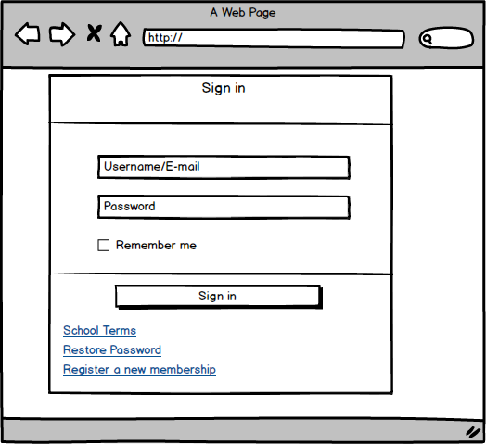

Figure 14: User Login Form (Prototyp)

Admin dashboard

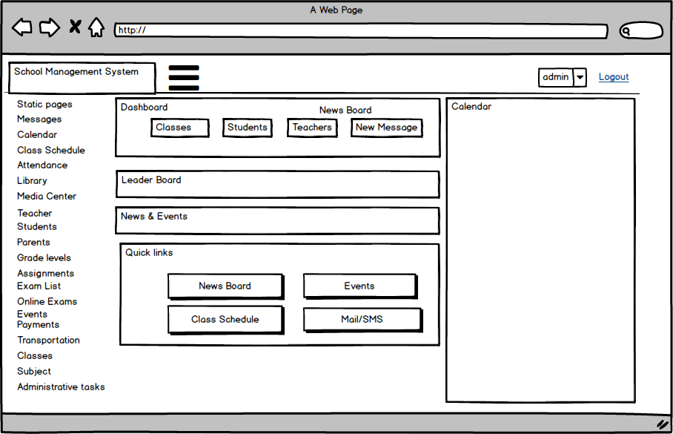

Figure 15: Admin Dashboard (Prototype)

Teacher Registration Form

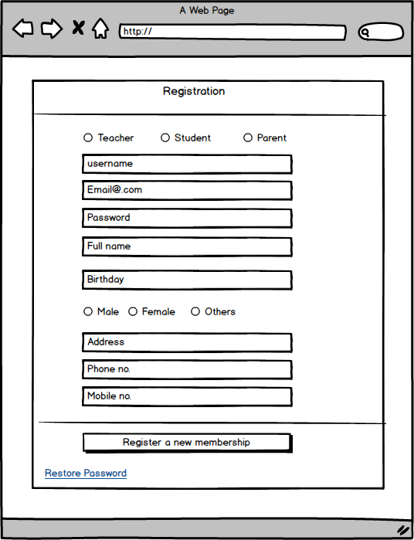

Figure : Teacher Registration Form (Prototype)

Student Registration form

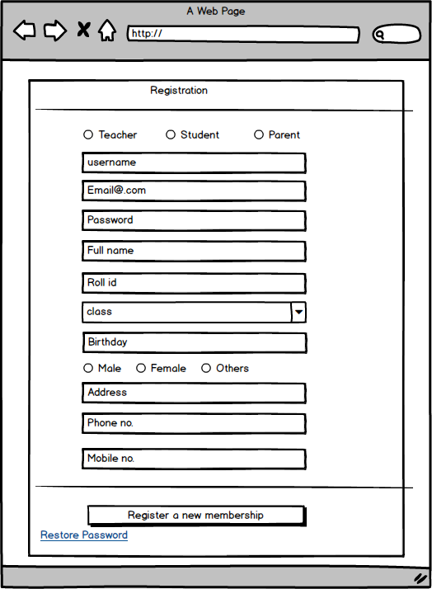

Figure : Student Registration Form (Prototype

Parent Registration form

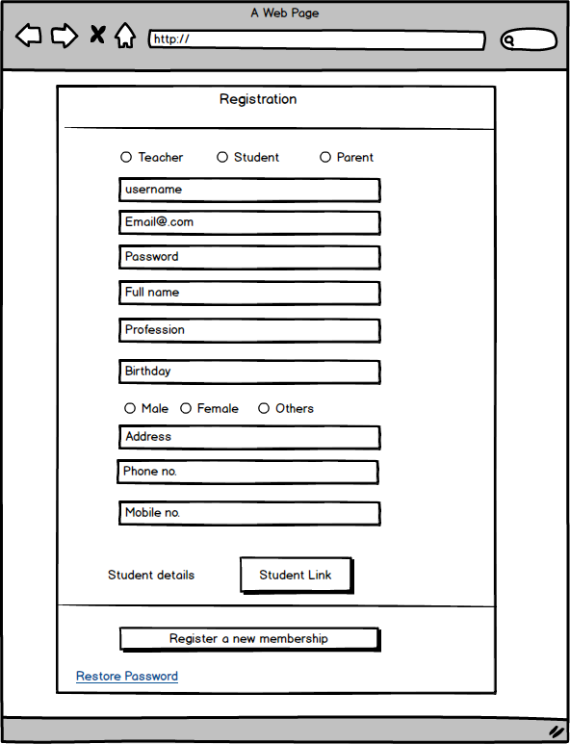

Figure 18: Parent Registration Form (Prototype)

# Chapter 4: Implementation

In this phase, we starts to make the product on the basis of analysis and design phase. Coding is the main objective in this phase.

### Language used

For the implementation of product, I chose PHP (Hypertext Preprocessor) language. PHP is an HTML embedded Web scripting language. The goal of the language is to allow Web developers to write dynamically generated pages quickly and easily. PHP is also great for creating database-driven Web sites. However, PHP has a number of unique features and specific functions as well.

### Development process

Frameworks used

Laravel and Symfony is used as framework which are an open-source PHP framework, which is flexible and easy to understand. Model-view-controller design pattern are used. Laravel reuses the existing components of different frameworks which helps in creating a web application.

Database used

MYSQL is used as database. MySQL is an Oracle-backed open source relational database management system([RDBMS](https://searchdatamanagement.techtarget.com/definition/RDBMS-relational-database-management-system)) that is based on Structured Query Language([SQL](https://searchsqlserver.techtarget.com/definition/SQL)).

MySQL runs on virtually all platforms, including [Linux](https://searchdatacenter.techtarget.com/definition/Linux-operating-system), [UNIX](https://searchdatacenter.techtarget.com/definition/Unix) and [Windows](https://searchwindowsserver.techtarget.com/definition/Windows). Although it can be used in a wide range of applications, MySQL is most often associated with web applications and online publishing.

Editor used

Sublime Text Editor (version 3) is used as editor which sophisticated and widely used by developers. It includes wide features such as Syntax Highlight, Auto Indentation, File Type Recognition, Sidebar, Macros, Plug-in and Packages that make it easy for working with code base.

# Chapter 5: Testing

Testing refers to the evaluation of software developed in order to ensure the quality of product and to identify defects. There are many types of testing approaches but, in this project I have done white box and black boxtesting only.

## White Box Testing

It is also called Structural, Glass Box Testing. White Box Testing is based on applications internal code structure. In white-box testing, an internal perspective of the system, as well as programming skills, are used to design test cases. This testing is usually done at the unit level. Unit testing is done as white box testing.

### Unit Testing:

**Unit testing** is a level of software testing where individual units/ components of a software are tested. The purpose is to validate that each unit of the software performs as designed. A unit is the smallest testable part of any software. It usually has one or a few inputs and usually a single output.

Pros

* Code optimization by finding hidden errors.
* White box tests cases can be easily automated.
* Testing is more thorough as all code paths are usually covered.
* Testing can start early in SDLC even if GUI is not available.

Cons

* White box testing can be quite complex and expensive.
* Developers who usually execute white box test cases detest it. The white box testing by developers is not detailed can lead to production errors.
* White box testing requires professional resources, with a detailed understanding of programming and implementation.
* White-box testing is time-consuming, bigger programming applications take the time to test fully.

### Black Box Testing

Black Box can be also known as Behavioral/Specification-Based/Input-Output Testing. In this testing, testers evaluate the functionality of the software under test without looking at the internal code structure.

Pros

* Tester can be non-technical.
* There is no need for the tester to have detailed functional knowledge of system.
* Testing helps to identify vagueness and contradictions in functional specifications.
* Test cases can be designed as soon as the functional specifications are complete.

Cons

Test cases are not easy to design without knowing clear functional specifications.

* It is difficult to identify tricky inputs if the test cases are not developed based on specifications.
* There are chances of having unidentified paths during the testing process.
* There is a high probability of repeating tests already performed by the programmer.

## Test cases

I have tested only one type of testing which is called black box testing which are given below

|  |  |  |  |  |  |
| --- | --- | --- | --- | --- | --- |
| Test_id | Description | Test value | Expected result | Actual Result | Pass or Fail |
| Test_01 | Testing: login done by admin | username=admin Password=admin | Should be logged in | Successful login page and opens dashboard | pass |
| Test_02 | Testing: login done by admin | username=admin Password=asdfgg | Should not login | Failed in login with message "please check your username and password" | fail |
| Test_03 | Testing: Registration by and login by Teacher | [Emai_id=giri@gmail.com](mailto:Emai_id=giri@gmail.com)  Password=giri123 | Should be registered and logged in | Successful registration with login page and opens dashboard | pass |
| Test_04 | Testing: login done by Teacher using wrong email_id or password | [Emai_id=babu@gmail.com](mailto:Emai_id=babu@gmail.com)  Password=babu123 | Should not be logged in | Failed in login with message "please check your username and password" | fail |
| Test_05 | Testing:  Registration by and login by Student | [Email_id=muskan@yahoo.com](mailto:Email_id=muskan@yahoo.com)  Password=muskan1 | Should be registered and logged in | Successful registration with login page and opens dashboard | Pass |
| Test_06 | Testing: login done by Student using wrong email_id or password | [Email_id=muskan@yahoo.com](mailto:Email_id=muskan@yahoo.com)  Password=muskan123 | Should not be logged in | Failed in login with message "please check your username and password" | fail |
| Test_06 | Testing  Update email_id of teacher on request of teacher by admin | old  [email_id=babu@yahoo.com](mailto:email_id=babu@yahoo.com)  new  [Email_id=babu@gmail.com](mailto:Email_id=babu@gmail.com) | Should update | Successful update of teacher email_id | Pass |
| Test_07 | Updating Teacher email_id by admin on request by teacher | Previous [email_id=giri@gmail.com](mailto:email_id=giri@gmail.com)  New Email_id=giri123@gmail.com | Should be updated | Successful update of email_id of Teacher | Pass |
| Test_08 | Registration and login by parent and link the student | Check to link the student and parent  Student=Dinesh Adhikari  Parent=Adhikari | Should be linked and shown the relationship | Linked to student successfully as mother to the student | Pass |
| Test_09 | Admin notifying holiday for all the users | Holiday on May 18 as Buddha Jayanti day | Holiday notification should be added to events list | Successfully added to events list as holiday event | Pass |
| Test_10 | Admin sending message to teacher | Admin asking attendance sheet to teacher | Should not be sent messeage | Message not sent since is not online school | fail |

Table 13: Test cases of black box testing

## Test log

Test_01 screenshots

Admin login with correct password

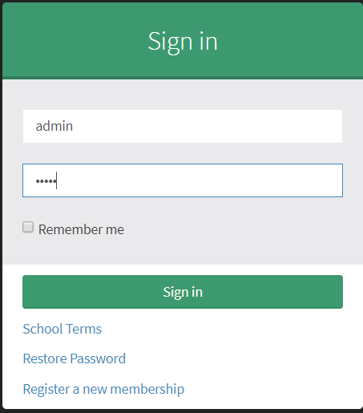

Figure : Admin Login Form

Dashboard

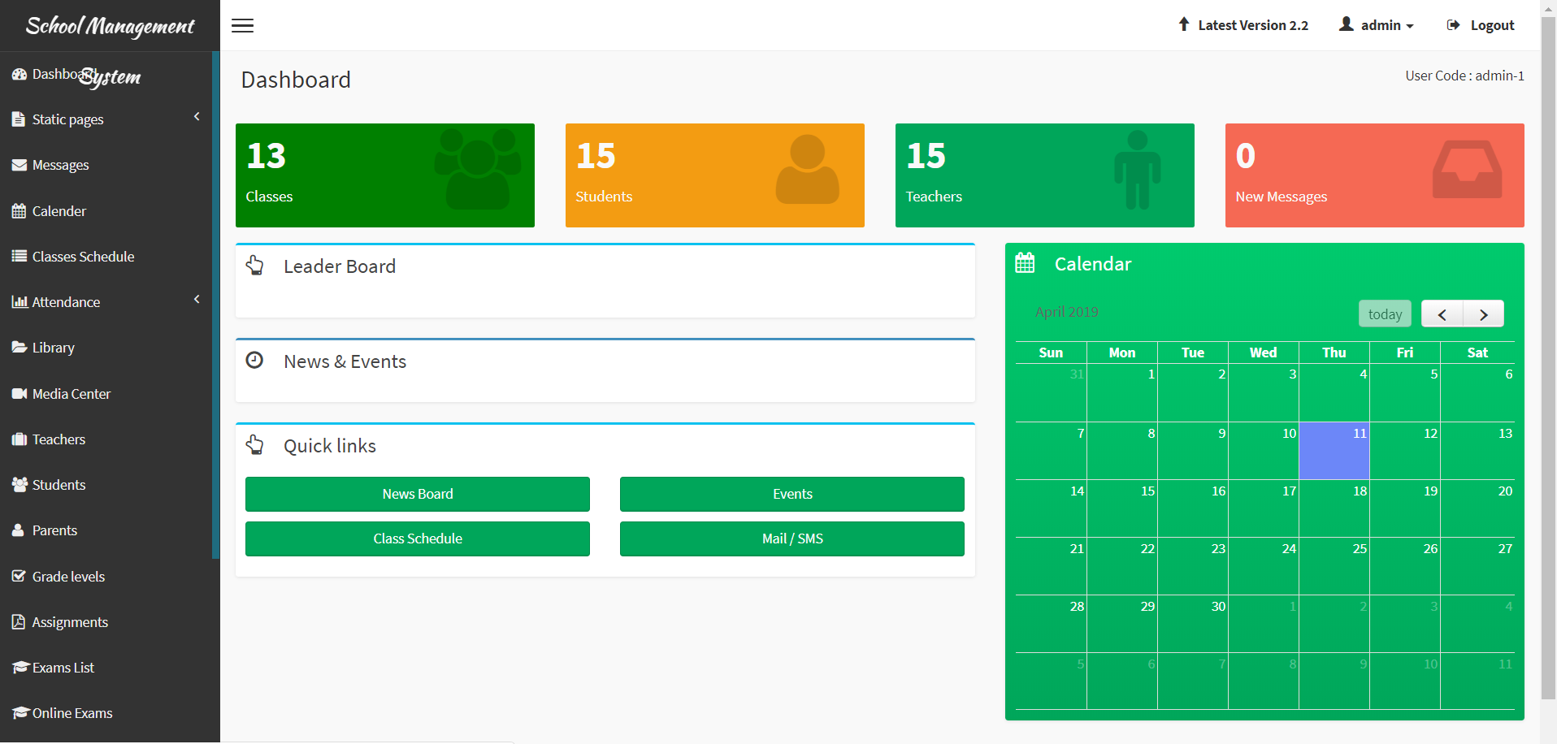

Figure : Admin Dashboard

Test_2 screenshots

Admin trying to login with wrong password

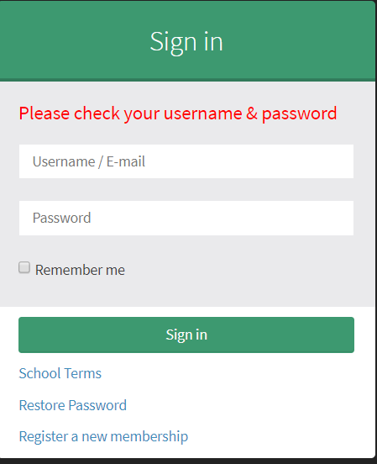

Figure 21: Admin unsuccessful login

Test_03

Registration and login by Teacher

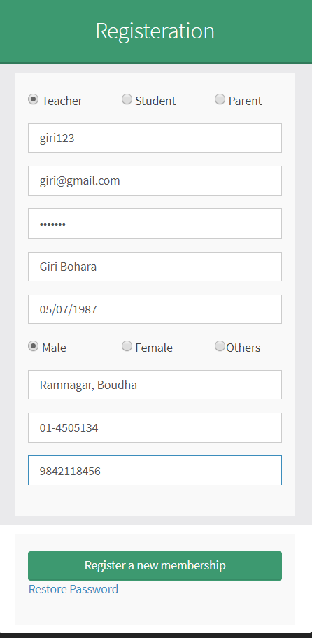

Figure : Teacher Registration Form

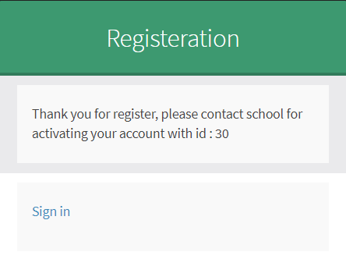

Figure 23: Registration for Teacher Approval

After teacher approves the teacher registration request, teacher can login the page.

Teacher Login Form

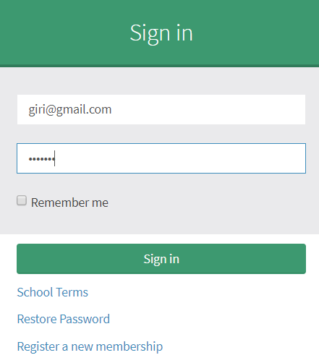

Figure 24: Teacher Login

Dashboard of Teacher

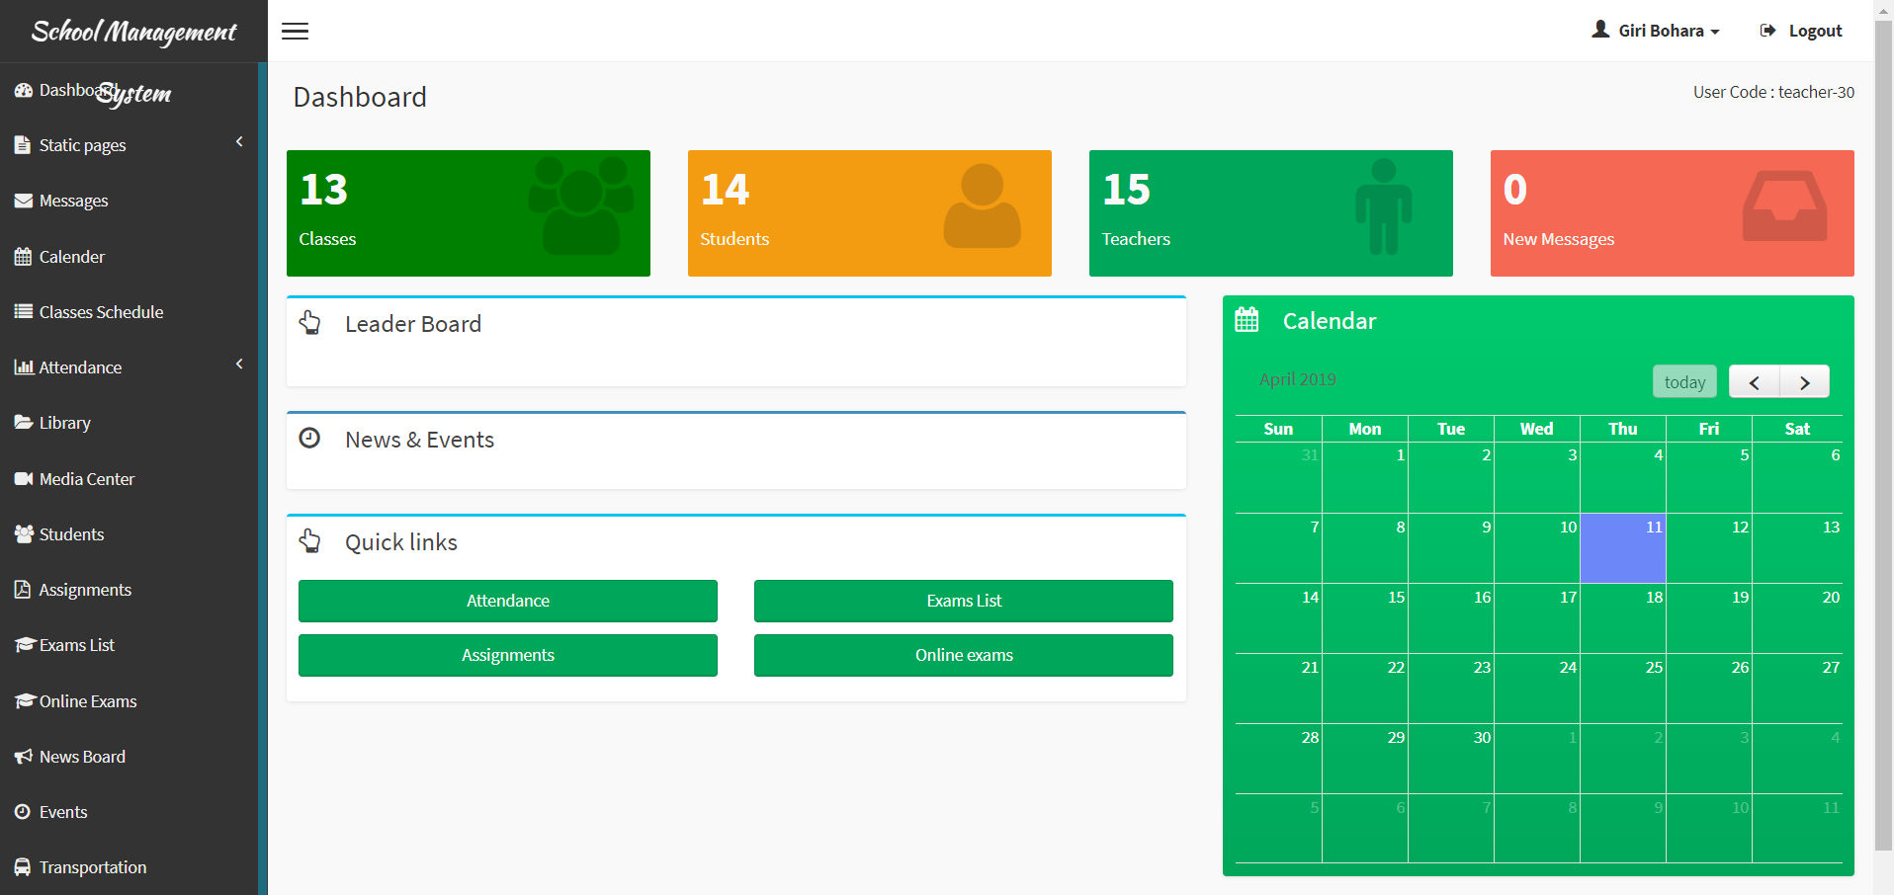

Figure 25: Teacher Dashboard

Test_04

Teacher login with wrong email_id or password

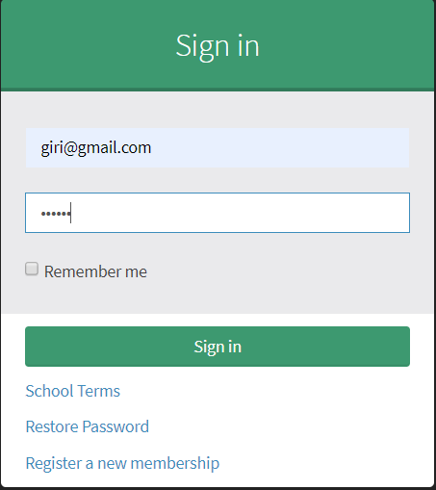

Figure 26: Teacher login with wrong email_id or password

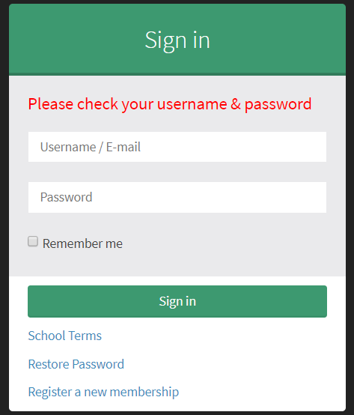

Figure 27: Teacher login unsuccessful

Test_05

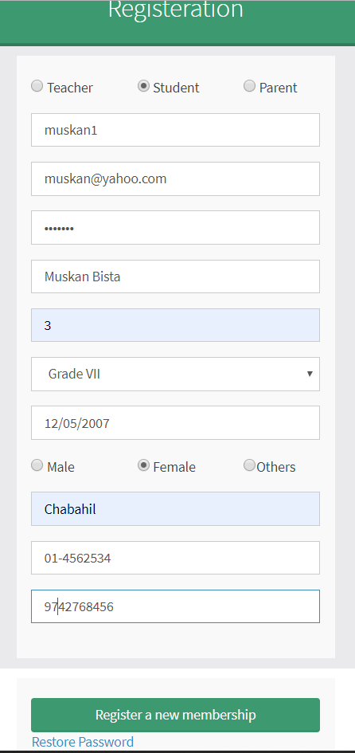

Figure :Student registration form

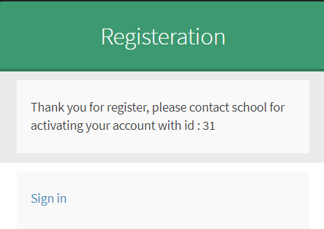

Figure 29: Student approval

After approval by admin

Login form for Student

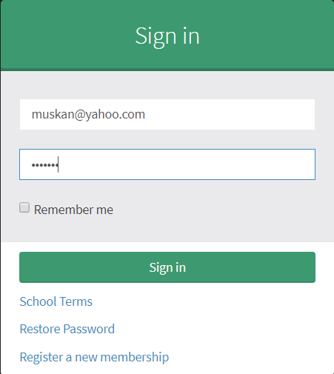

Figure 30: Student Login successful

After successful login by Student, he/she can view the student dashboard

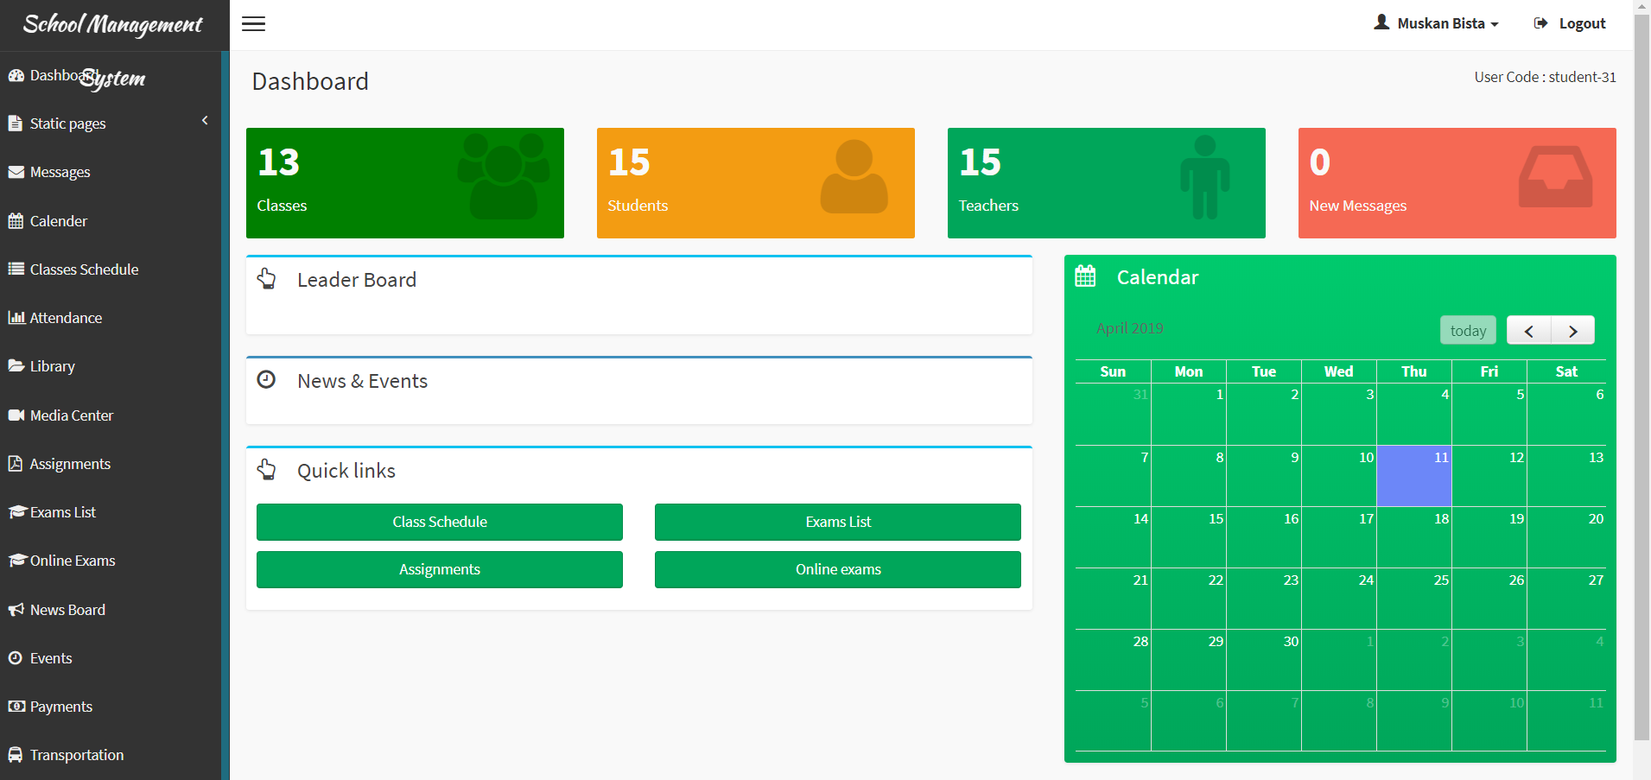

Figure 31: Student dashboard

Test_06

unsuccessful login by Student

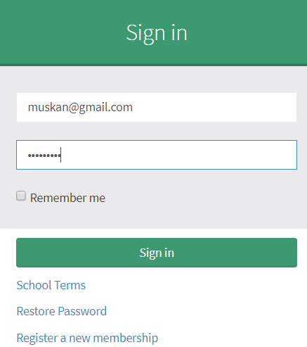

Figure 32: Student login by wrong password

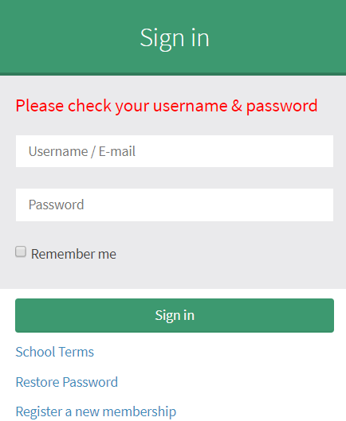

Figure 33: Unsuccessful Login by Student

Test_07

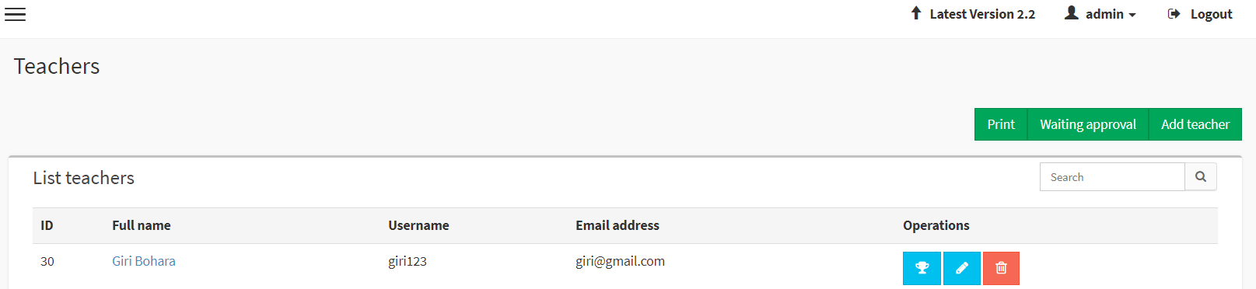Updating Teacher email_id by admin

Figure : Previous email _id of teacher

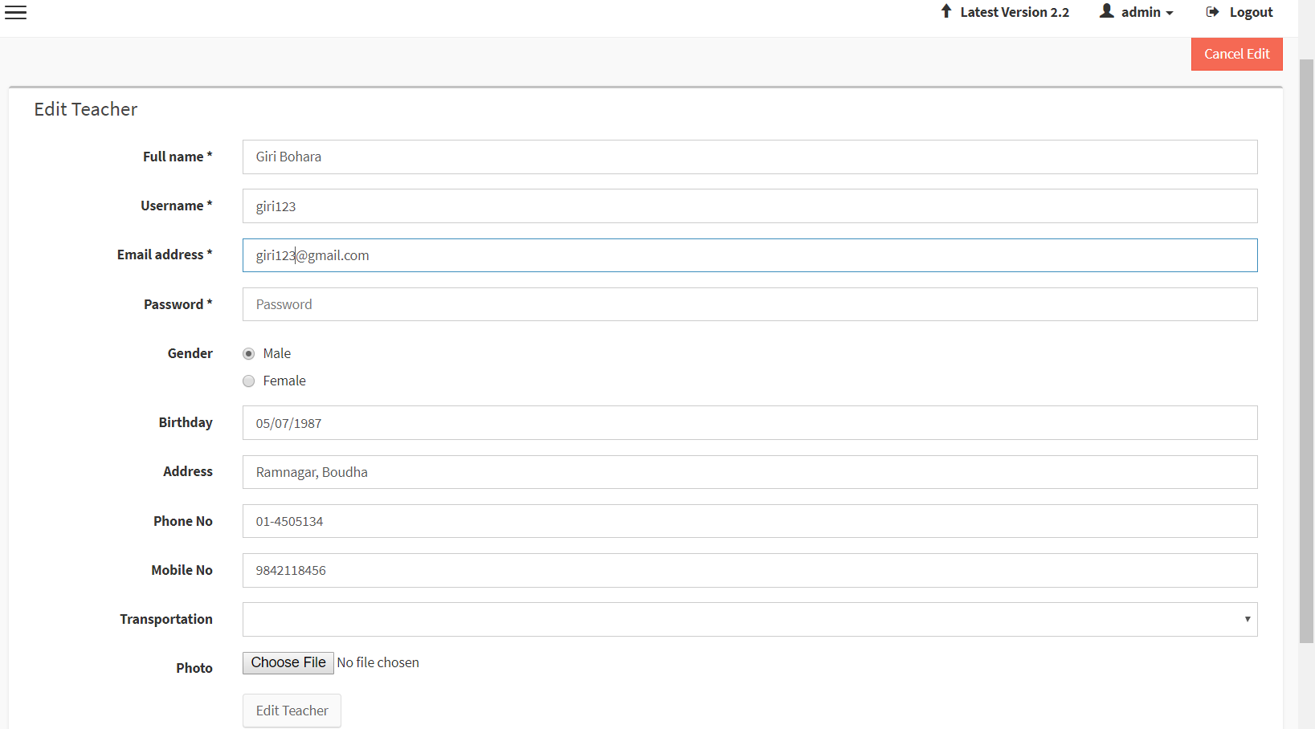

Figure : New email_id of Teacher

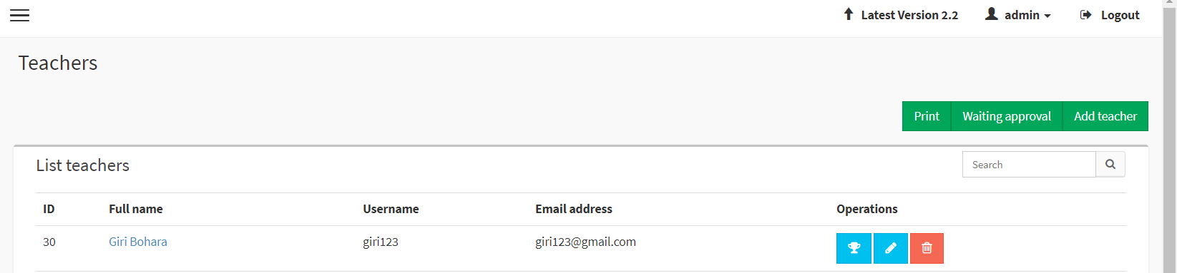

Figure : Updated email_id of Teacher by admin

Test_08

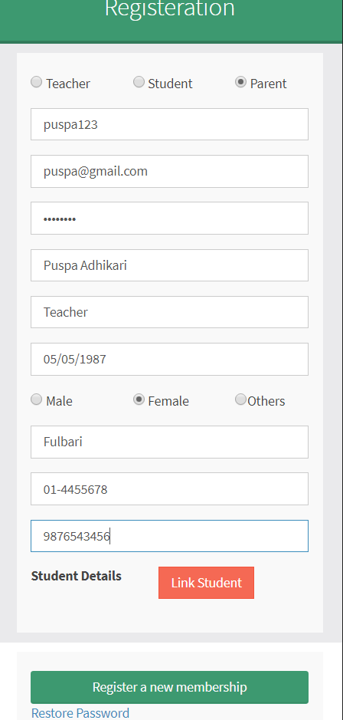

Figure : Parent registration form

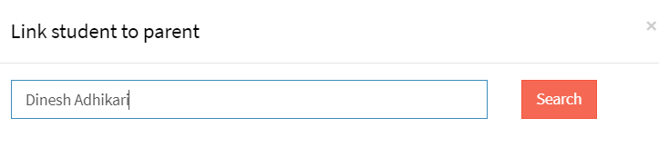

Figure : Student list to parent

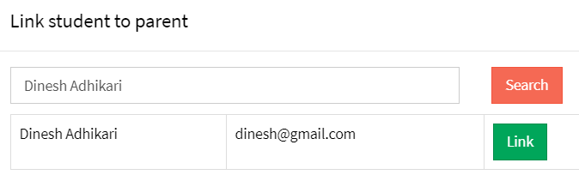

Figure : Student Link to parent

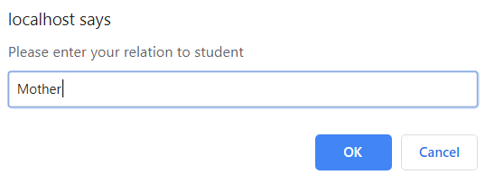

Figure : identifying as mother to that student

Test_09

Admin notifying holiday by adding to new list

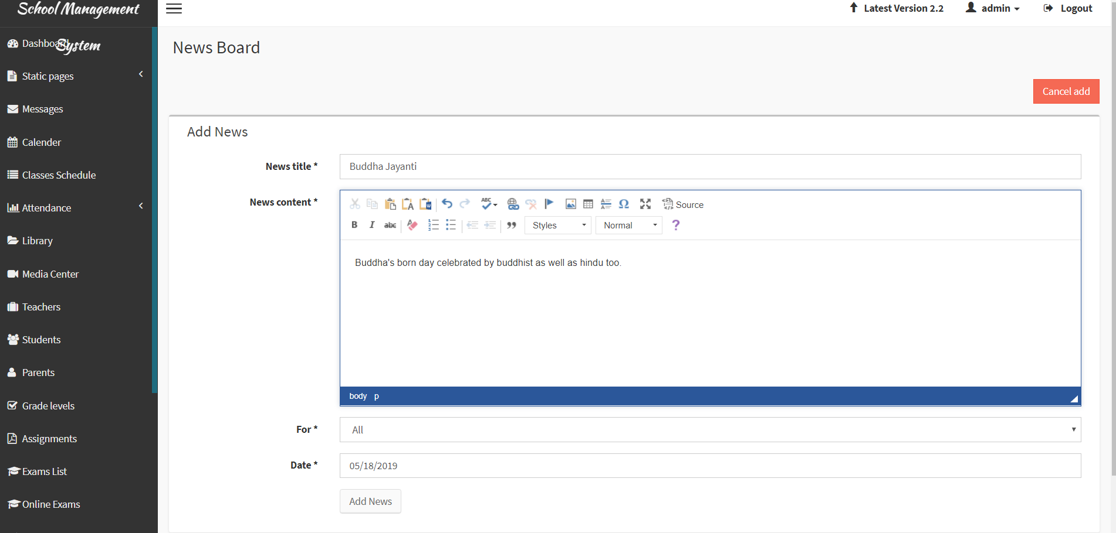

Figure : admin notifying holiday

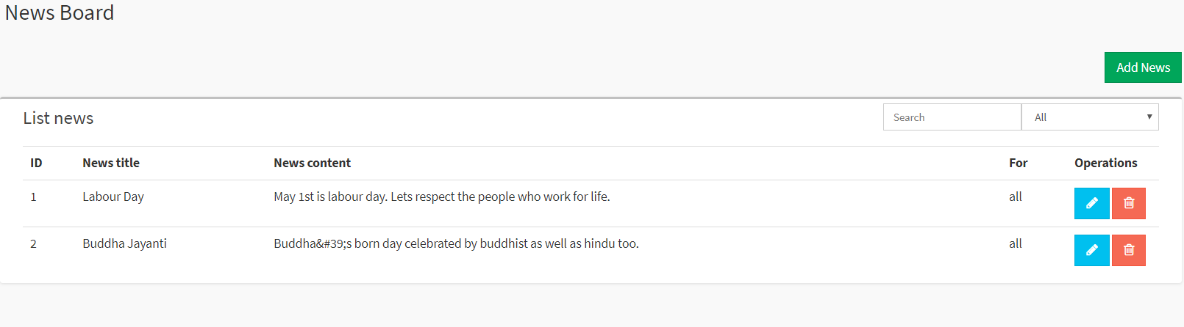

Figure : news board with holiday list

Test_10

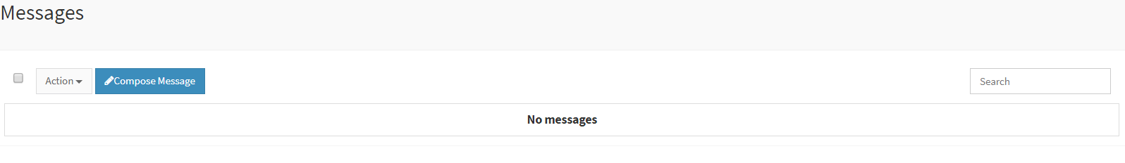

Figure : Admin message to Teacher

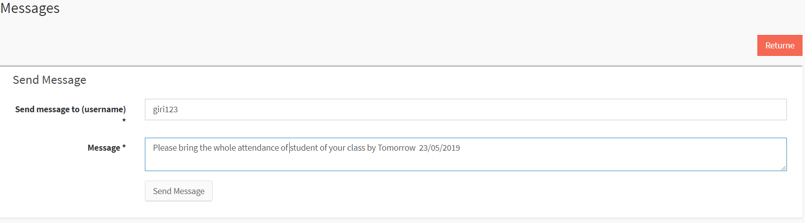

Figure : Admin message to admin1

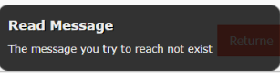

Figure : message not sent

# Chapter 6: Other project issues

## Risk management

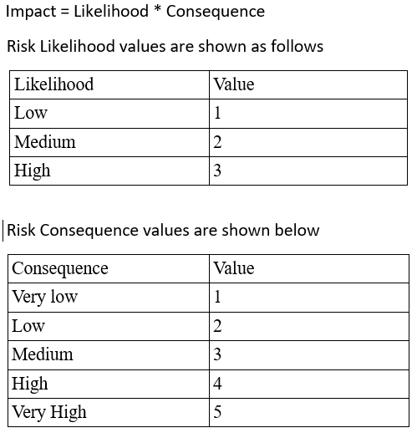

Figure : Risk management chart

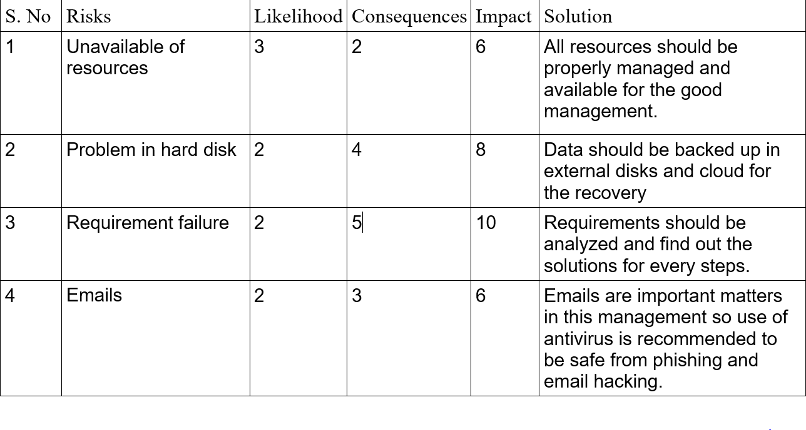

Figure : Risk management1

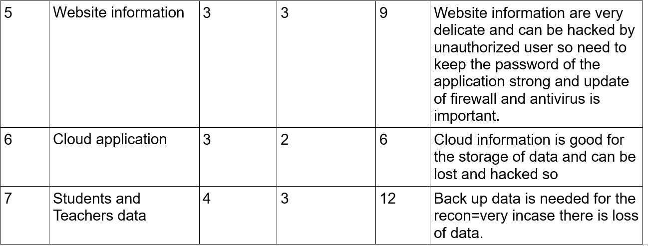

Figure : Risk Management2

## Configuration management

## Scheduling

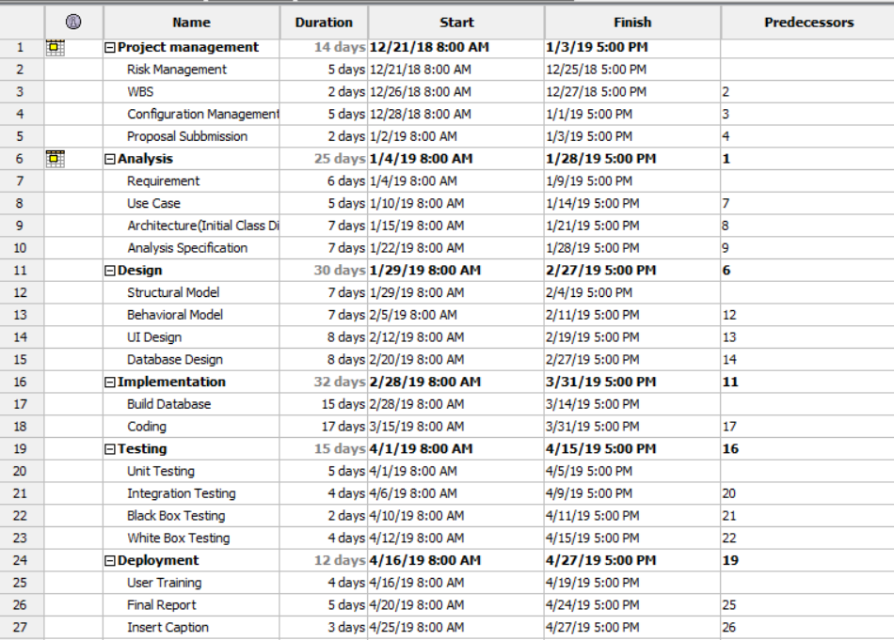

Figure 49: Gantt chart

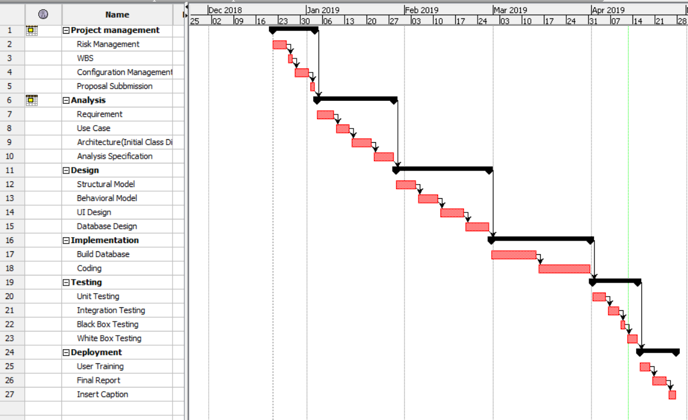

Figure : Gantt Chart1

## Future work

Future work are as follows for my school management system

* Online school management system is one of my future work
* Student can pay through online their fees
* Teacher can easily get paid through online.

## User manual

User's main feature

* All user can get registered and login in the page with the approval of the admin
* User can view and send messages
* User are notified about the events and holidays of he school
* User can view the calendar and see the scheduling of the routine

Admin Main feature

* Admin can register the students, teacher and parent
* Admin can update and delete the information of students, teachers
* Admin can assign the subject to the teacher for each class
* Admin can notify the events and holidays of the school

Teacher's main feature

* Teacher can give assignment to the students
* Teacher can take the attendance of the students
* Teacher can give exams and check the papers and prepare the results of the student

Student's main feature

* Students can view their attendance
* Students can view their homework assigned by the teacher
* Students can see their results

For the user guidance following steps are to be followed to get access in this system

To get registered to the school, go to the button **Register a new membership** and then click and choose whether you are **Teacher, Student** or **Parent** then fill the all credentials given in the form. Parents need to have their child already registered to sign up the form.

Sign-up form for Teacher

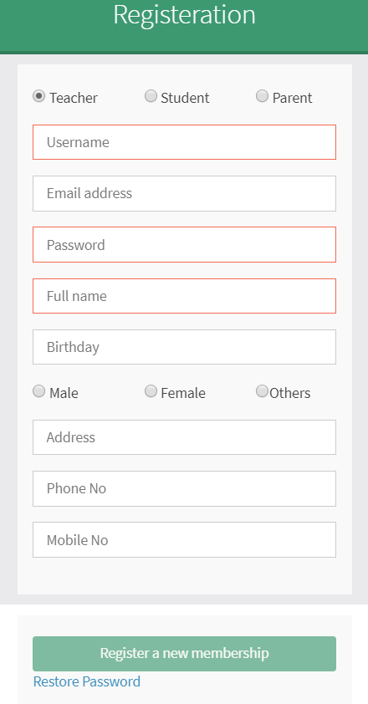

Figure : Teacher Sign up Form

Student signup form

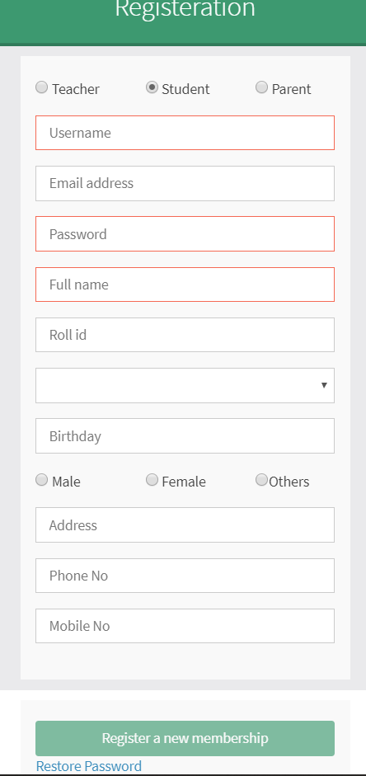

Figure : Student sign up form

Parent sign up form

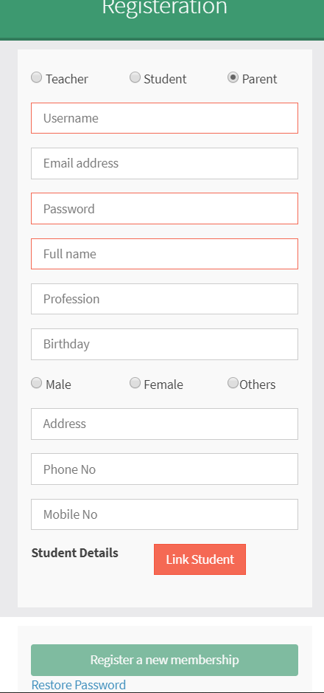

Figure : Parent sign up form

After successful registration approved by admin, users can login the page

Login page for all users

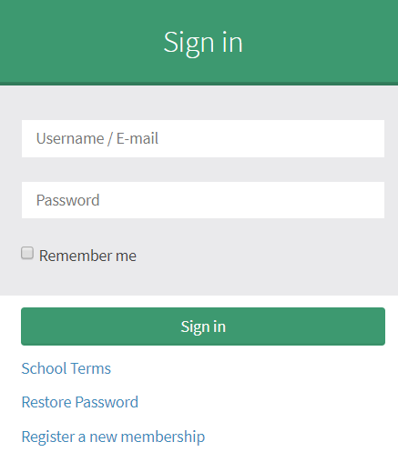

Figure : Login form for users

Steps for login

Put the username/E-mail id of the user and click to the button

**Sign in** which will lead you to the dashboard of the school

Let's see now how admin can modify the student details or name

Admin login with his/ her username and password

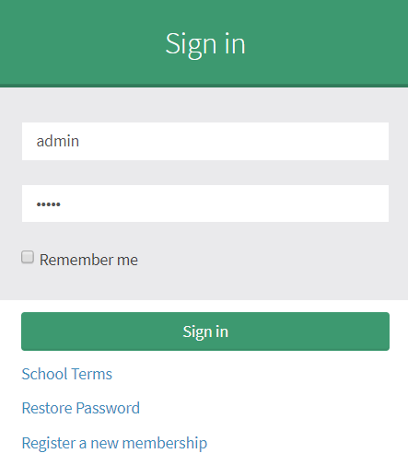

Figure : Admin Login form

After logging select the student icon

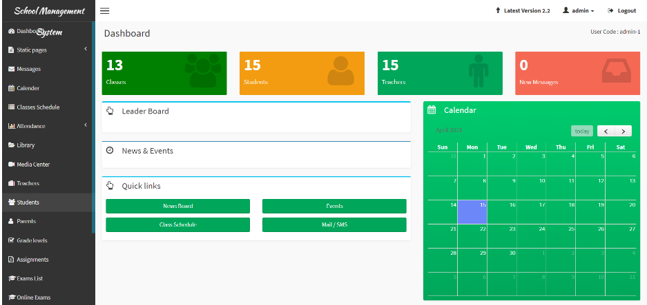

Figure : Dashboard of Admin

Then choose student to be modified

let's change the name of student named as Maya Tamang

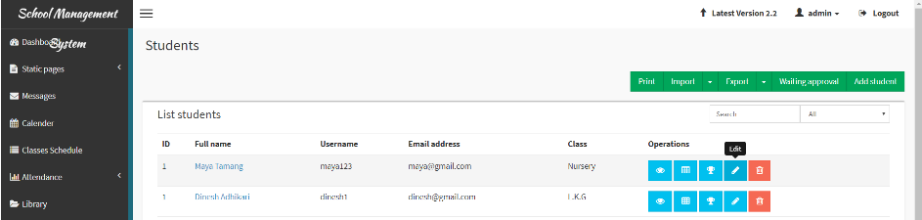

Figure : student name before changing

Then change the name and click to button Edit student

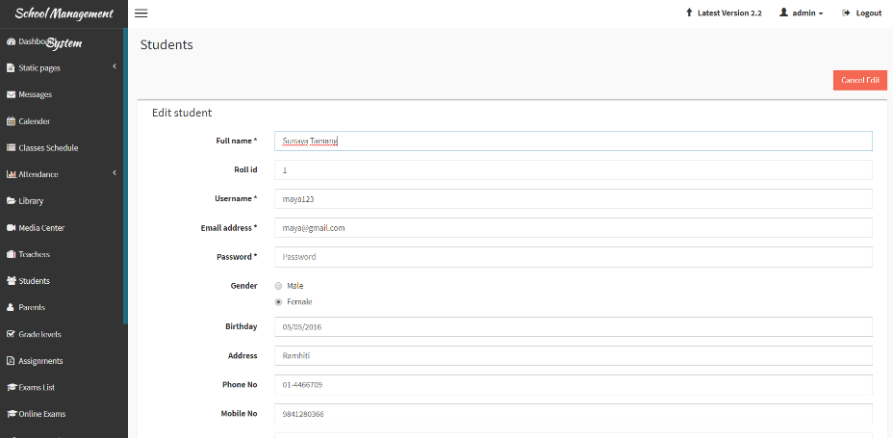

Figure : Student name renamed

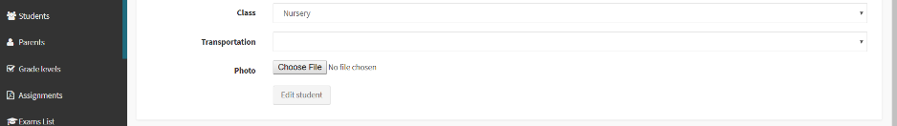

Figure : Student name renamed1

After edition of the student, there comes a message box which is displayed below

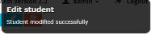

Figure : Student name modified successfully

Now, we can see the modification data of the student

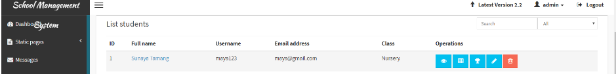

Figure : Student name being modified

## Limitation

* If the system crashes this application will be corrupted.
* Backend can be accessed for the storage but there is limit in storage.
* It is not online software.
* This application can be used only by school management.

# Chapter 7: Conclusion

## Conclusion of the project

So the main thing in this project is that I have used various design to develop which has made the system very reliable and user friendly and any school management can have good use of this system. Now with this system school have very much benefit in running school management.

# Chapter 8: Reference and bibliography

<https://www.workbreakdownstructure.com/>

<https://en.wikipedia.org/wiki/Configuration_management>

<https://www.tutorialspoint.com/mvc_framework/mvc_framework_introduction.htm>

# Chapter 9: Appendix

Laravel files in sublime editor.

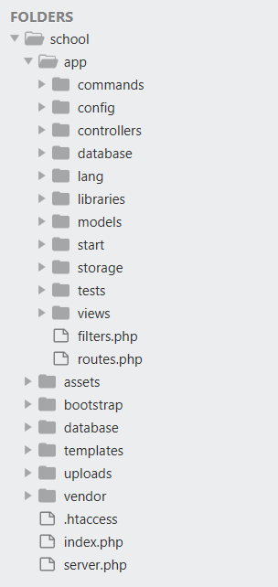

Figure : Files from the Laravel project

Folders in database

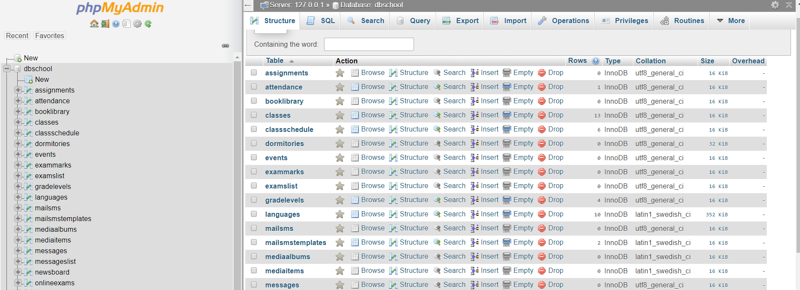

Figure : Database in MYSQL

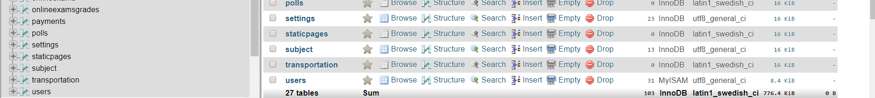

Figure : Database in MYSQL1

Models on Laravel

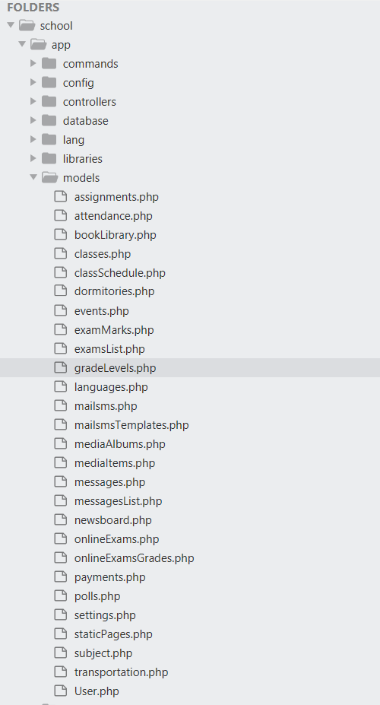

Figure : models files in Laravel

Controllers in Laravel

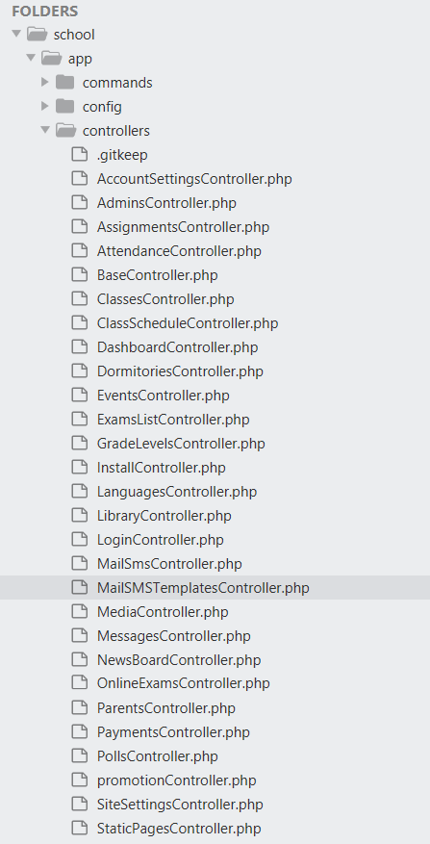

Figure : Controllers

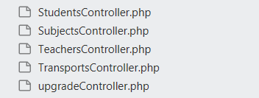

Figure : Controllers1

Views files

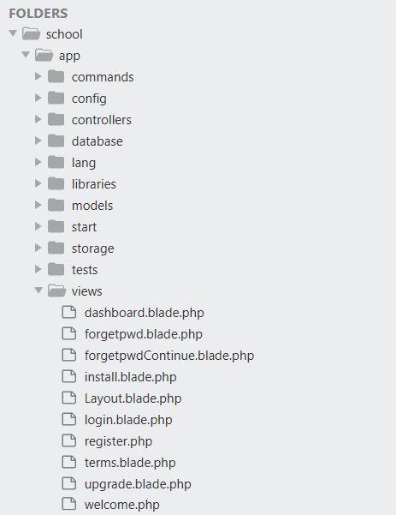

Figure : Views files

UI Design of my project(School Management System)

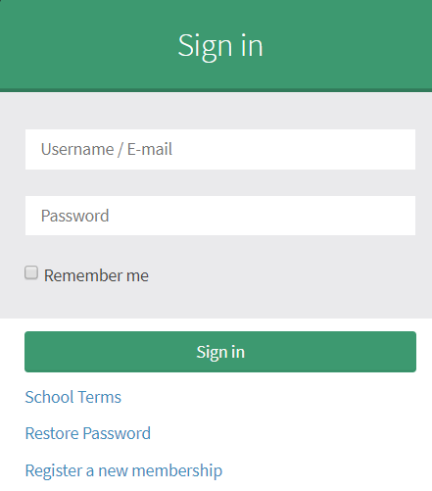

Figure : Admin and User UI Login Form

Dashboard of the System

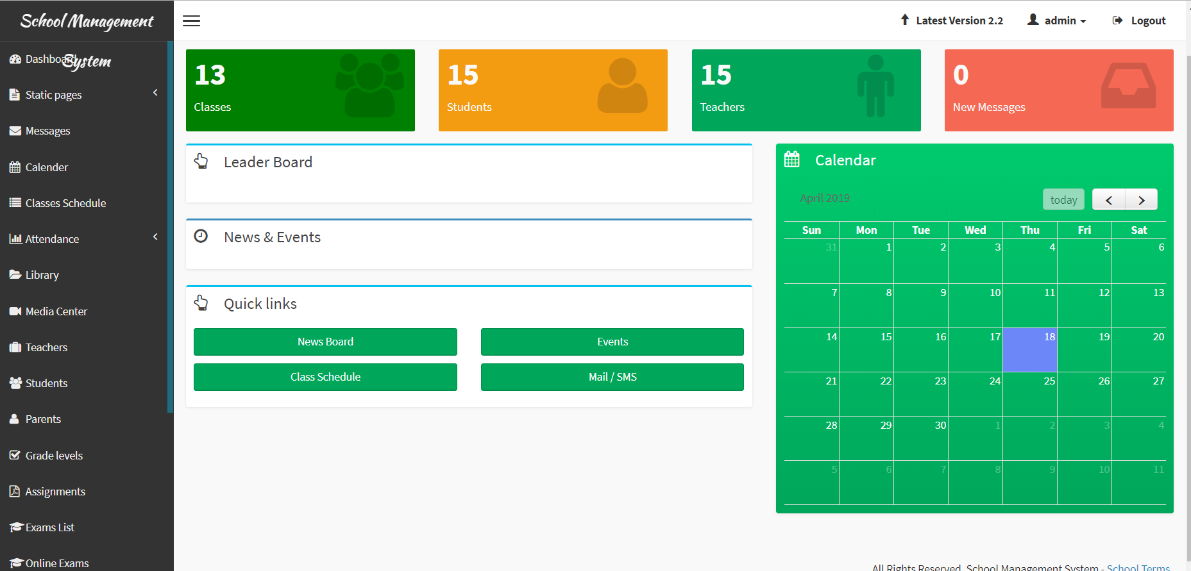

Figure : Dashboard for the system

Teachers List

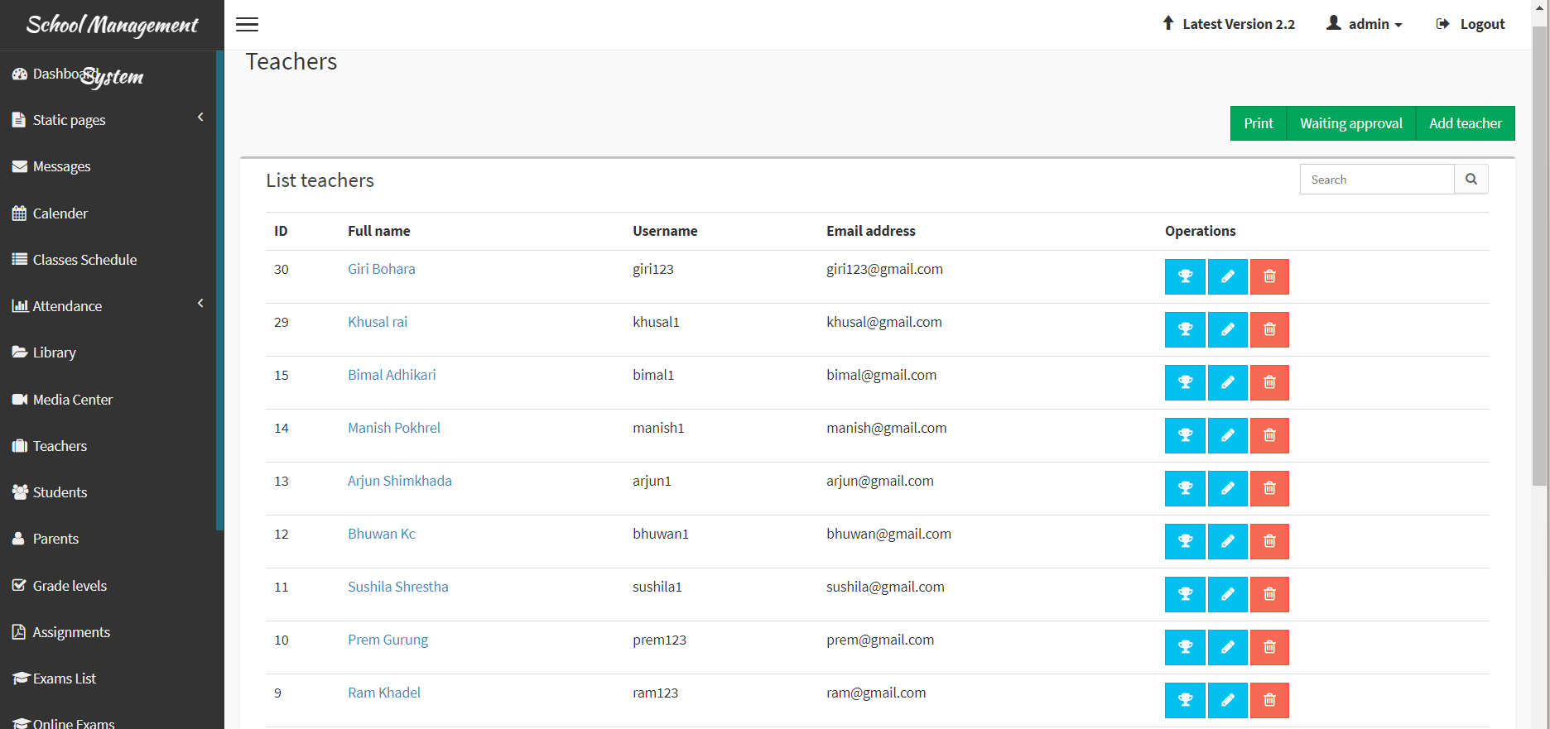

Figure 71: Teachers list

Registration for Users



Figure : Teacher Registration Form



Figure : Student Registration Form



Figure : Parent Registration Form

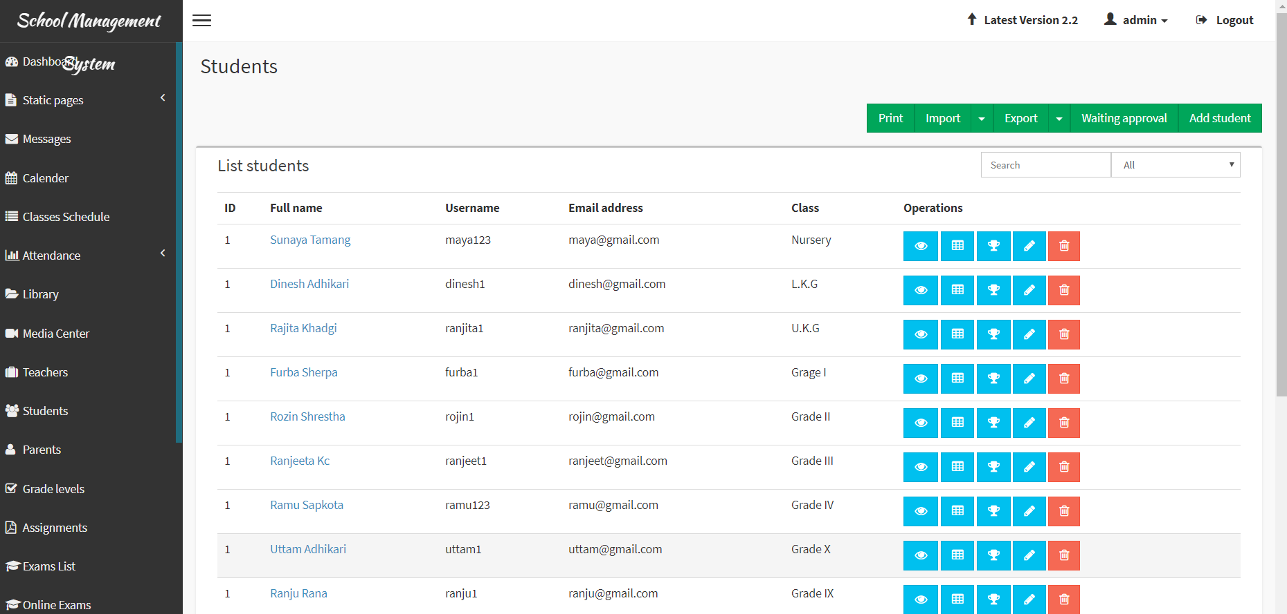

Figure : List of Students

Class

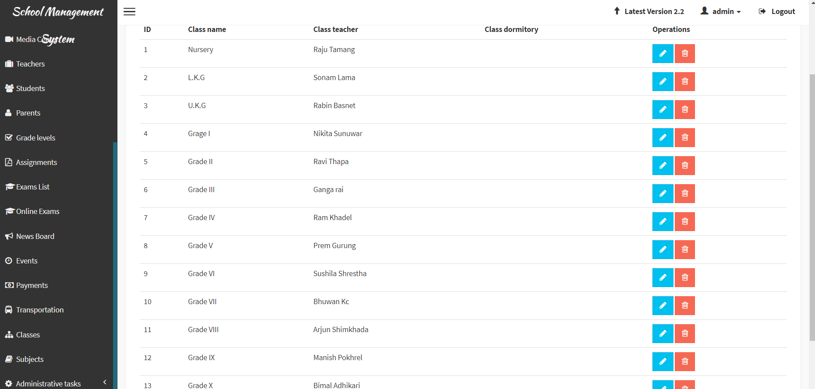

Figure : Name of the classes

Subjects

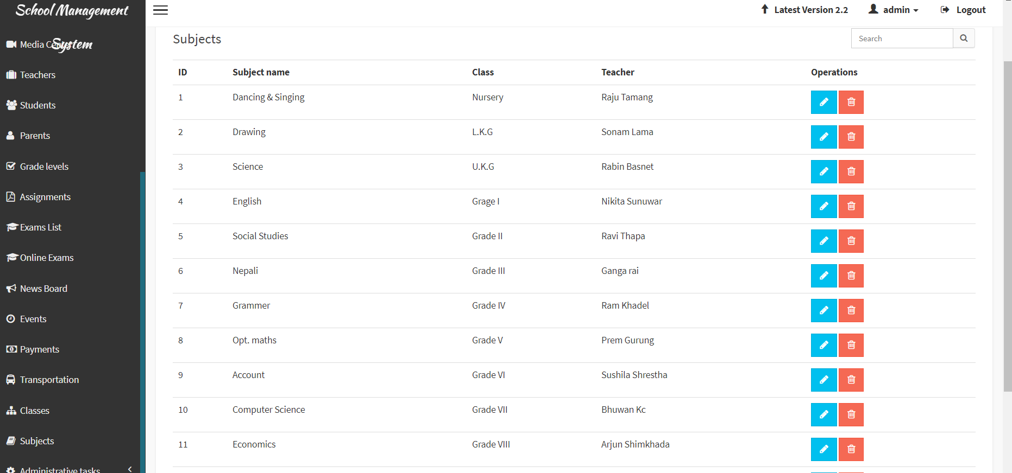

Figure : List of Subject UI design

Controllers

AccountSettingsController.php

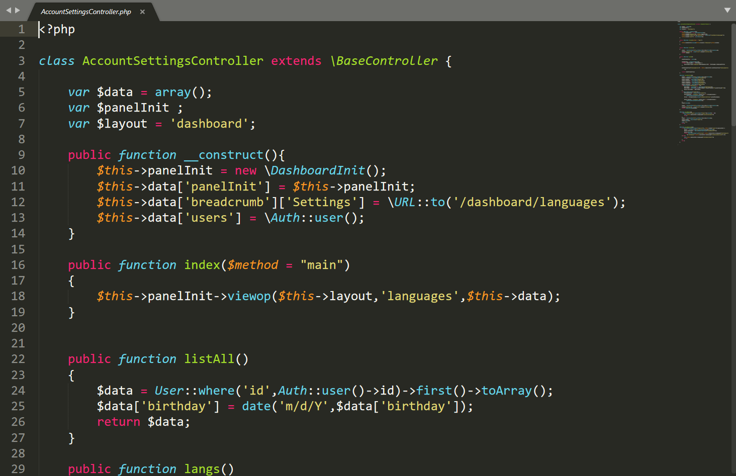

Figure : AccountSettingsController

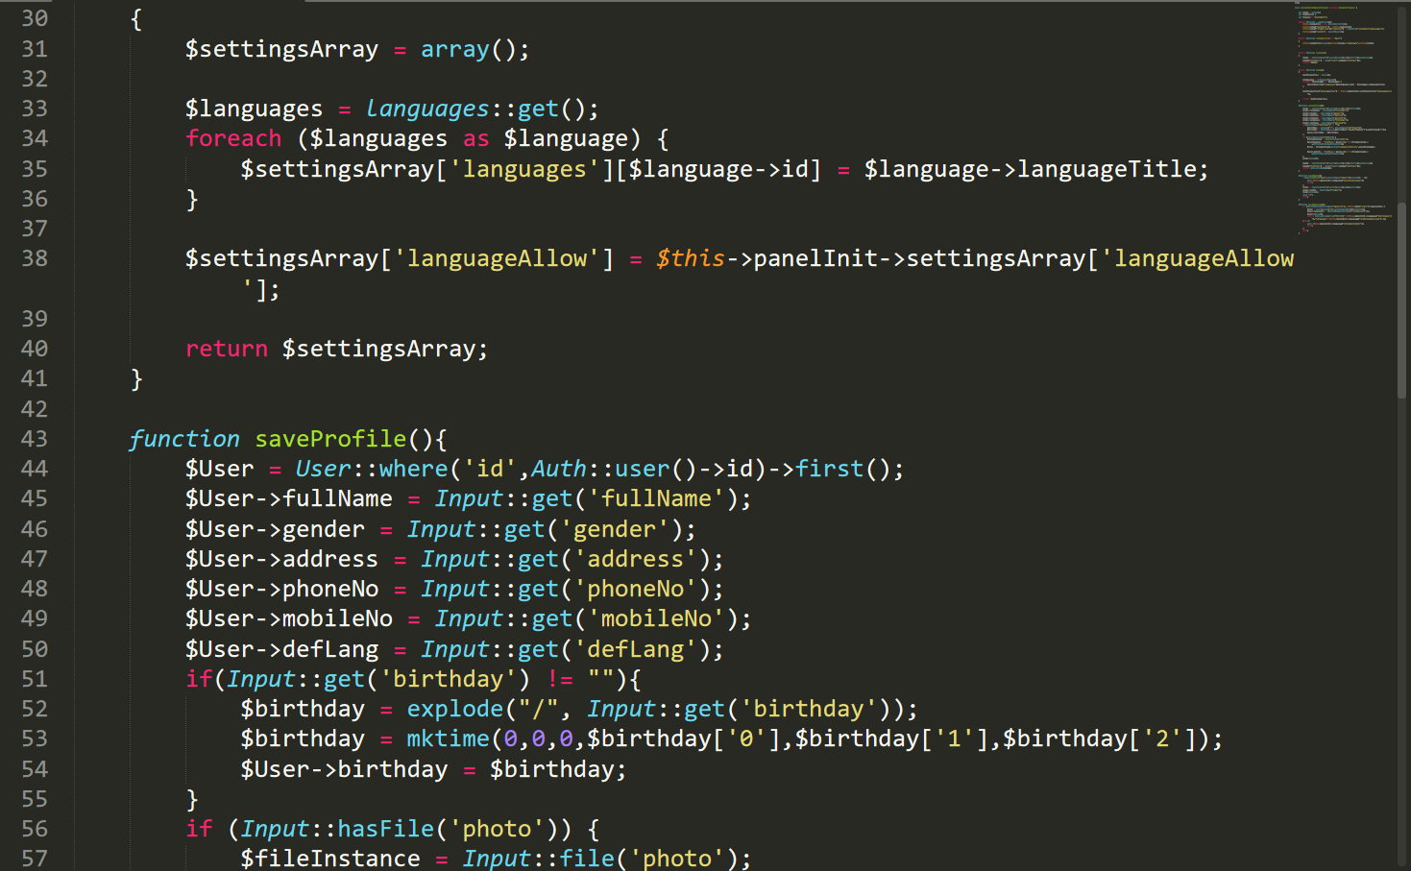

Figure : AccountSettingsController1

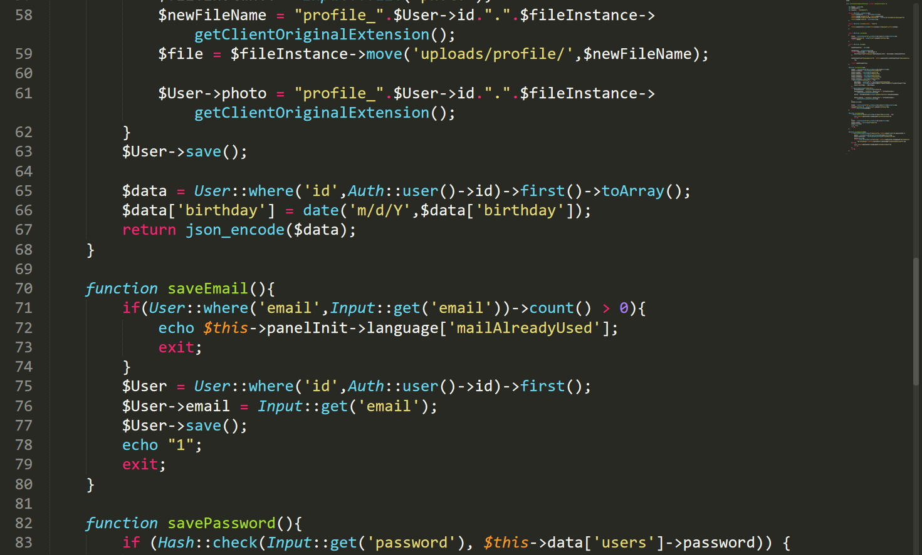

Figure : AccountSettingsController2

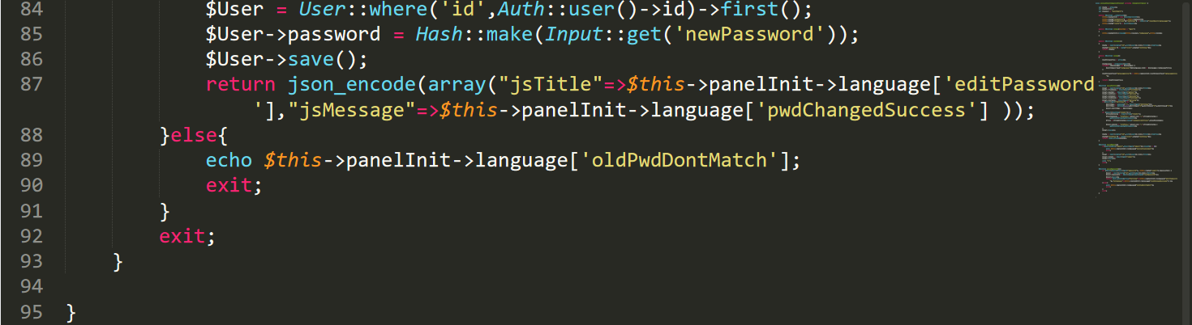

Figure : AccountSettingsController3

Adminscontroller.php

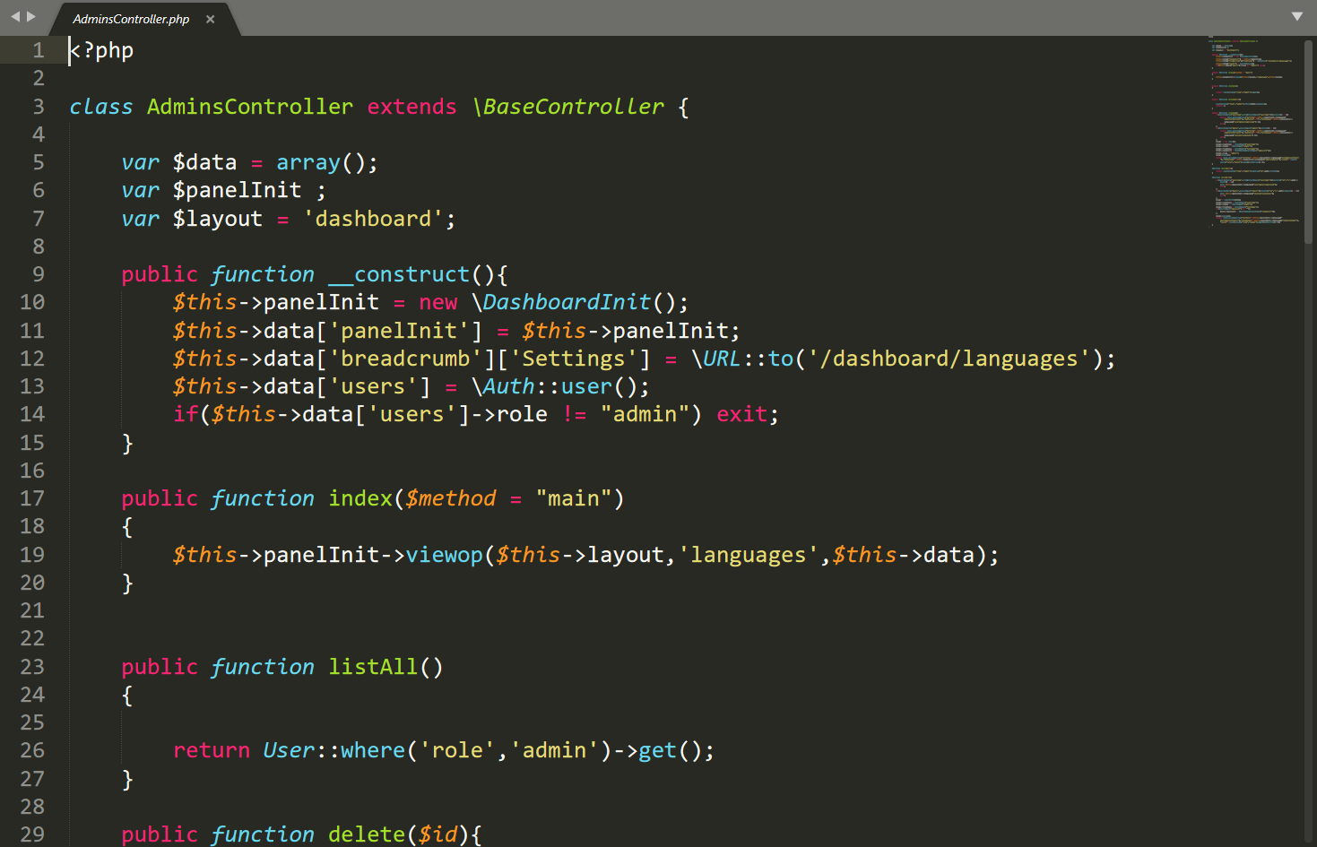

Figure : Adminscontroller.php

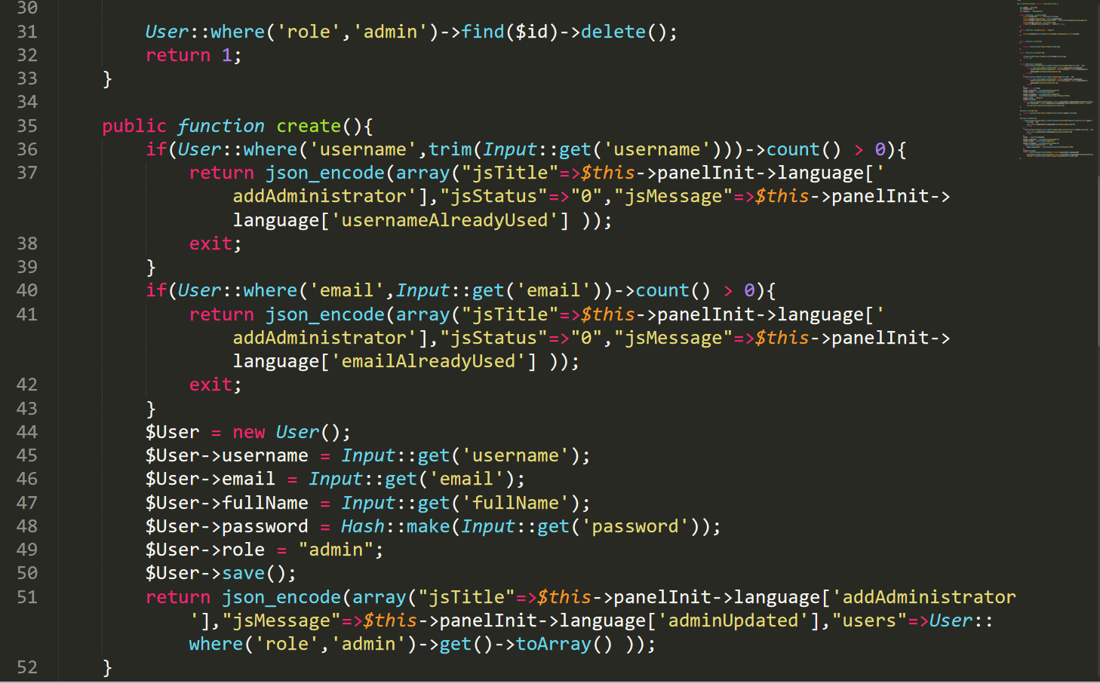

Figure : Adminscontroller.php

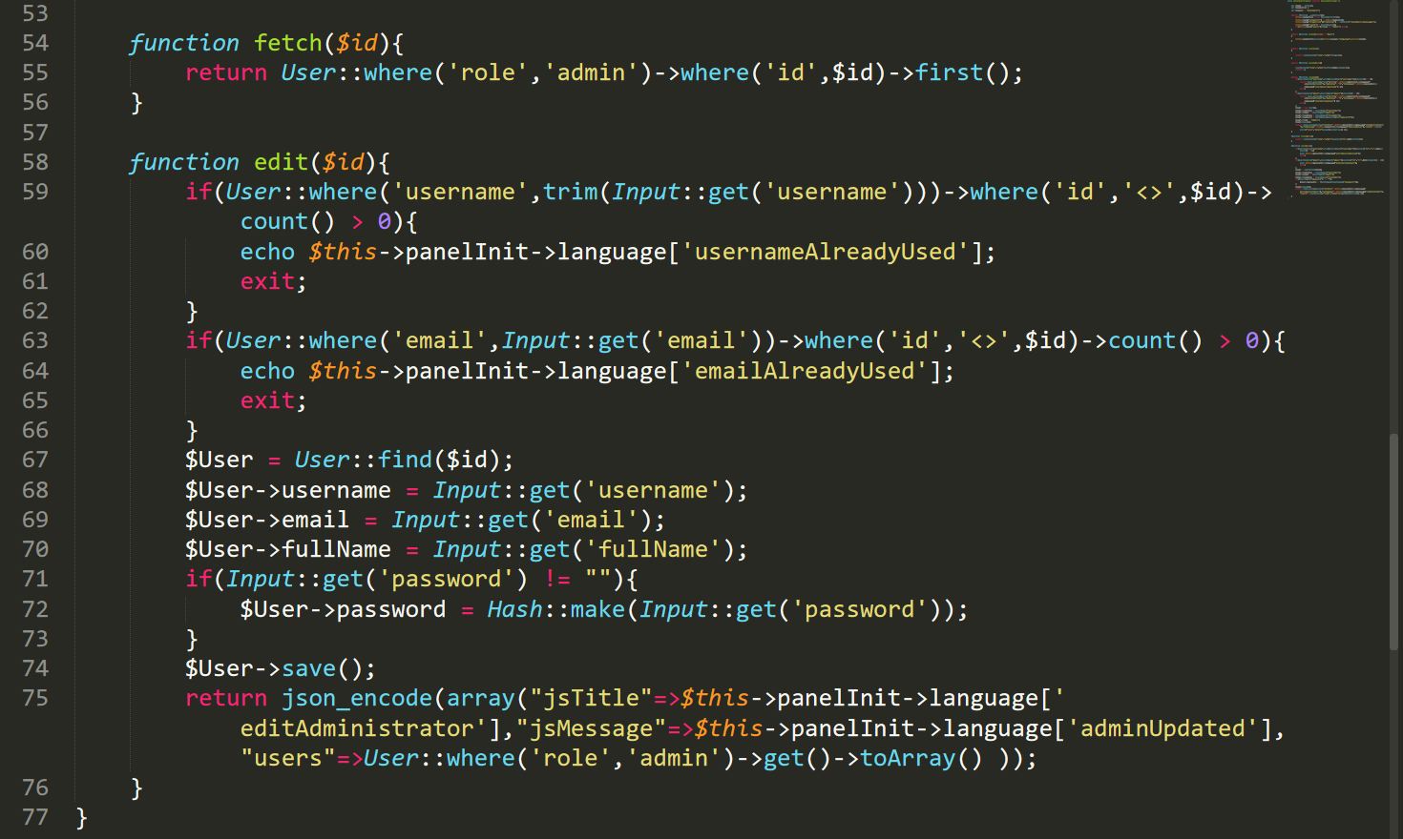

Figure : Adminscontroller.php

TeachersController.php

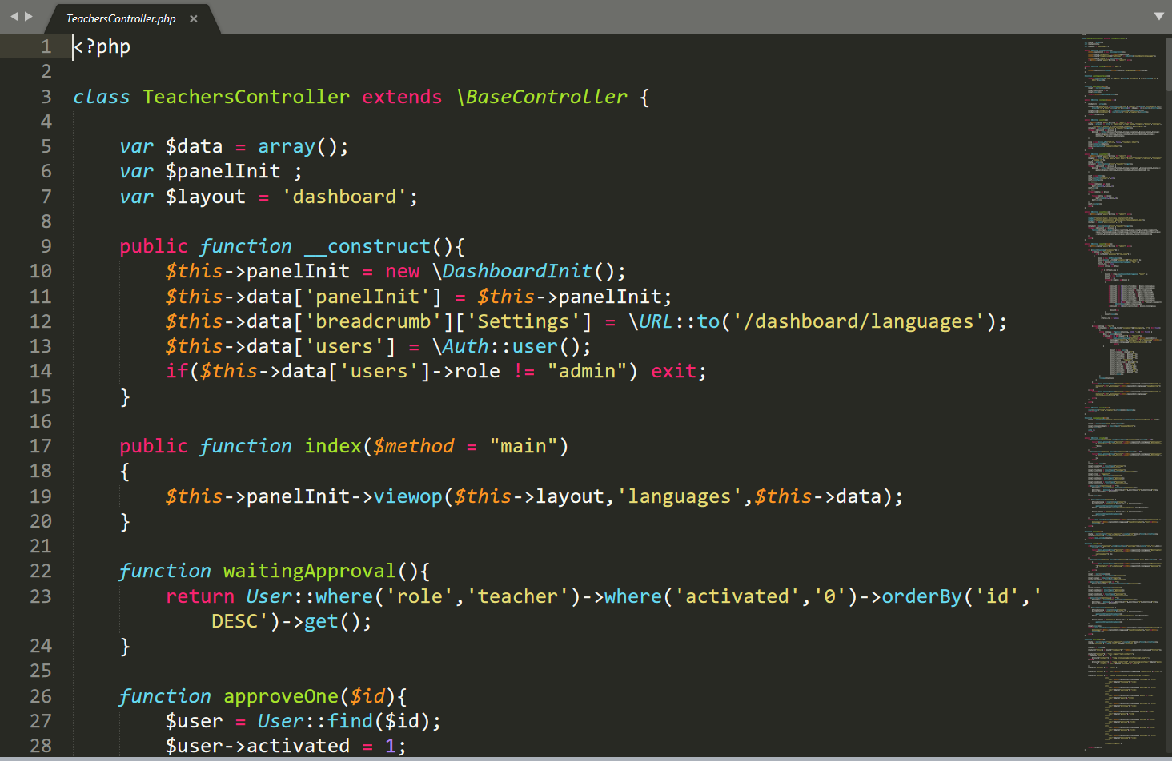

Figure : TeachersController.php

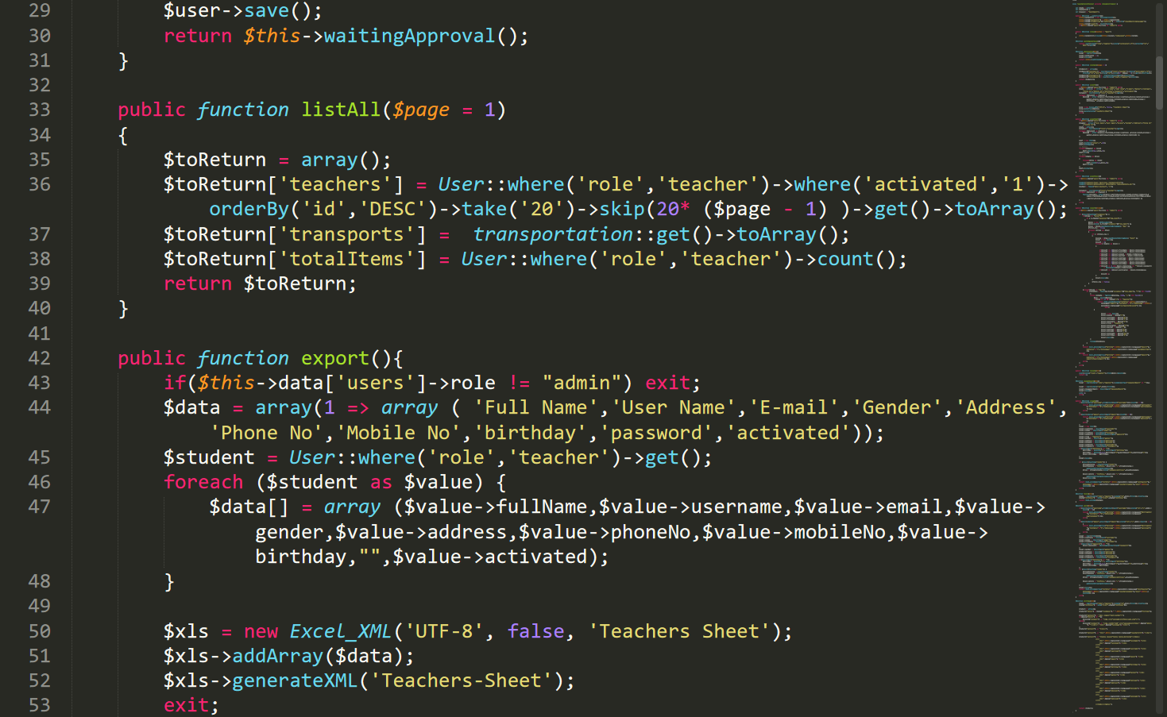

Figure : TeachersController.php1

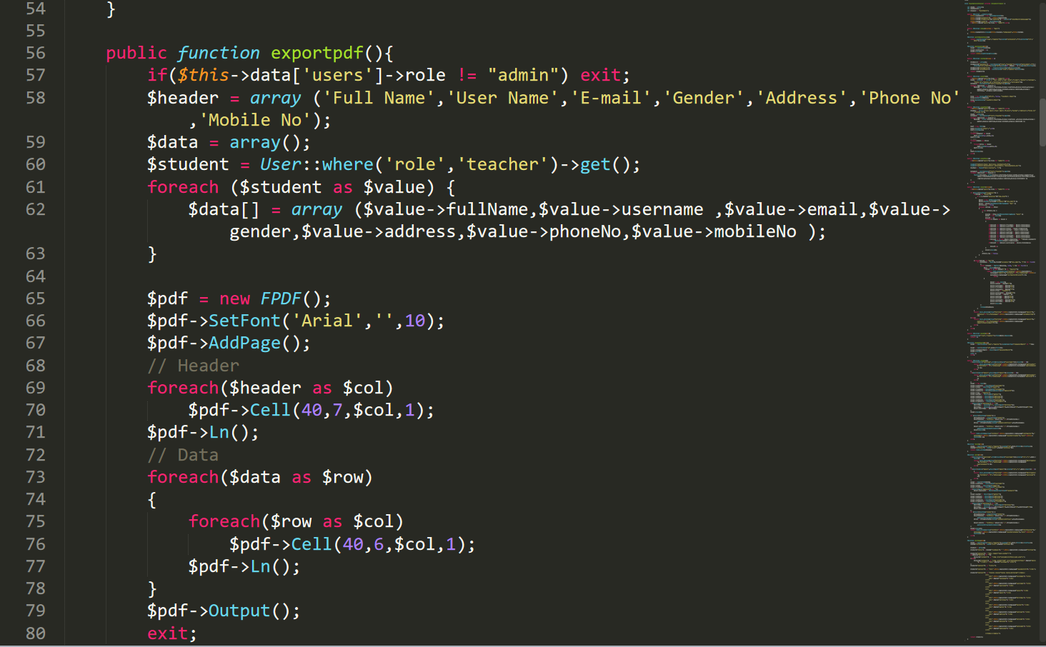

Figure : TeachersController.php2

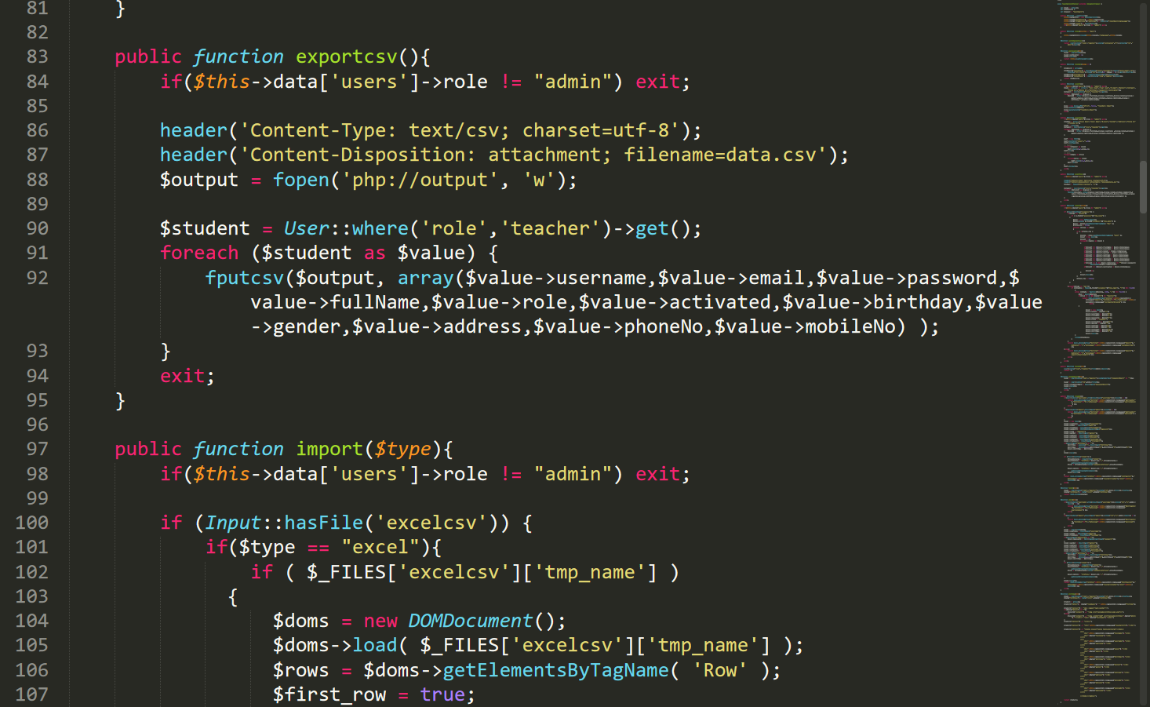

Figure : TeachersController.php3

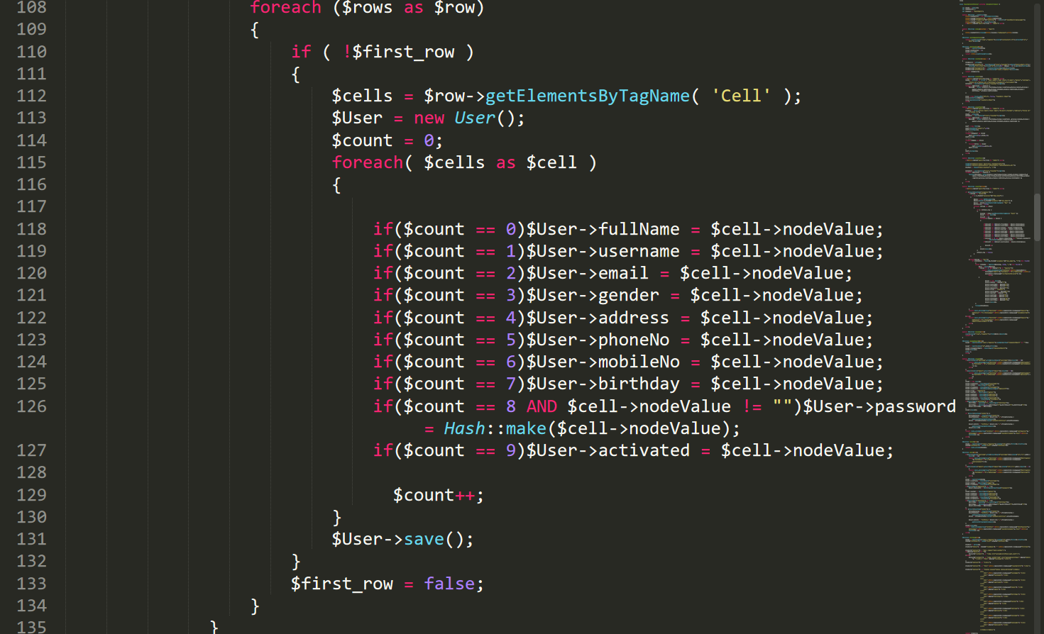

Figure : TeachersController.php4

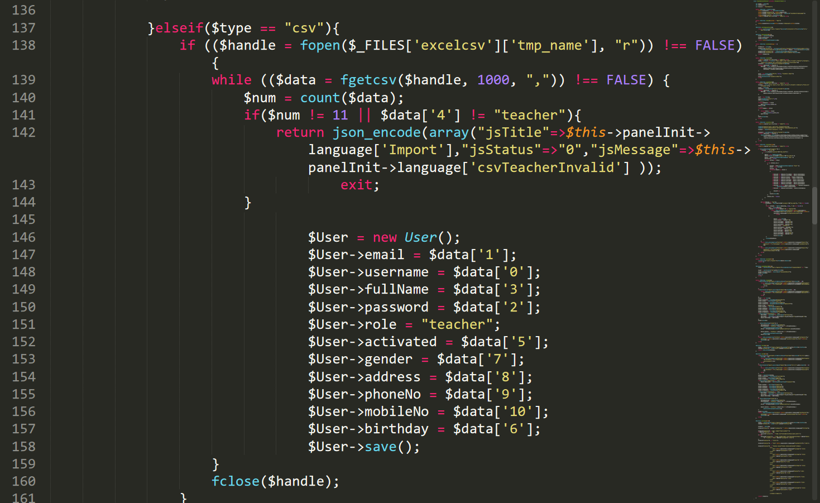

Figure : TeachersController.php5

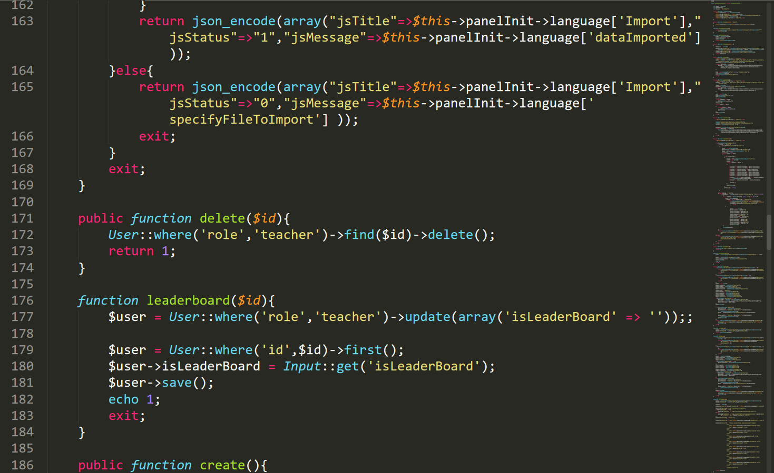

Figure : TeachersController.php6

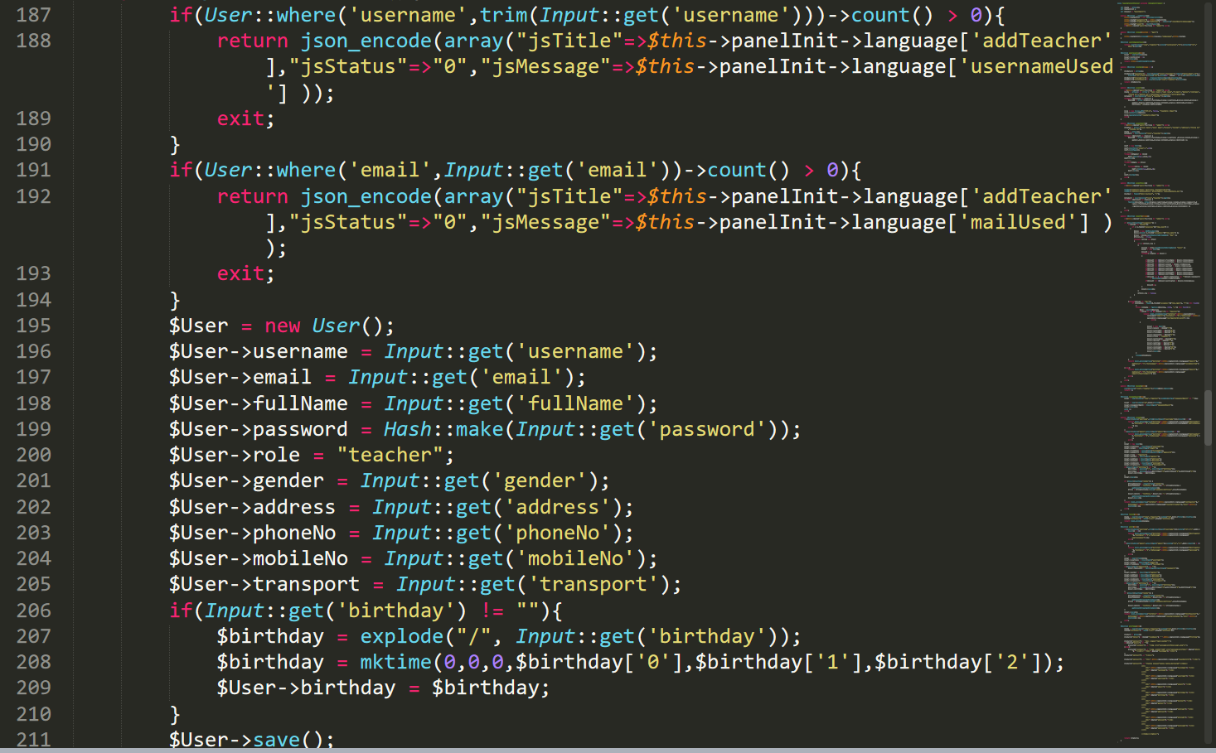

Figure : TeachersController.php7

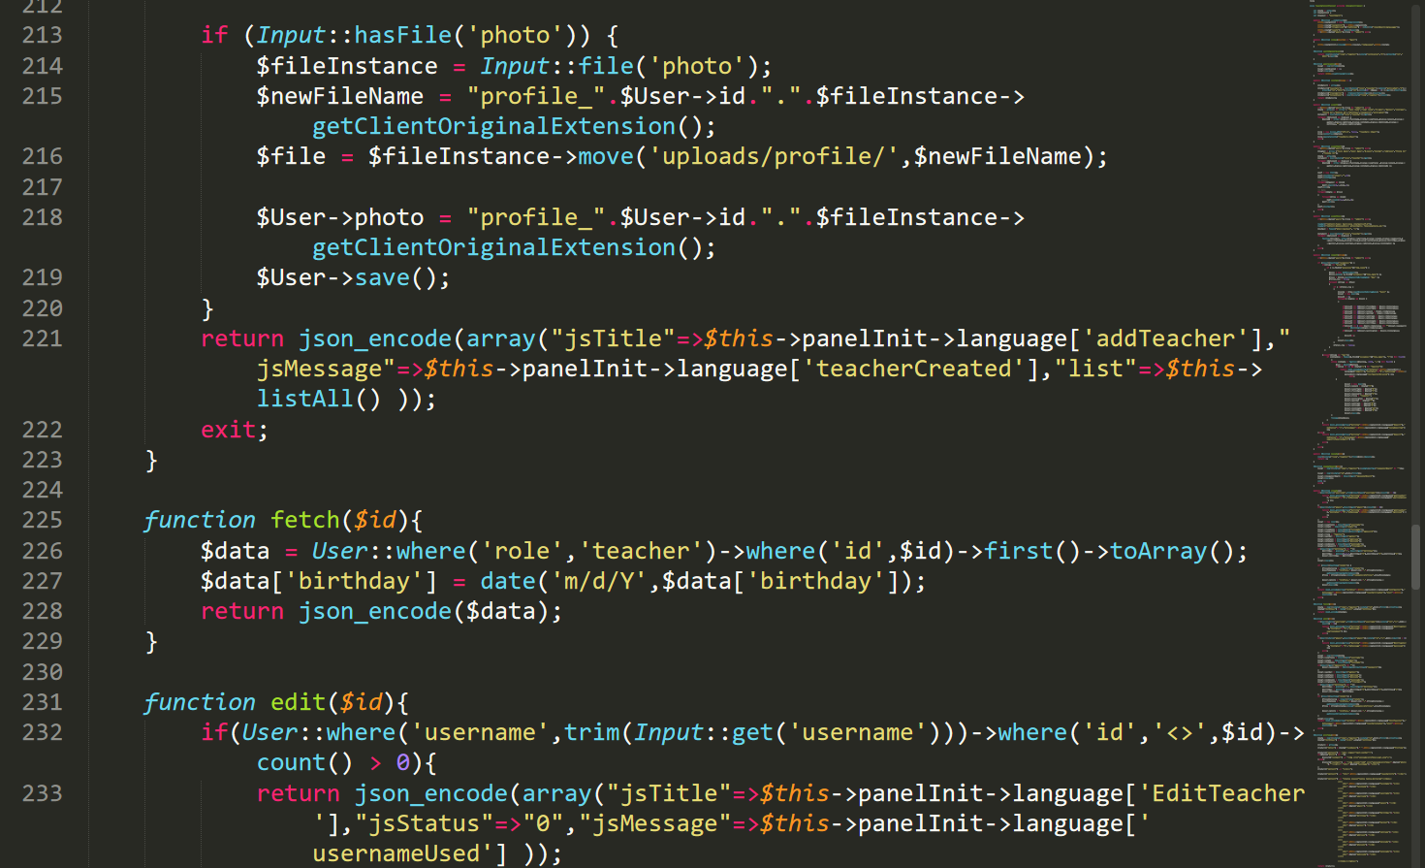

Figure : TeachersController.php8

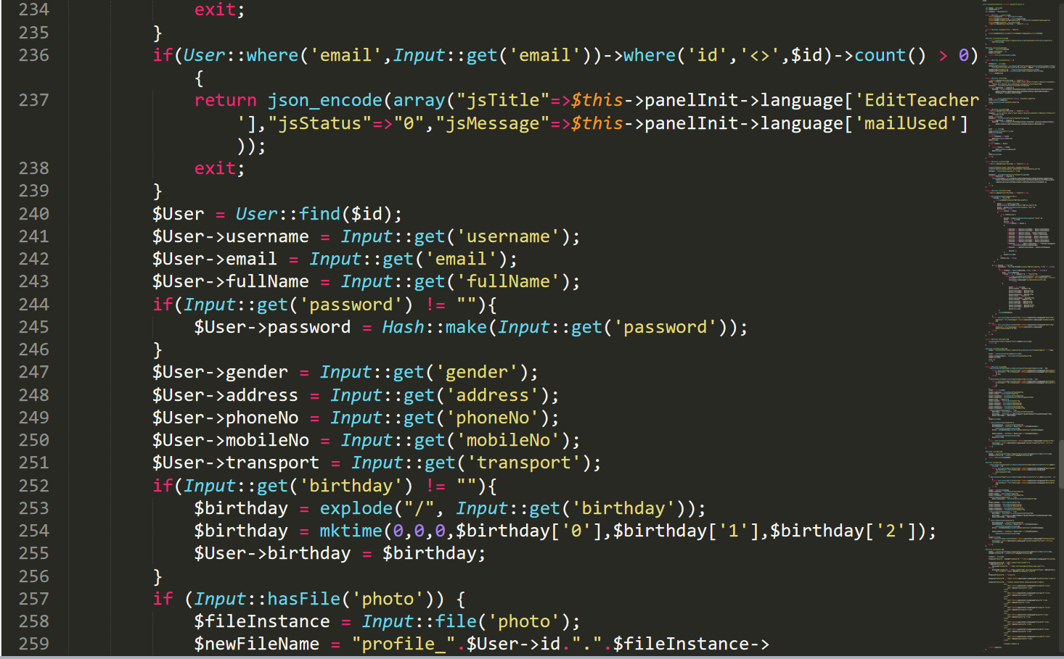

Figure : TeachersController.php9

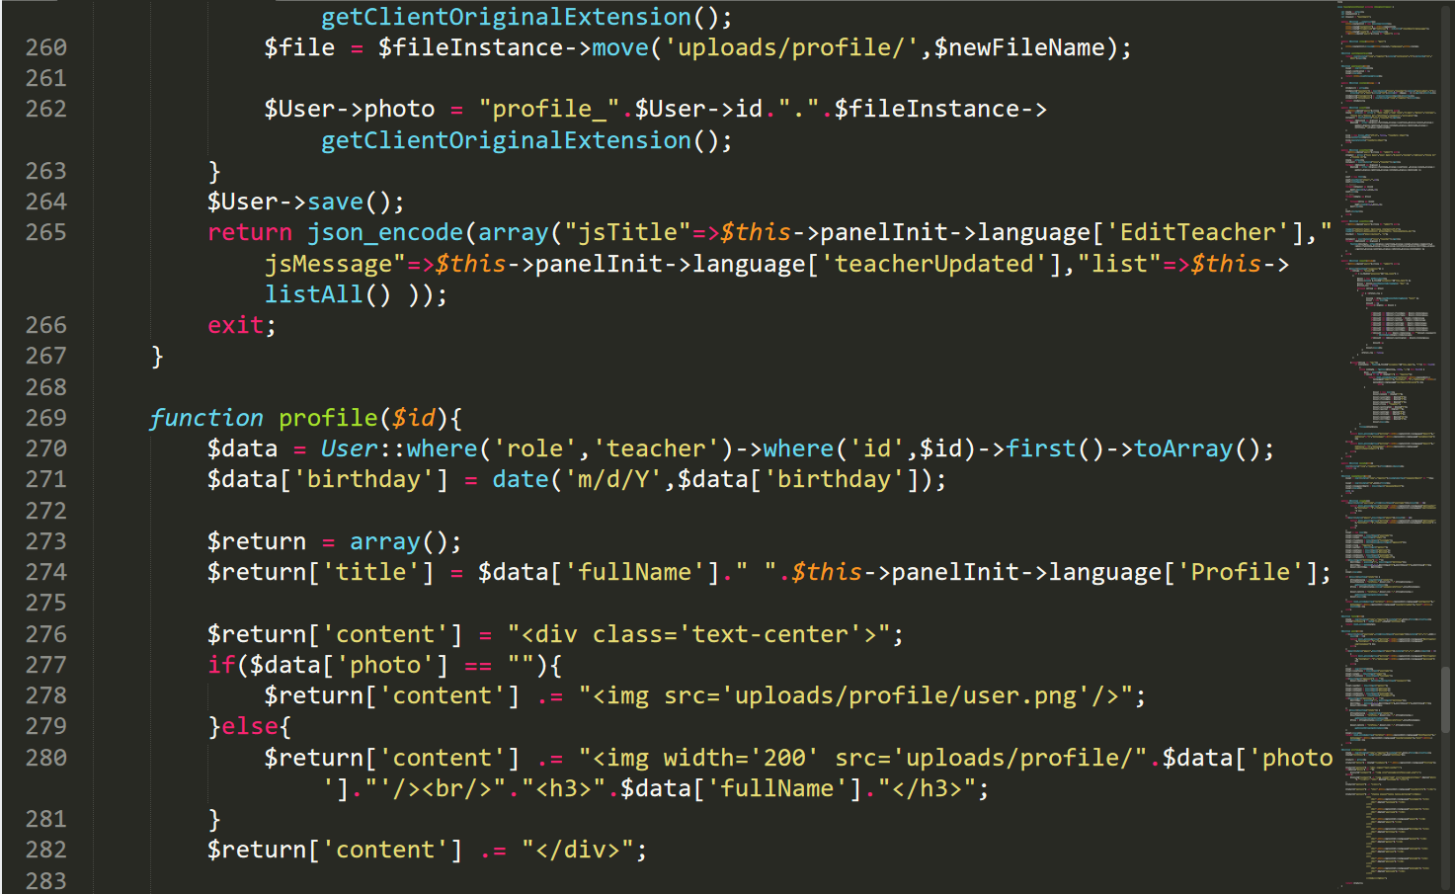

Figure : TeachersController.php10

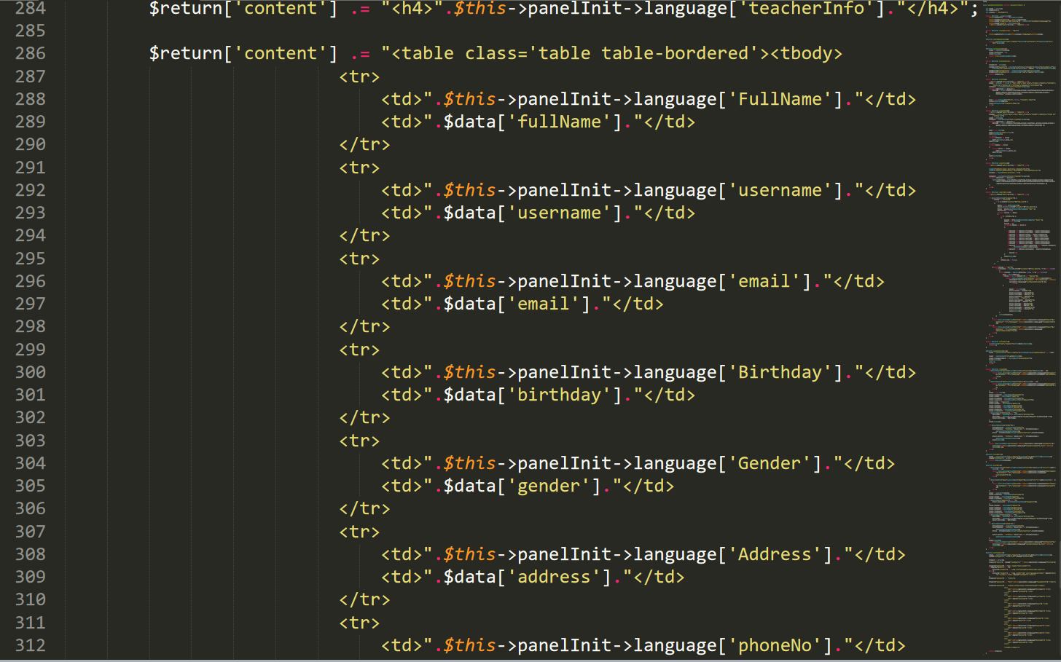

Figure : TeachersController.php11

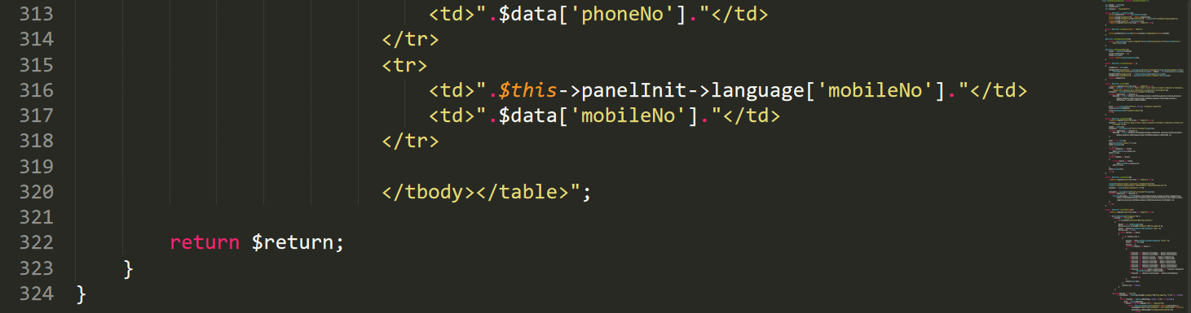

Figure : TeachersController.php12

LoginController.php

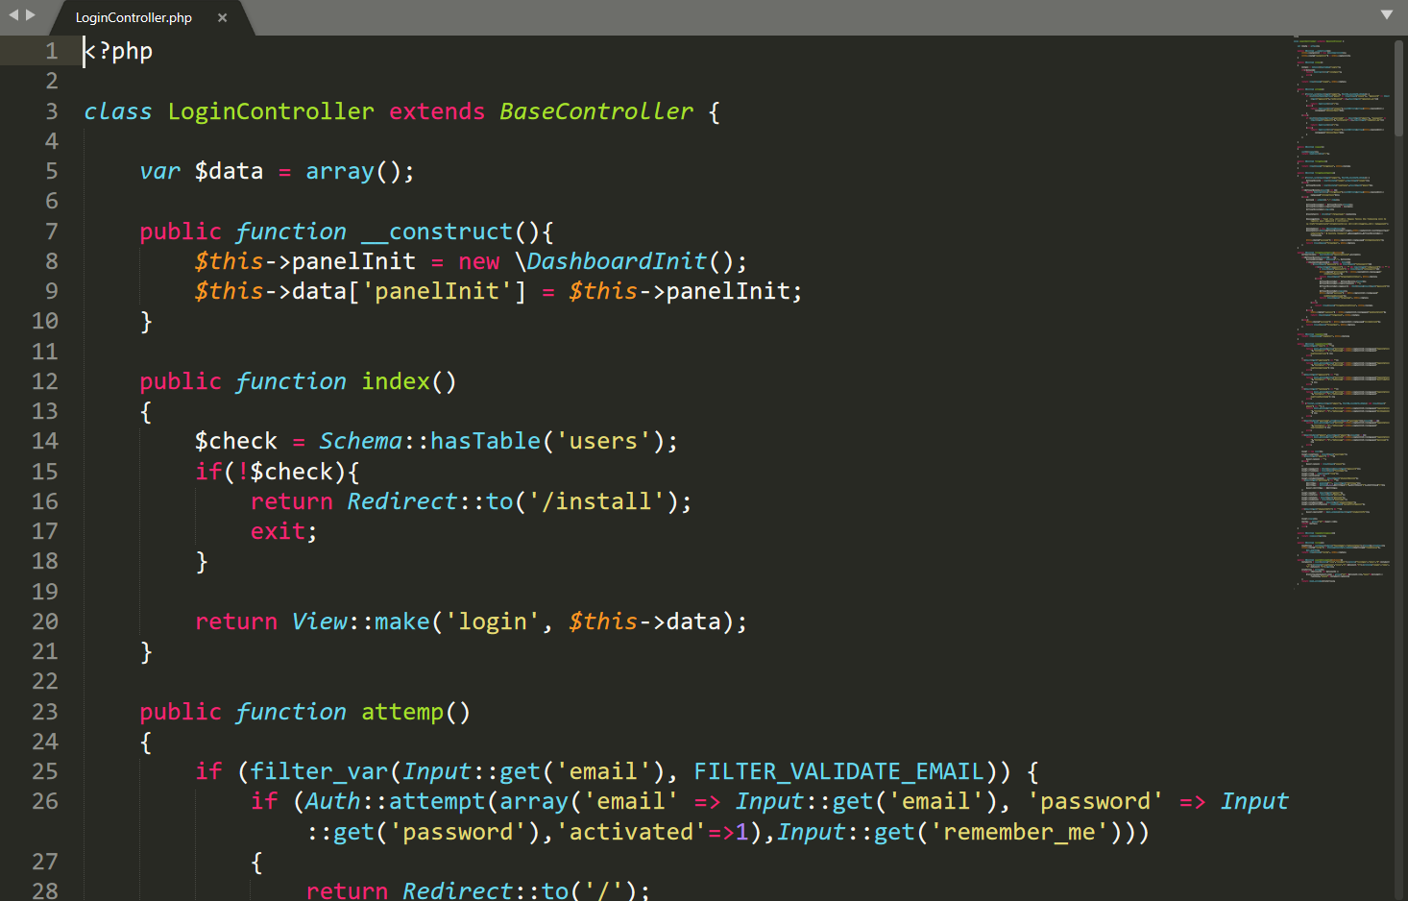

Figure : LoginController.php

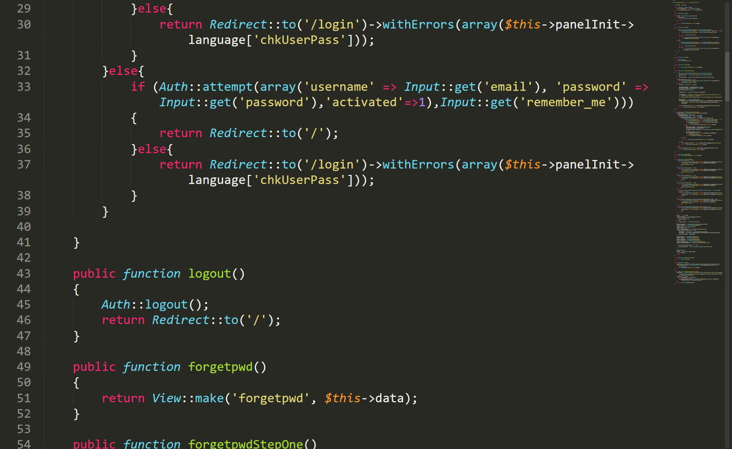

Figure : LoginController.php1

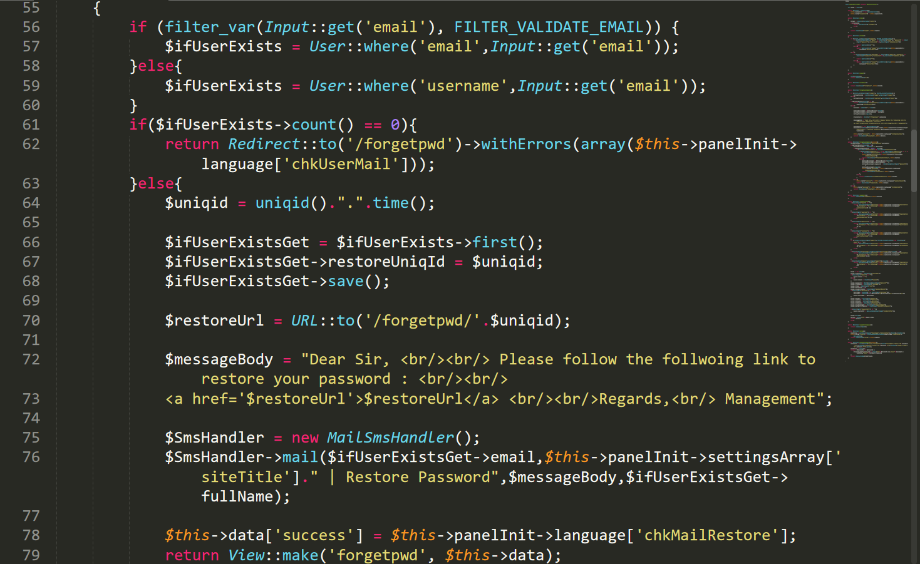

Figure : LoginController.php2

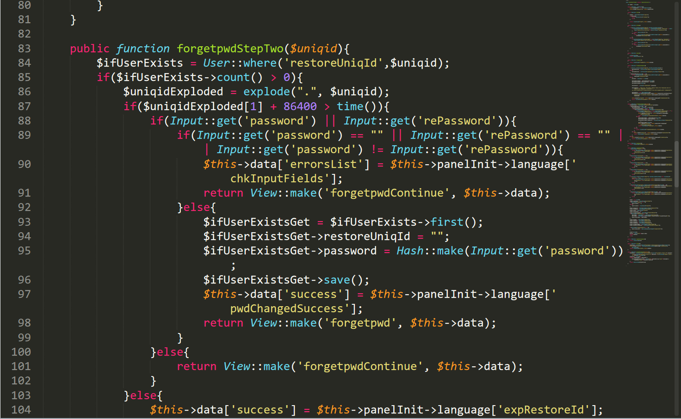

Figure : LoginController.php3

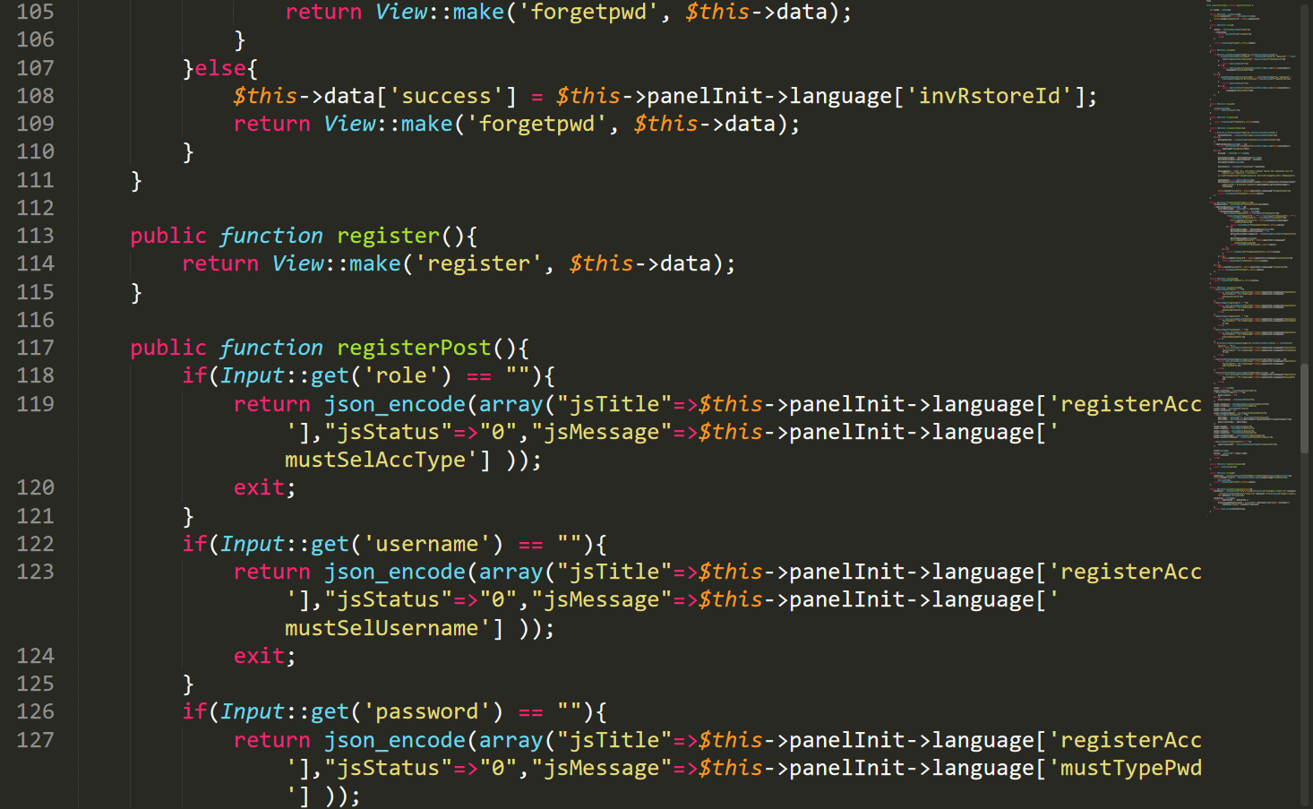

Figure : LoginController.php4

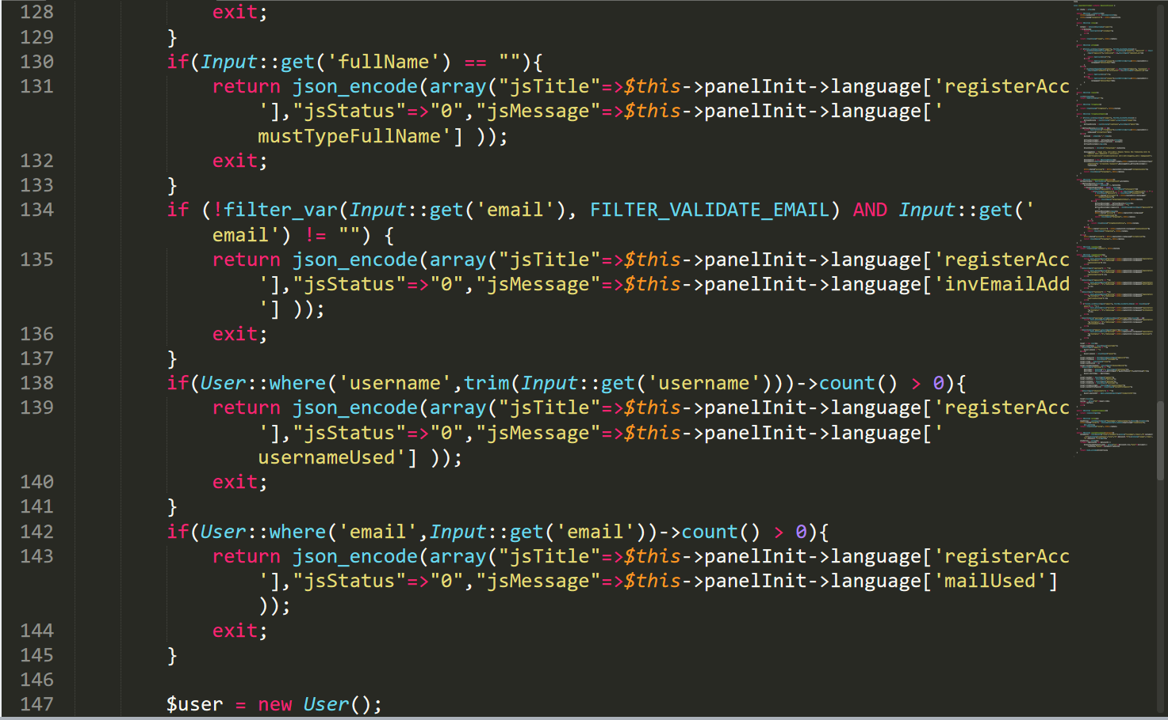

Figure : LoginController.php5

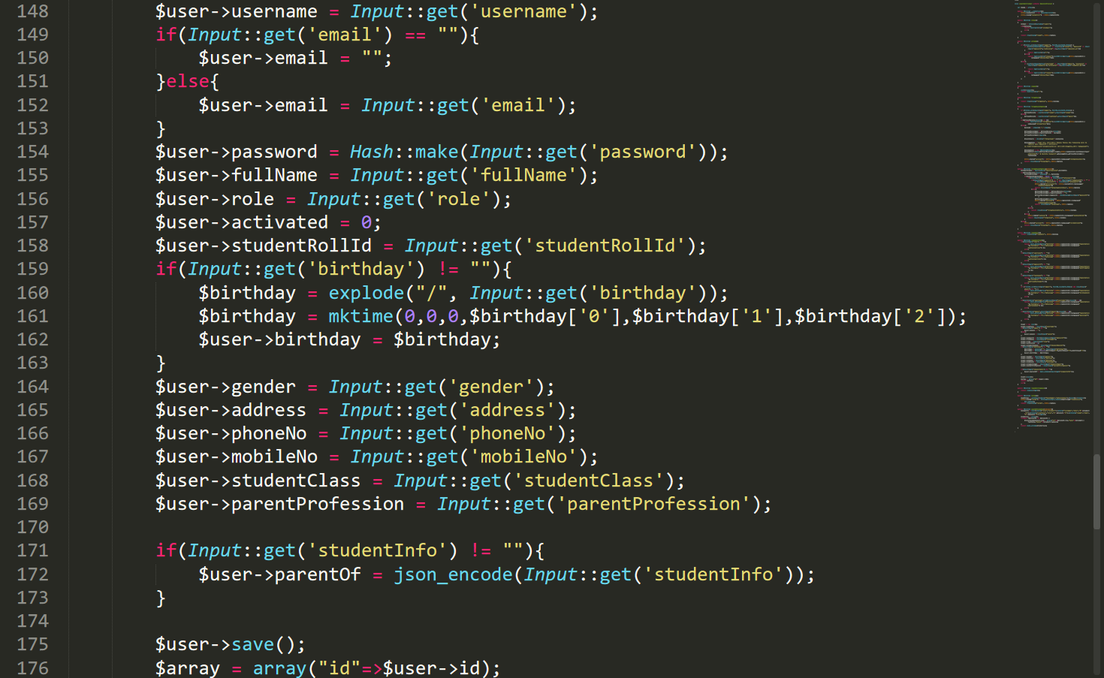

Figure : LoginController.php6

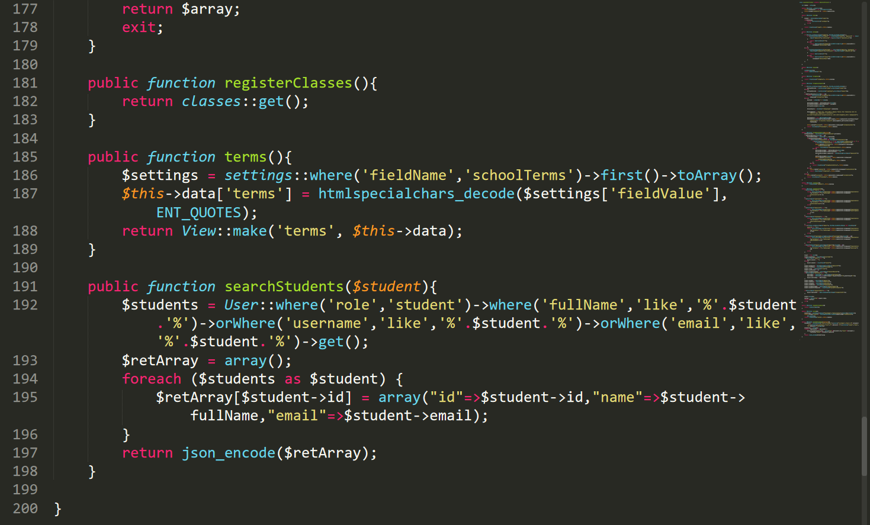

Figure : LoginController.php7

ClassesController.php

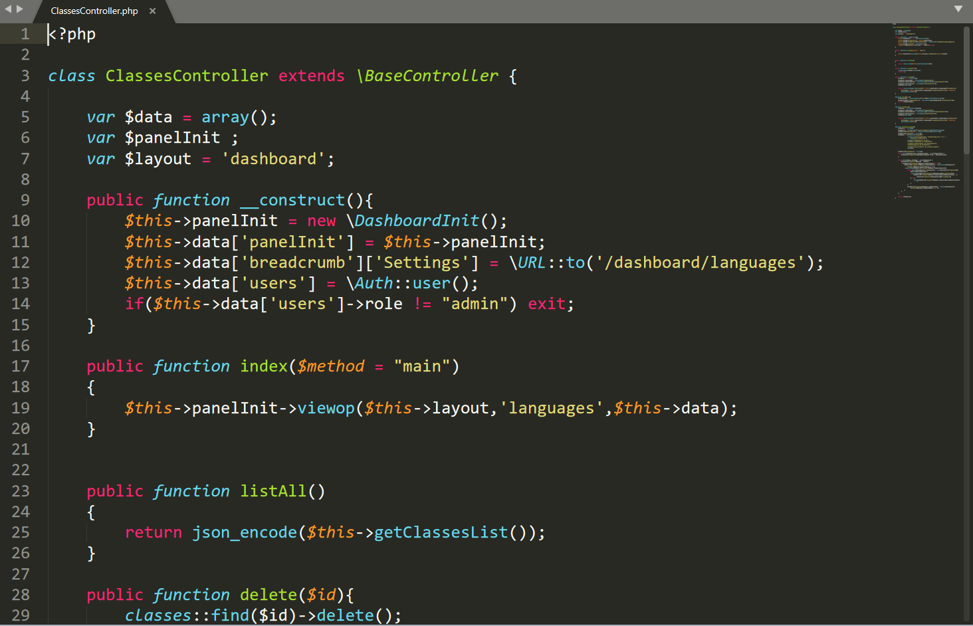

Figure : ClassesController.php

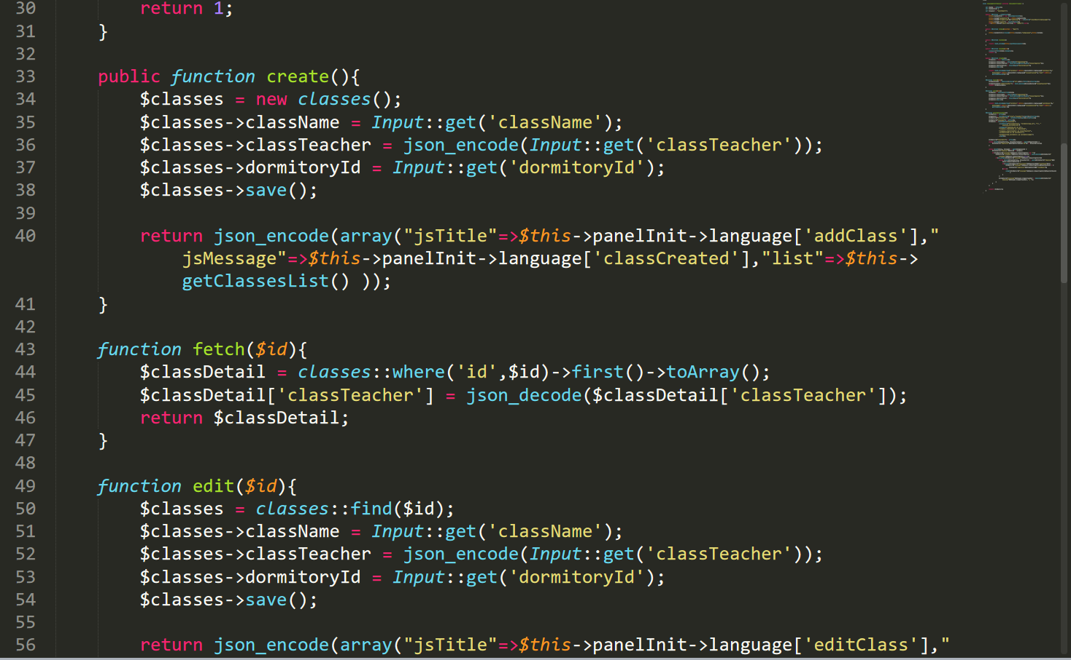

Figure : ClassesController.php1

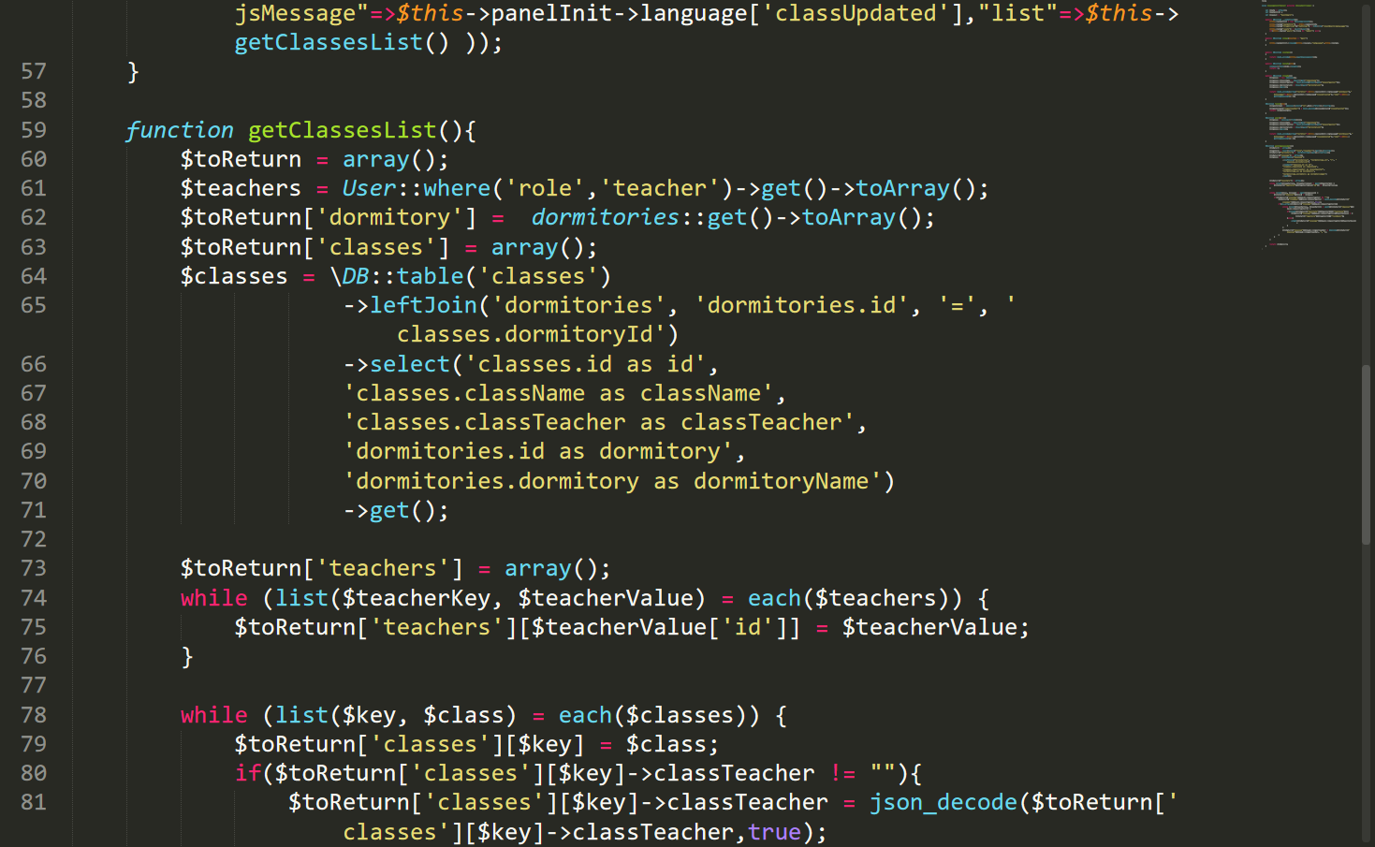

Figure : ClassesController.php2

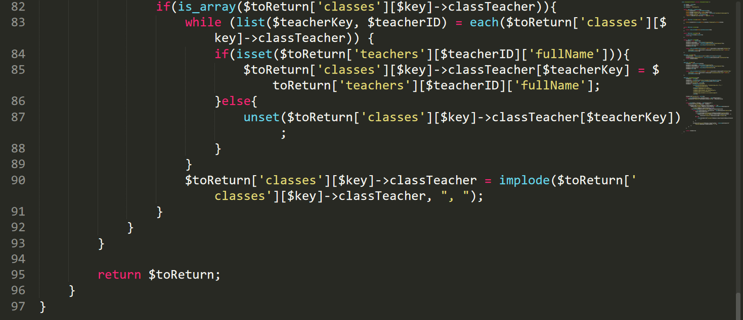

Figure : ClassesController.php3

DashboardControllers.php

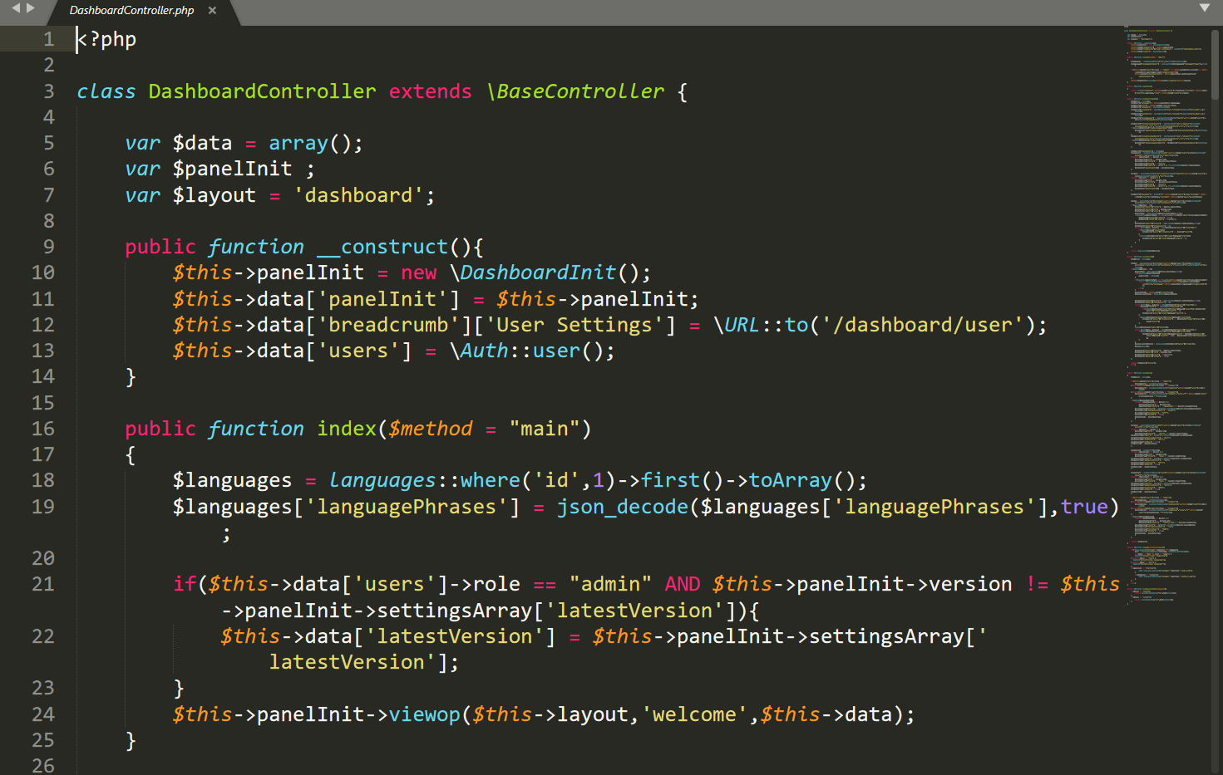

Figure : DashboardControllers.php

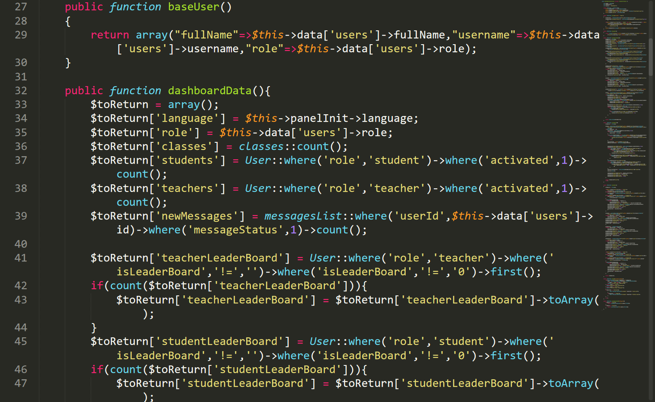

Figure : DashboardControllers.php1

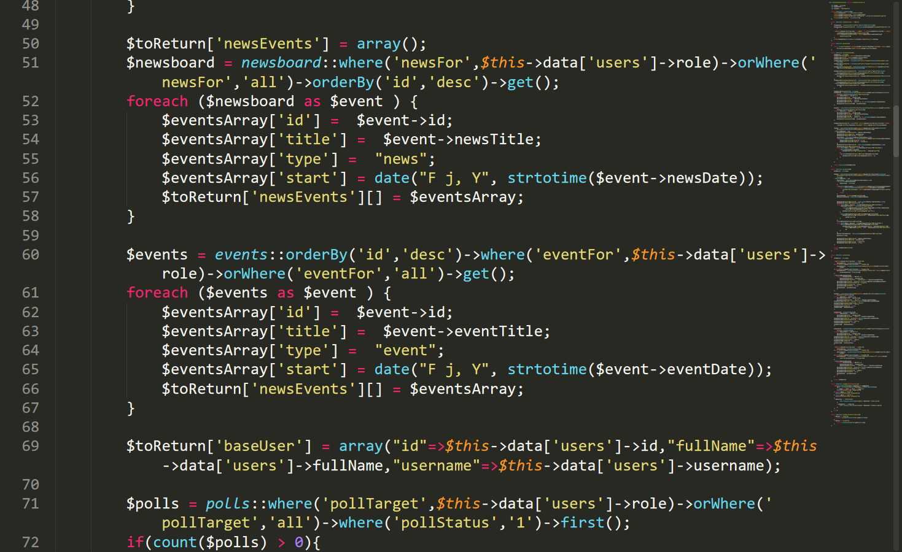

Figure : DashboardControllers.php2

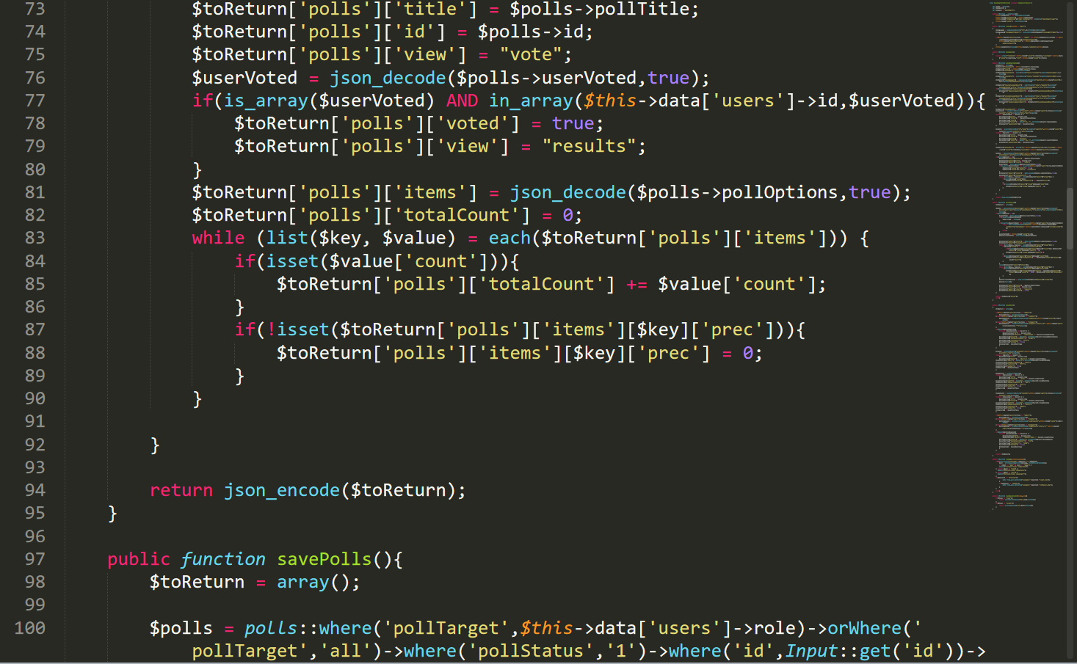

Figure : DashboardControllers.php3

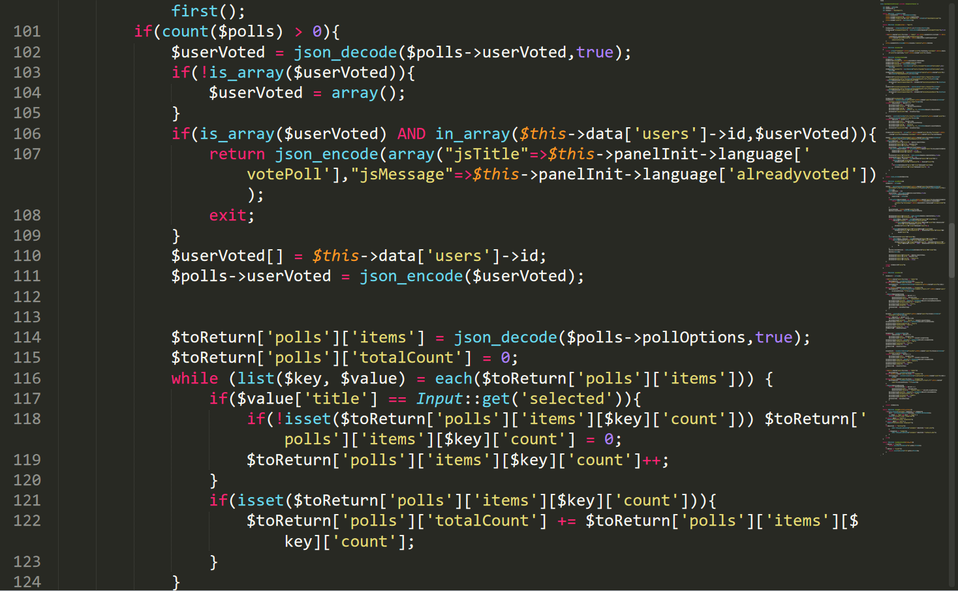

Figure : DashboardControllers.php4

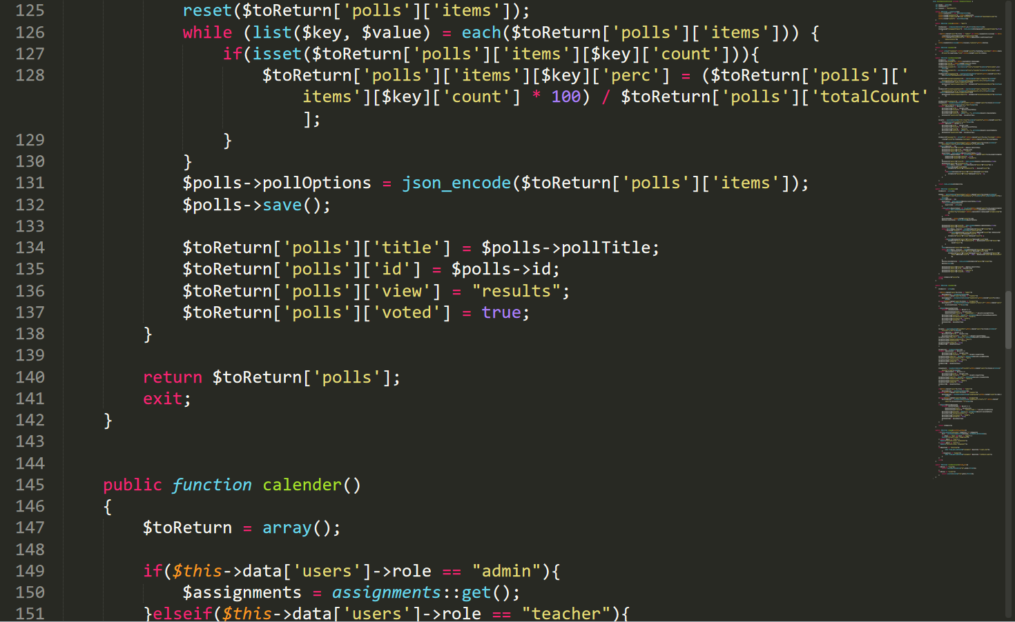

Figure : DashboardControllers.php5

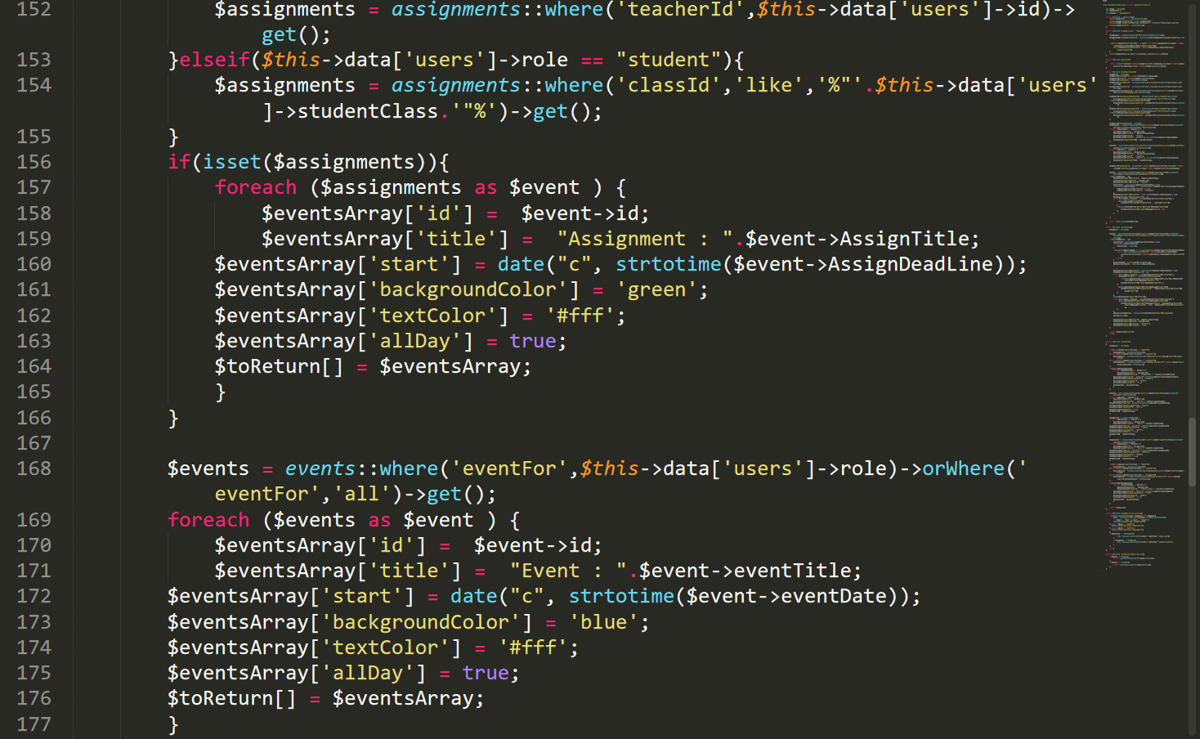

Figure : DashboardControllers.php6

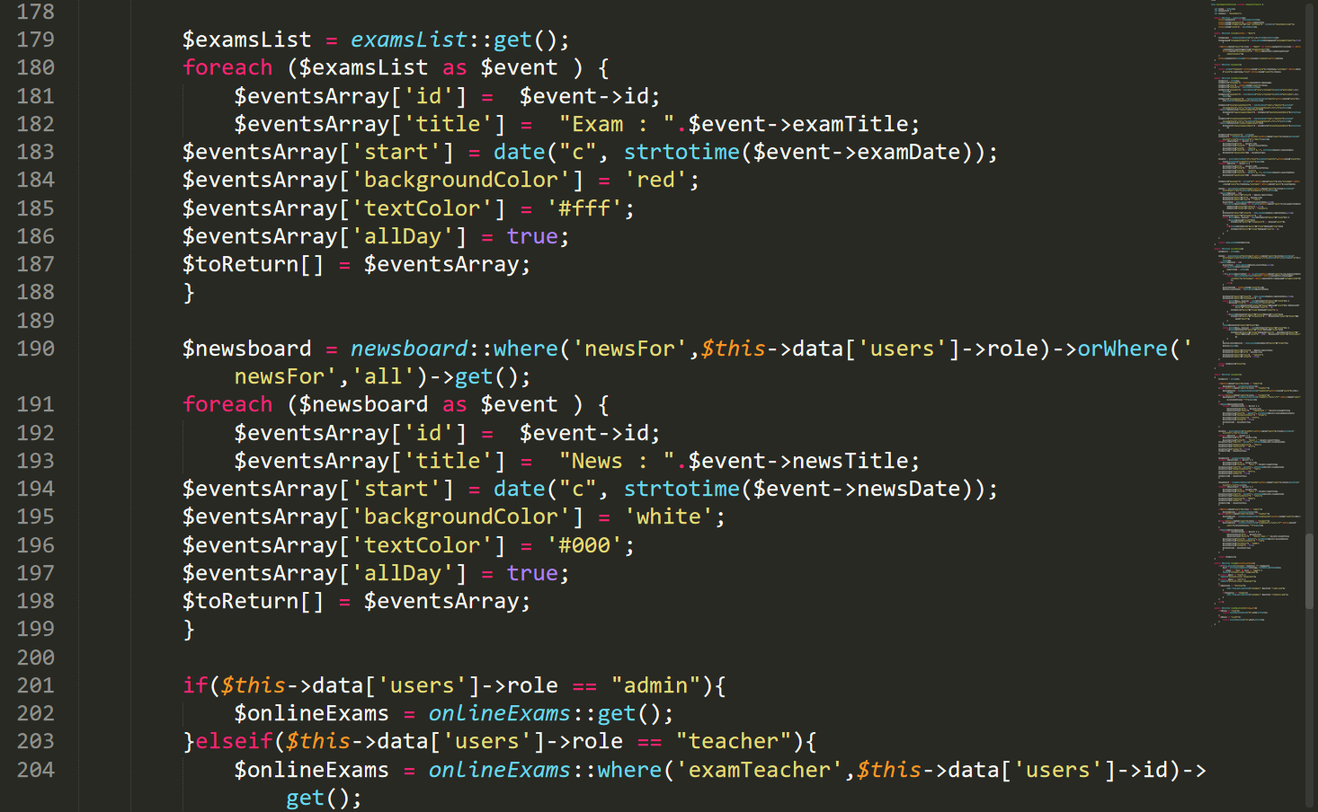

Figure : DashboardControllers.php7

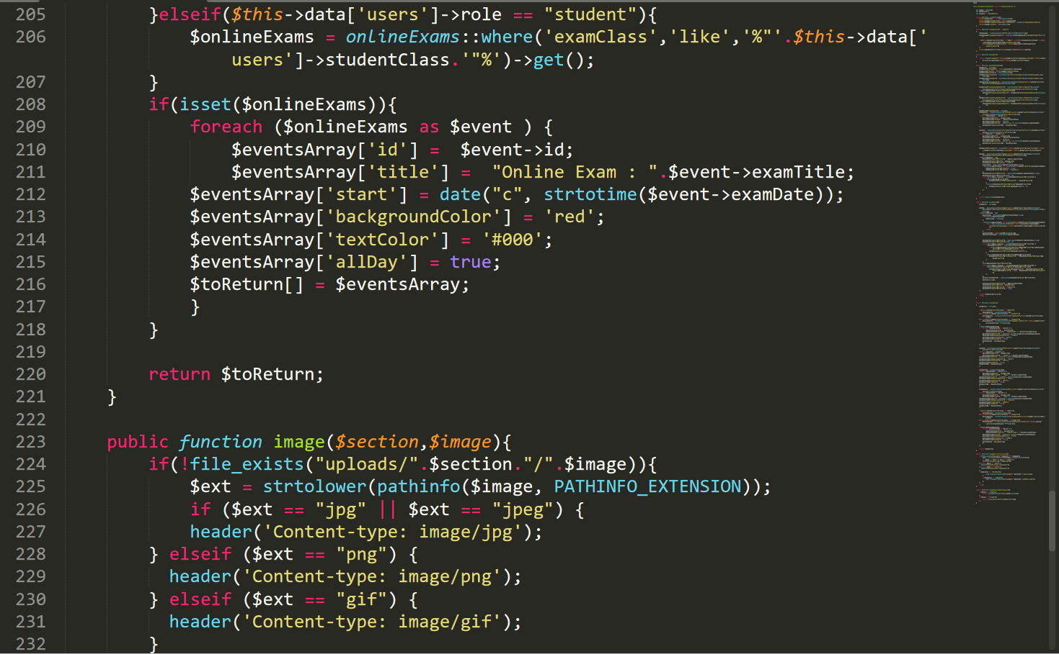

Figure : DashboardControllers.php8

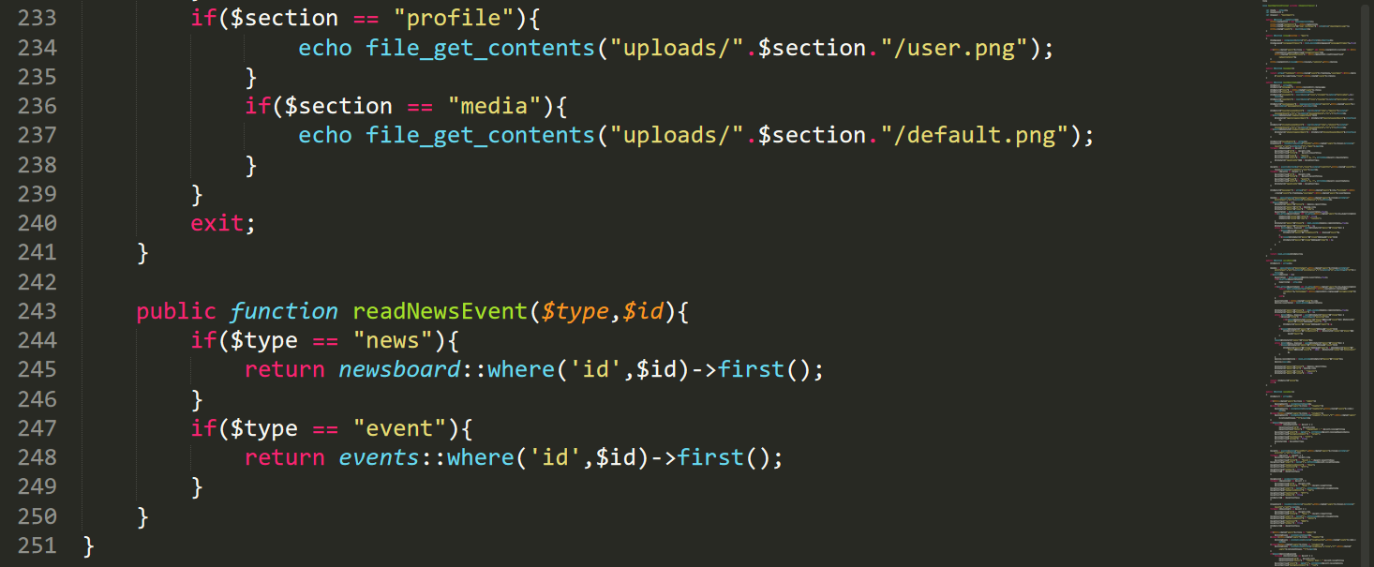

Figure : DashboardControllers.php9

StudentsController.php

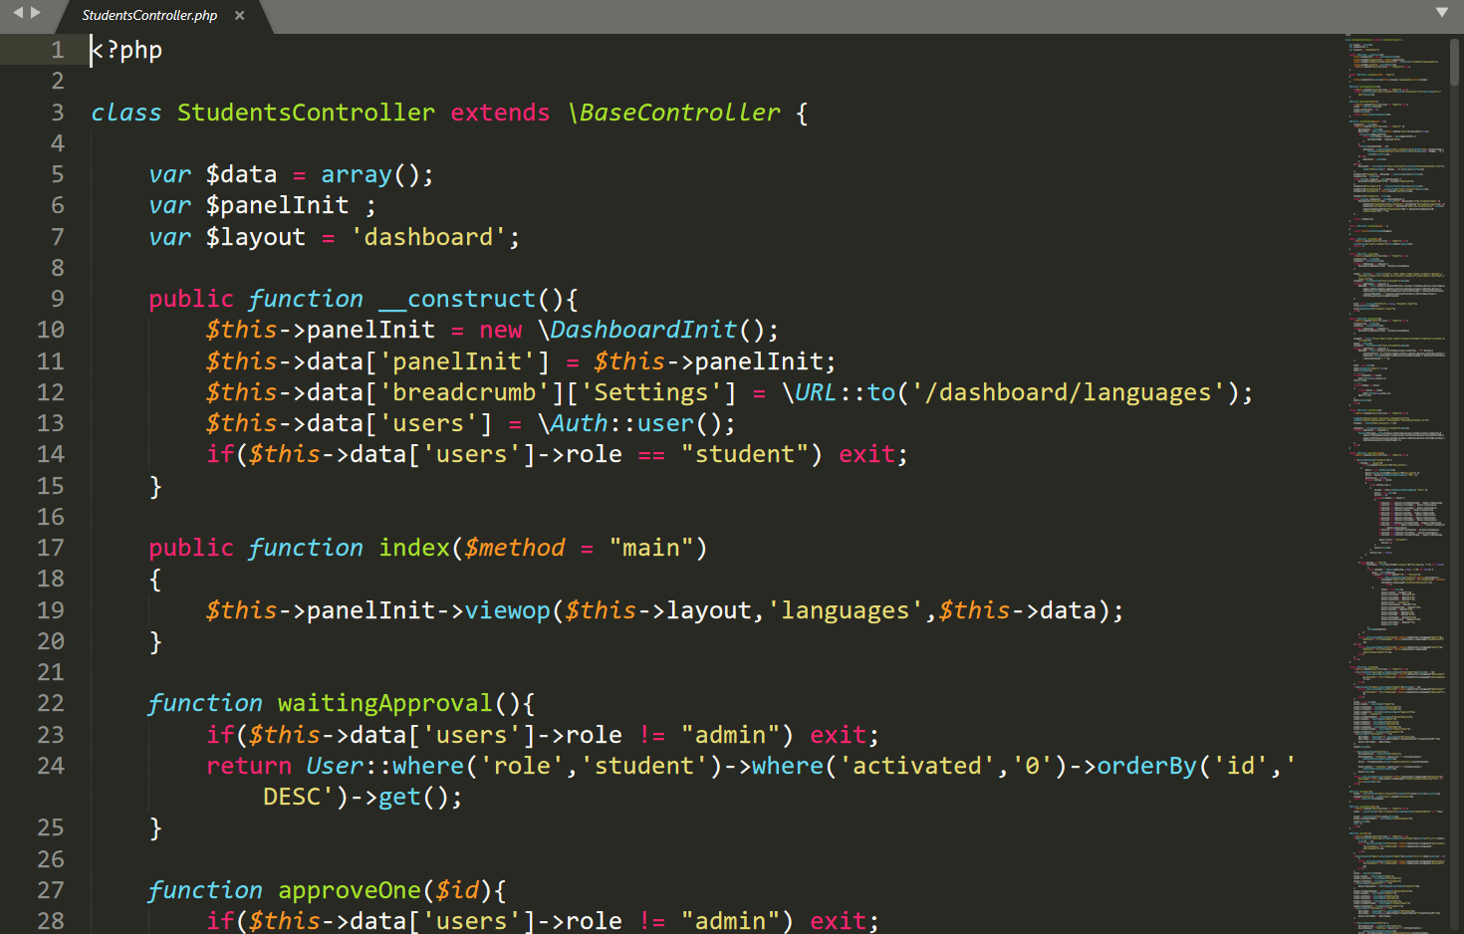

Figure : StudentsController.php

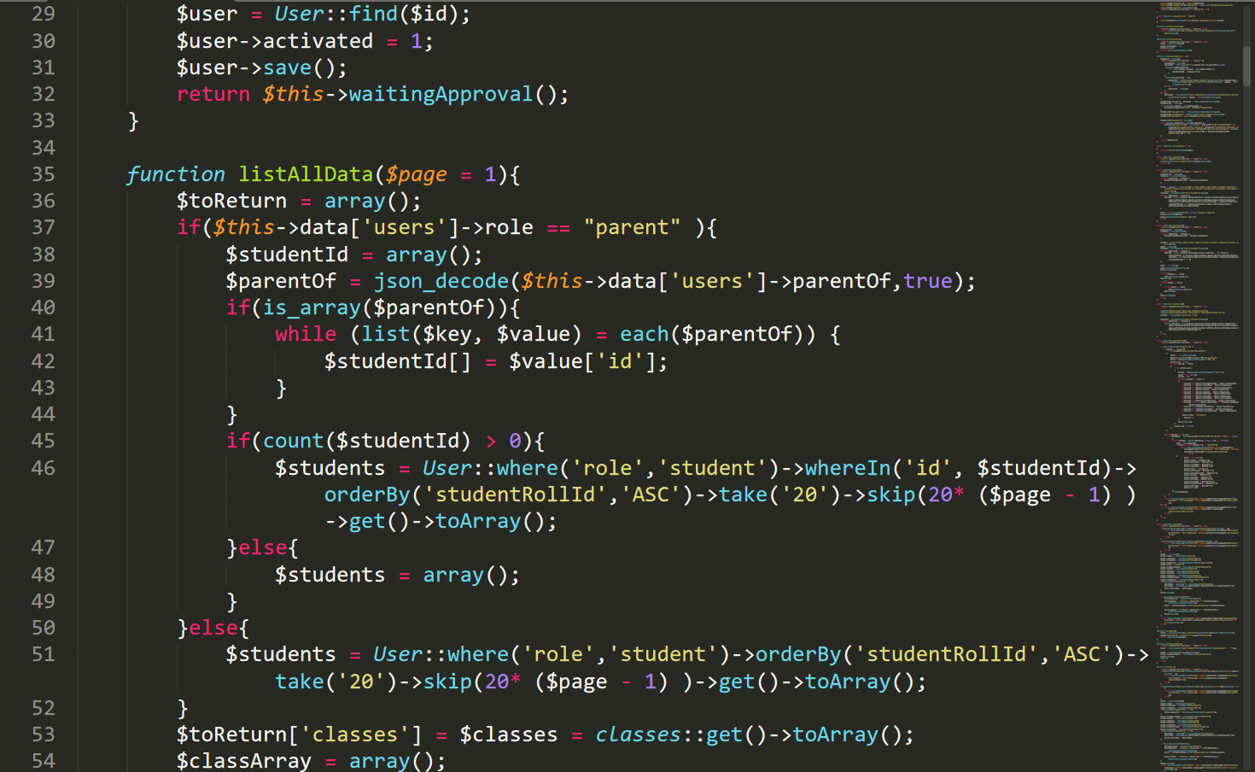

Figure : StudentsController.php1

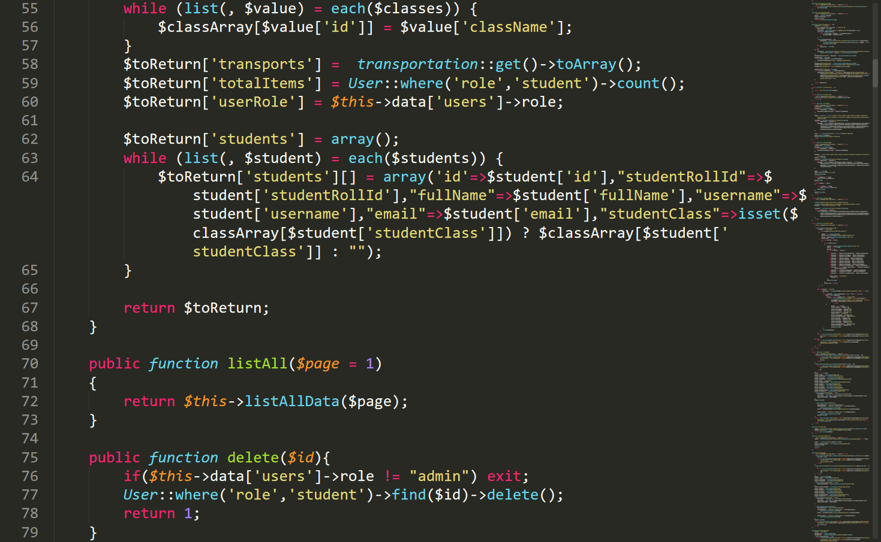

Figure : StudentsController.php2

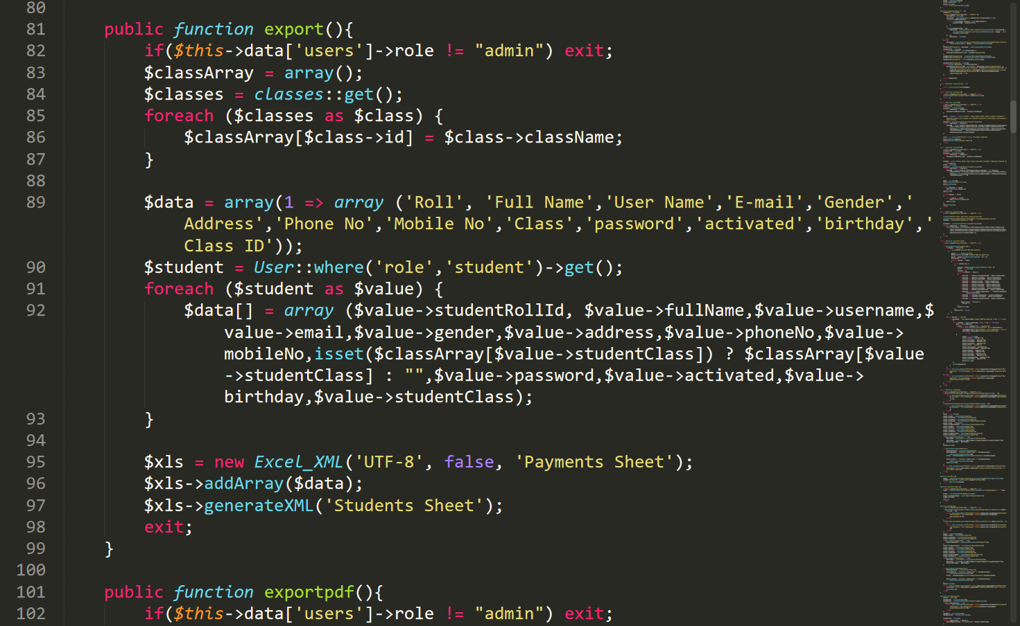

Figure : StudentsController.php3

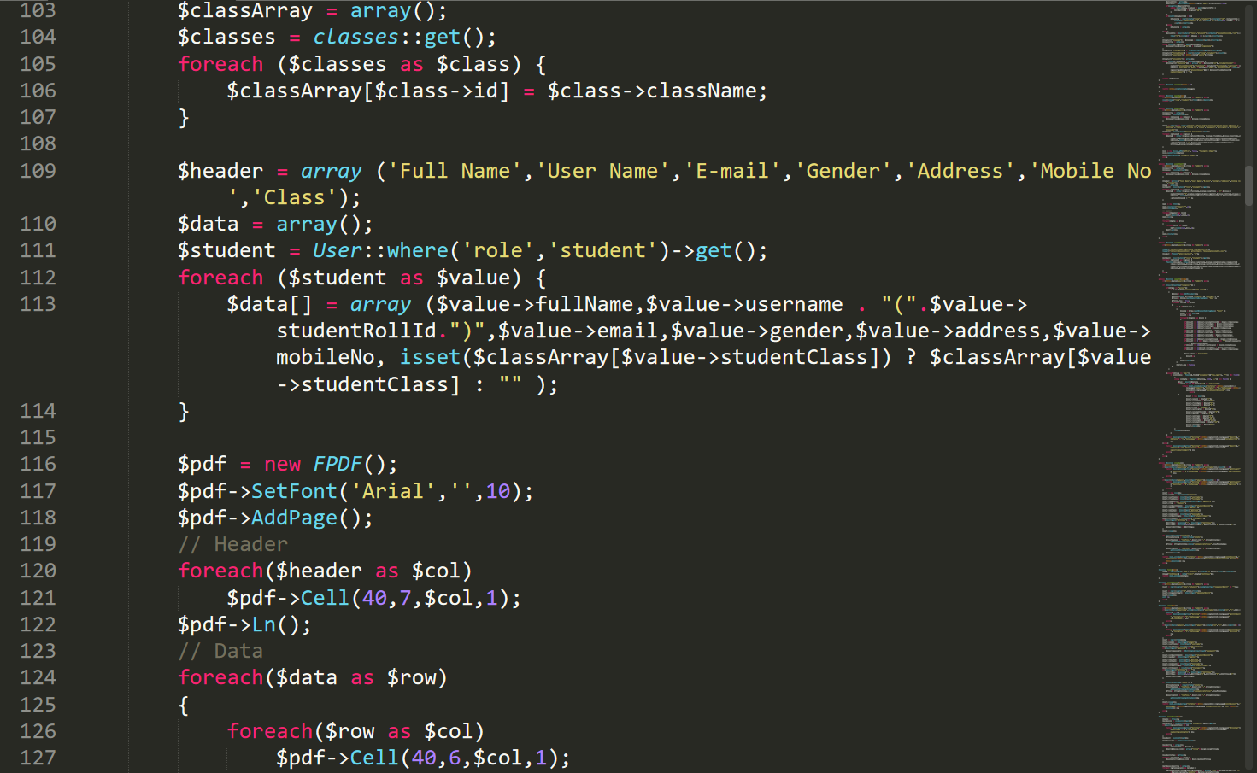

Figure : StudentsController.php4

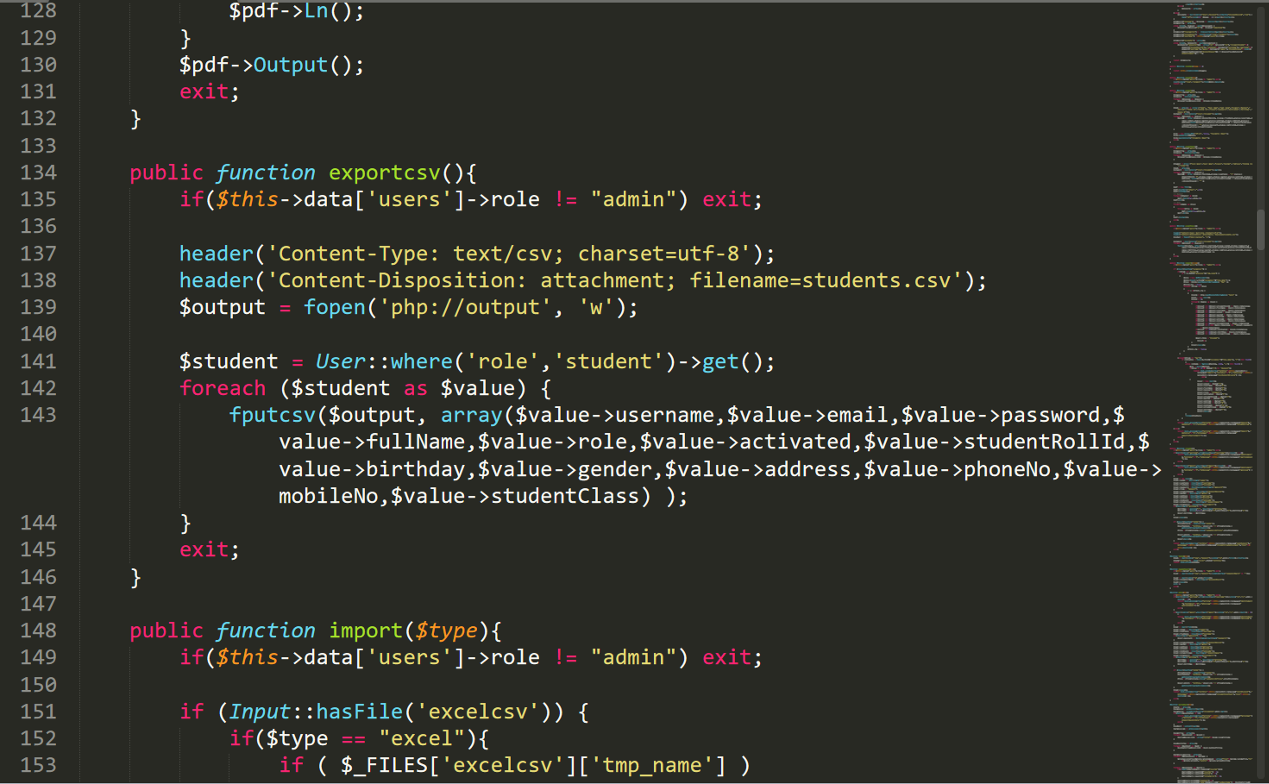

Figure : StudentsController.php5

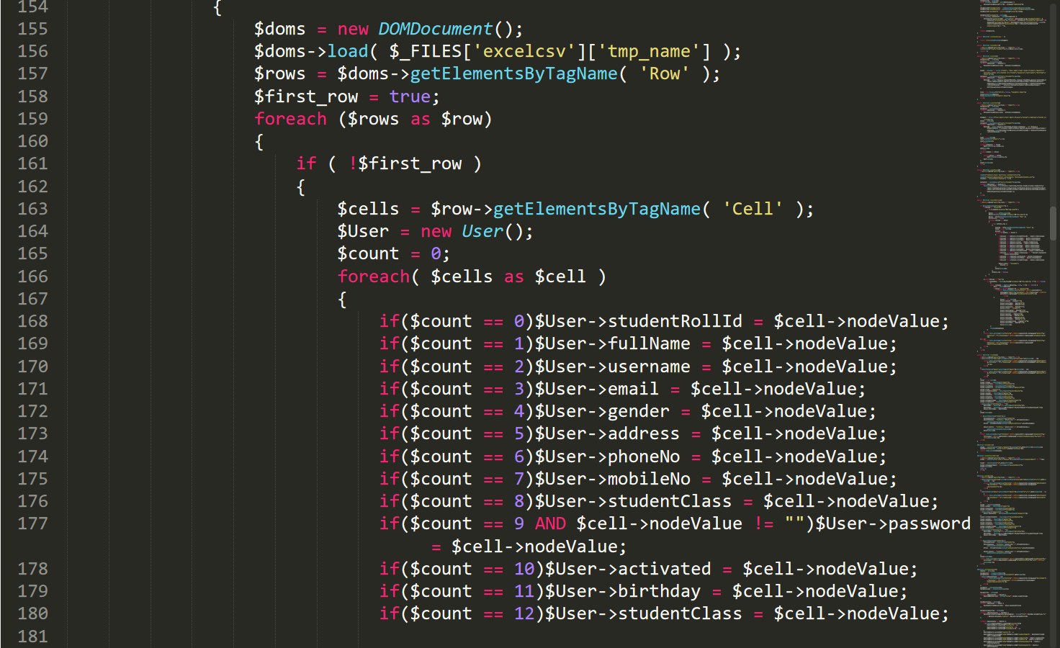

Figure : StudentsController.php6

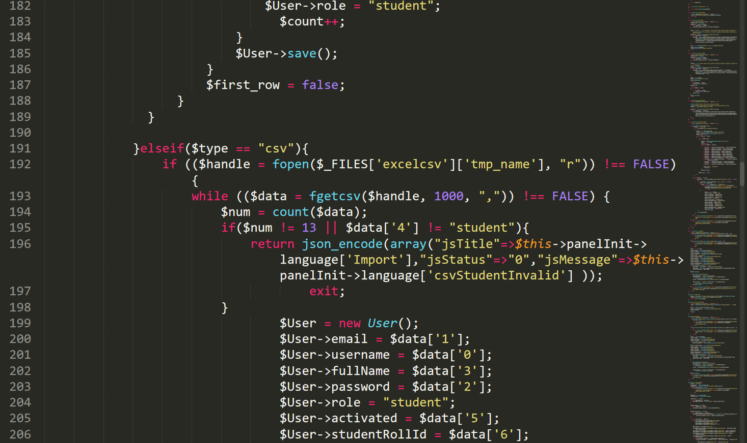

Figure : StudentsController.php7

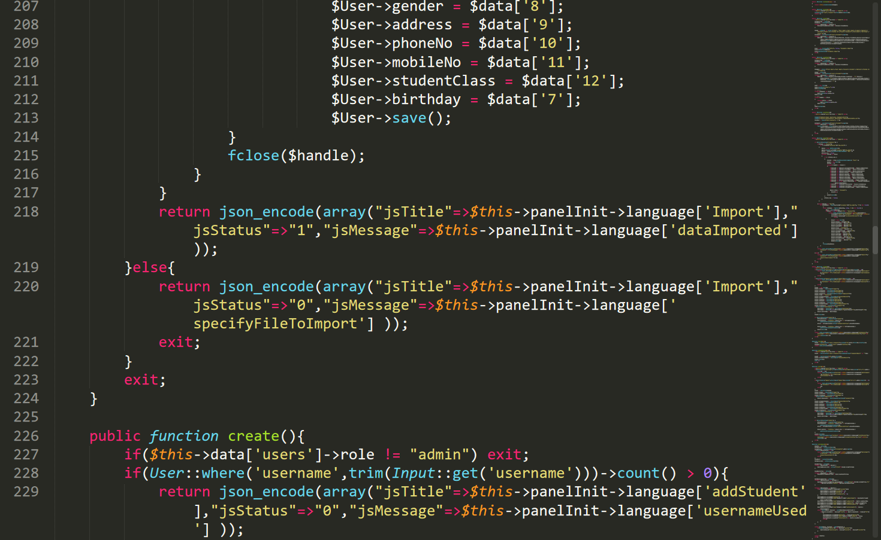

Figure : StudentsController.php8

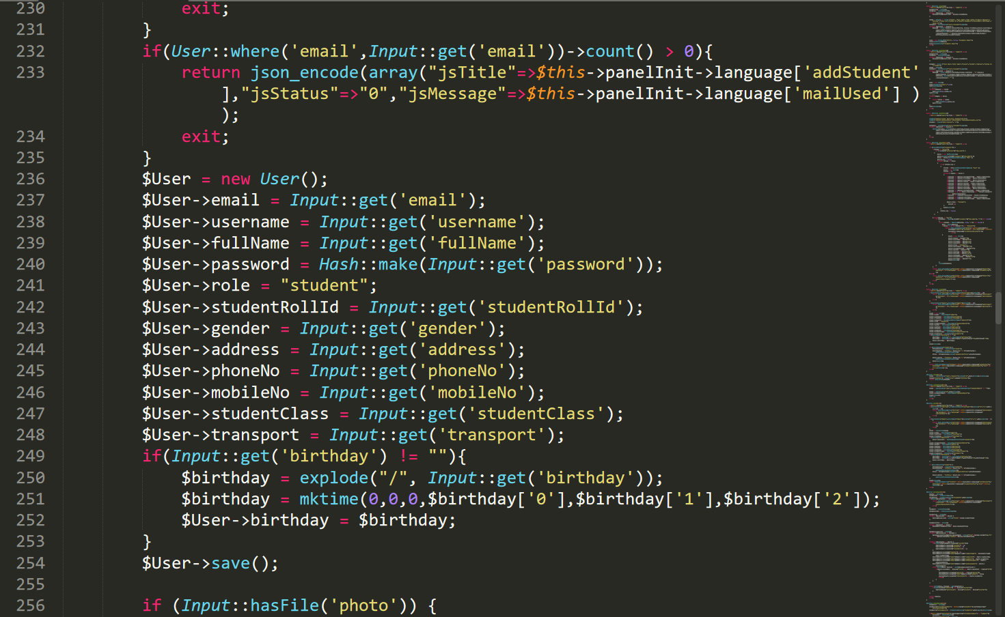

Figure : StudentsController.php9

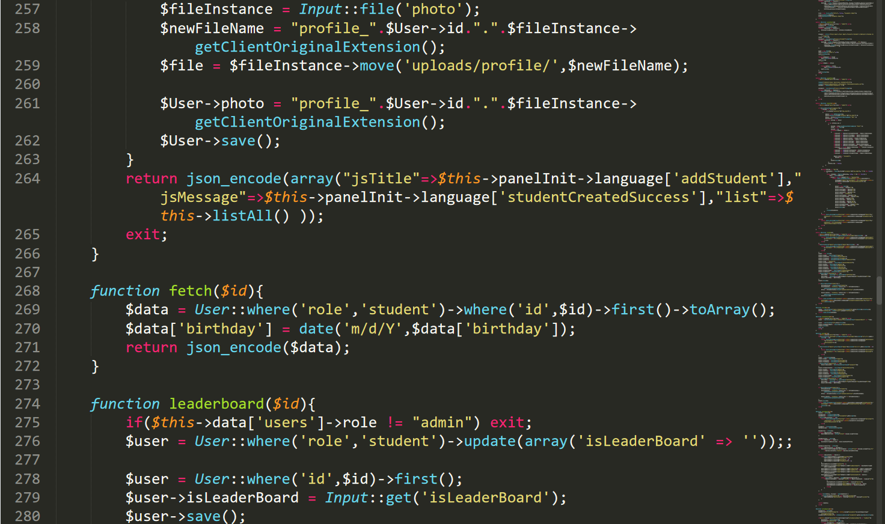

Figure : StudentsController.php10

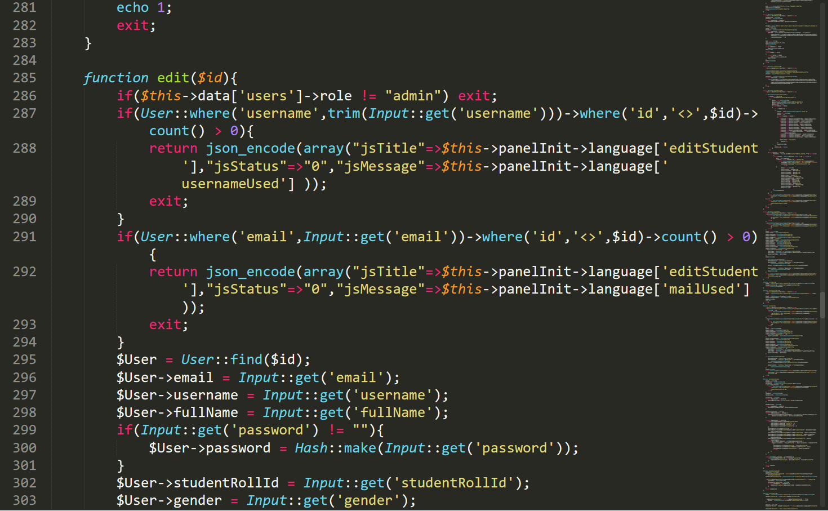

Figure : StudentsController.php11

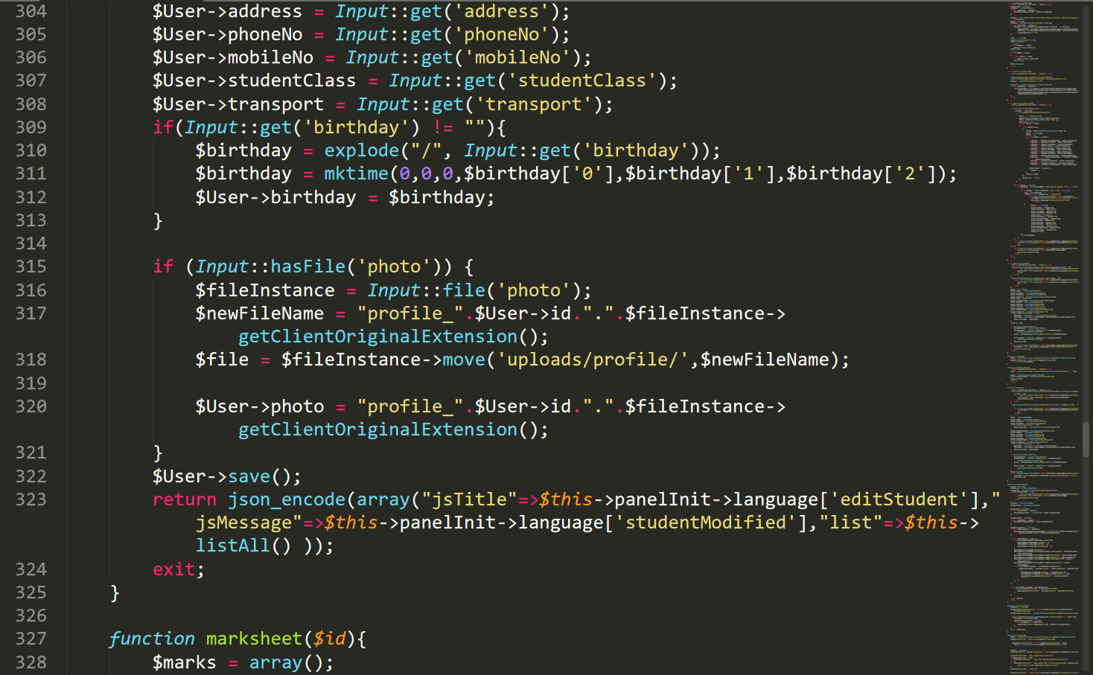

Figure : StudentsController.php12

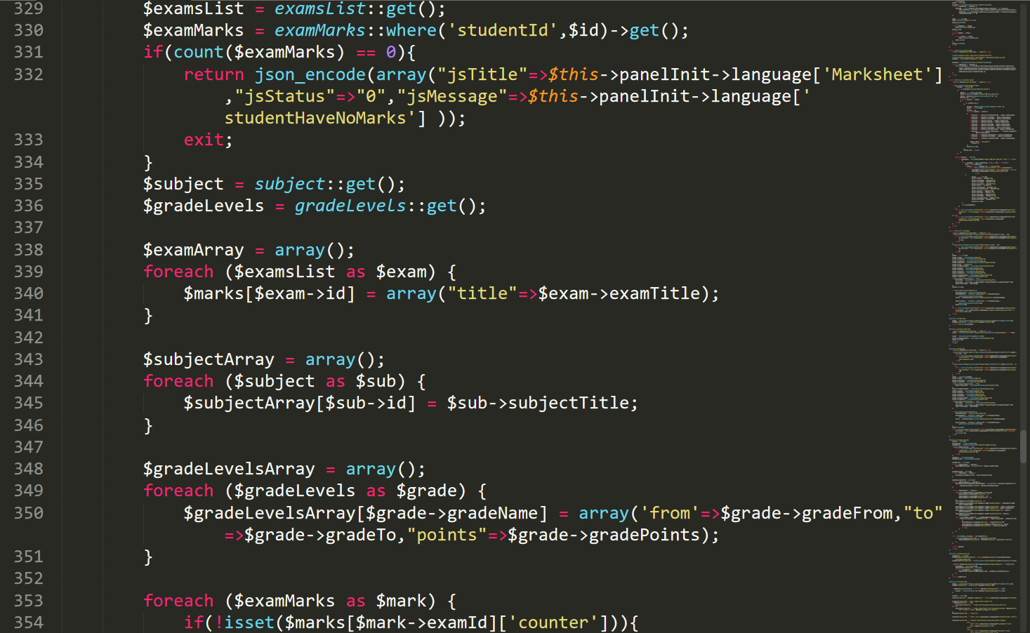

Figure : StudentsController.php13

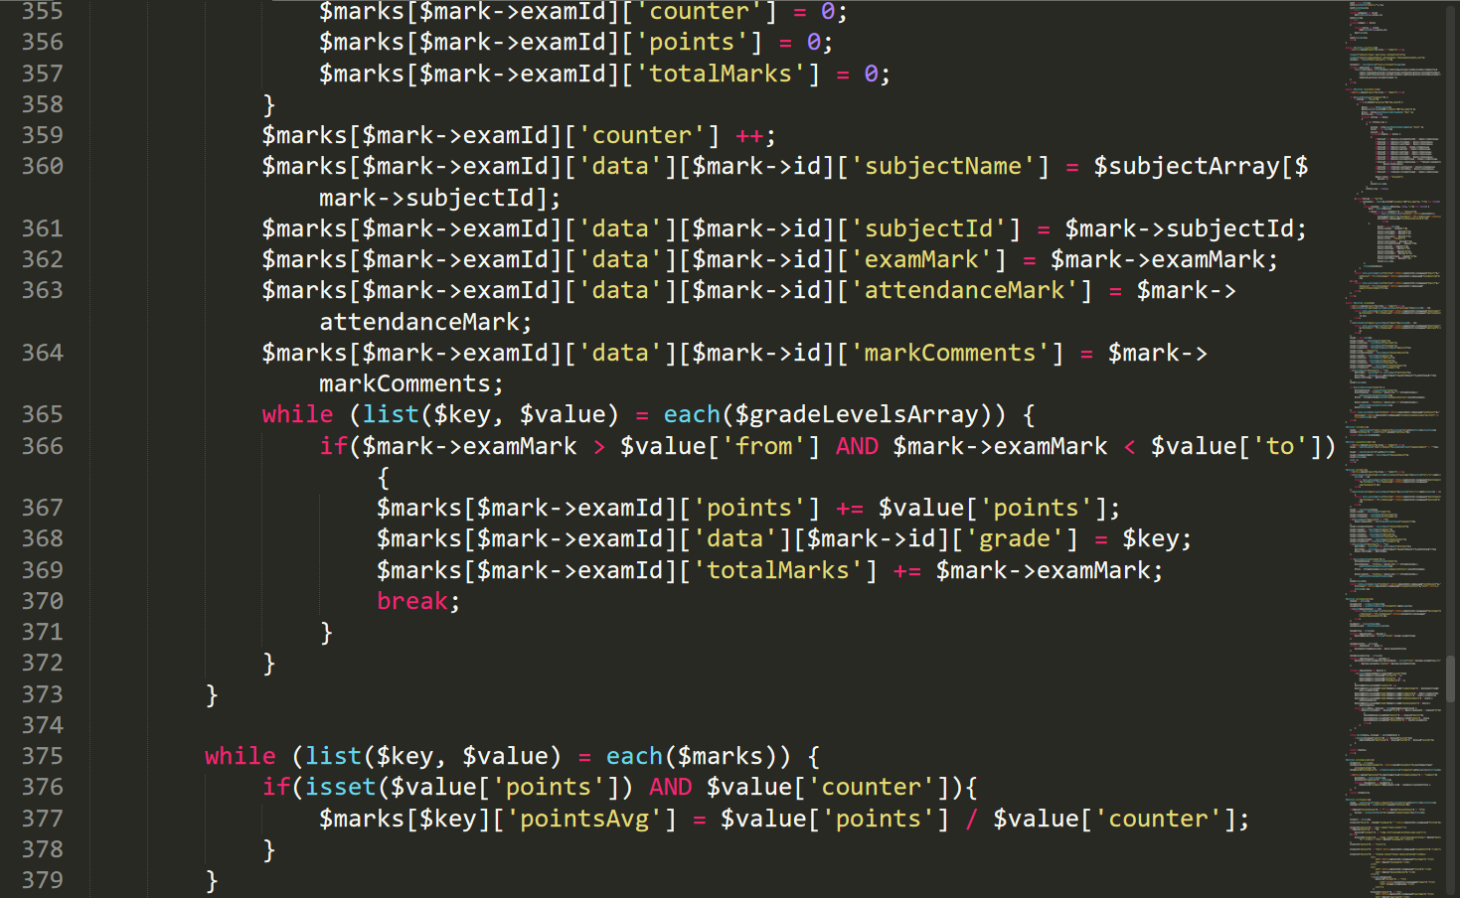

Figure : StudentsController.php14

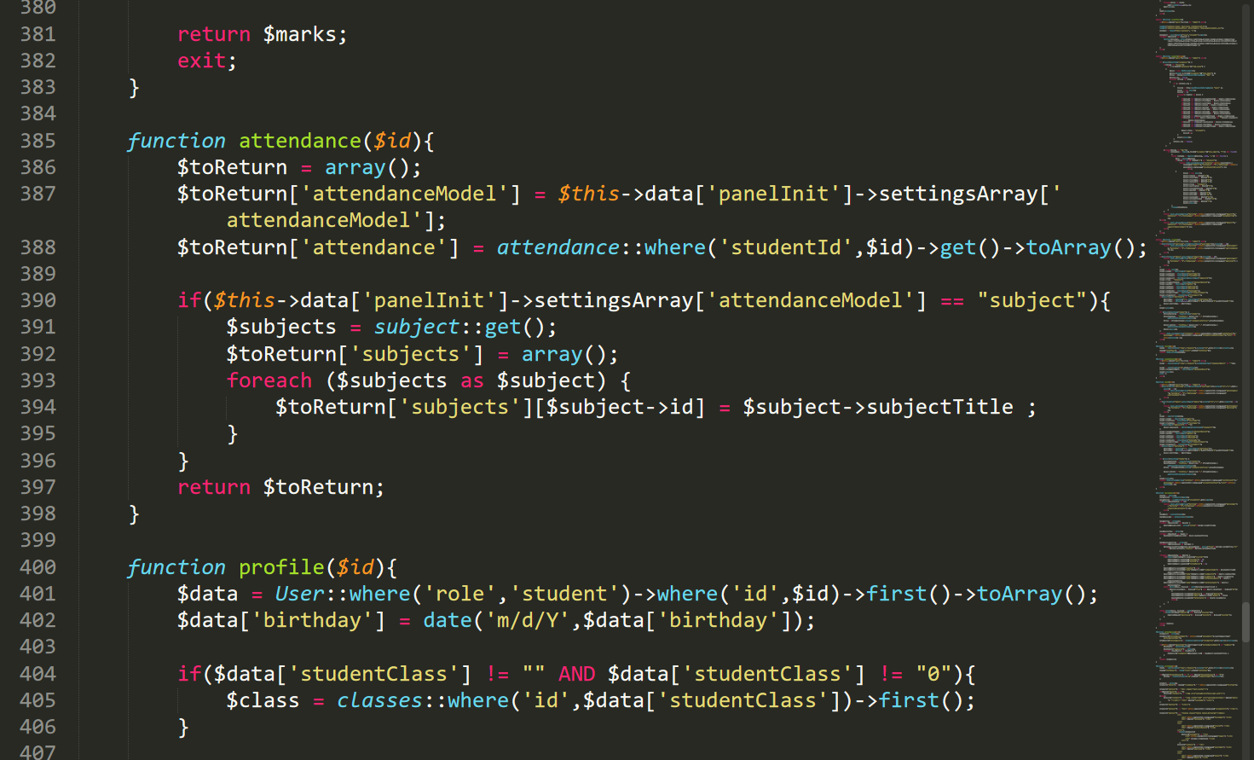

Figure : StudentsController.php15

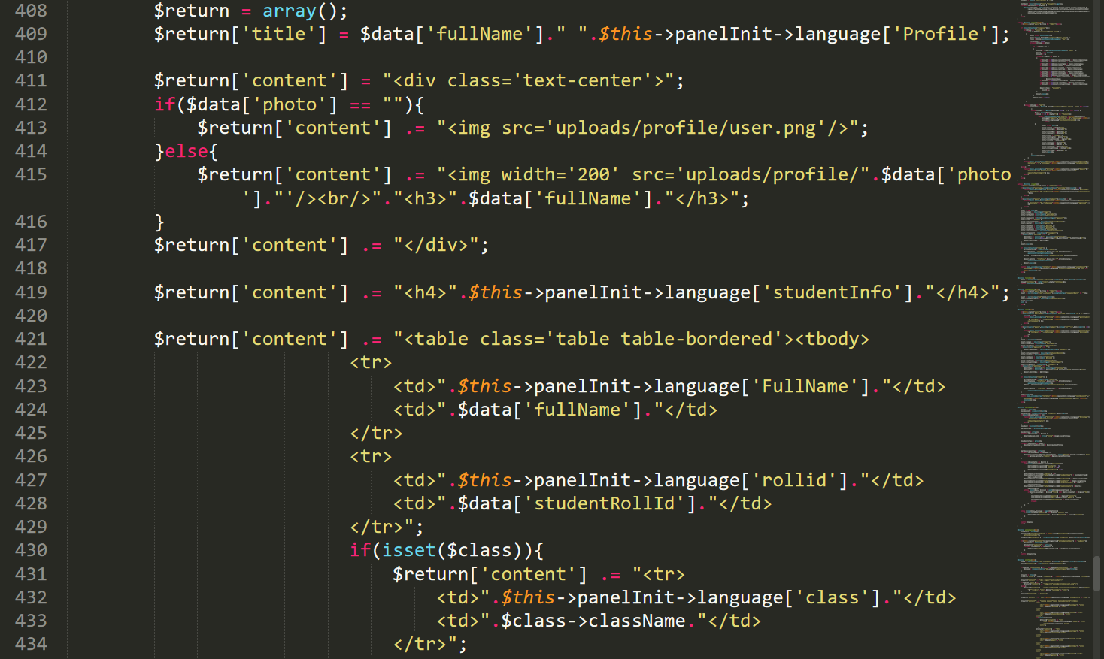

Figure : StudentsController.php16

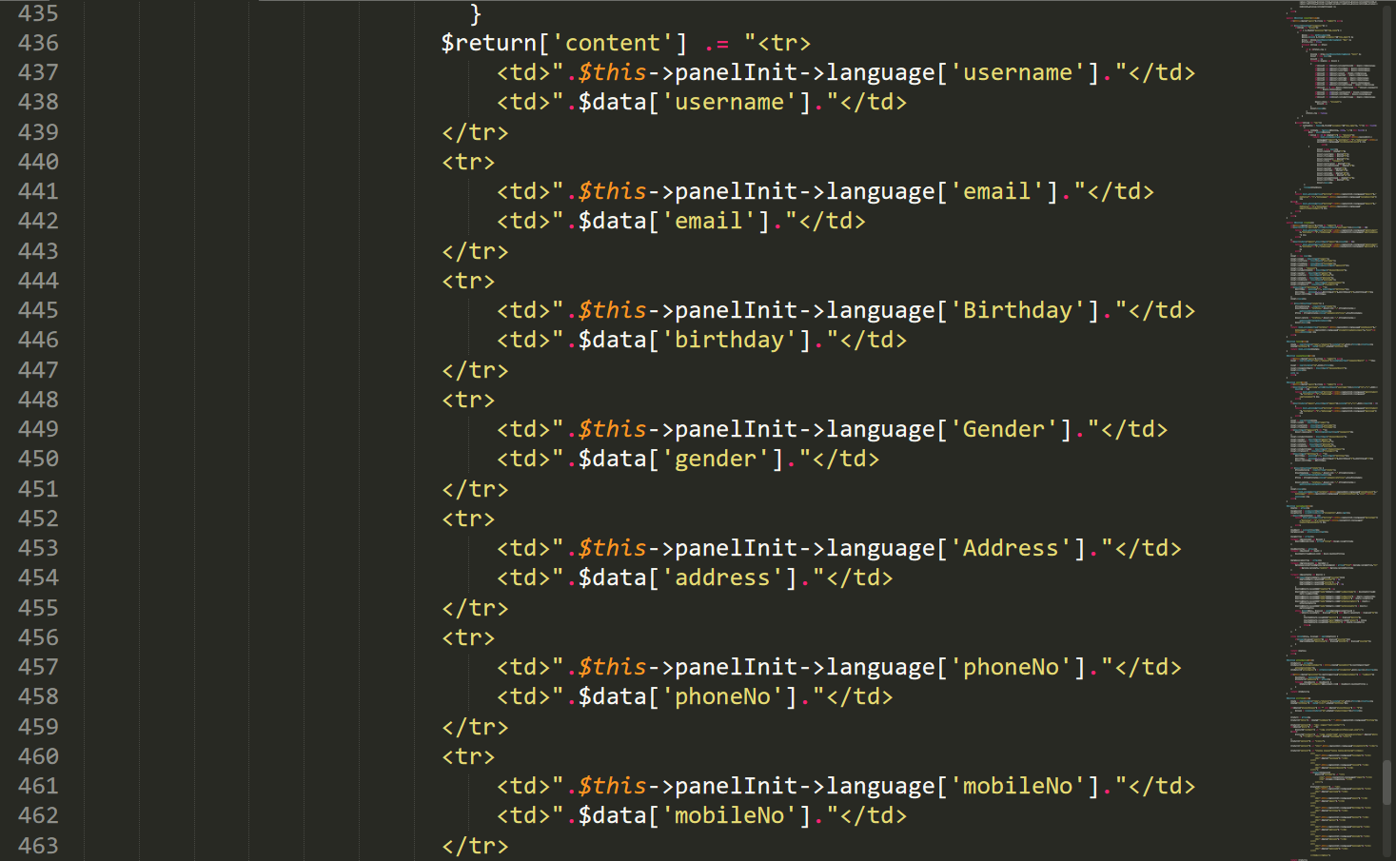

Figure : StudentsController.php17

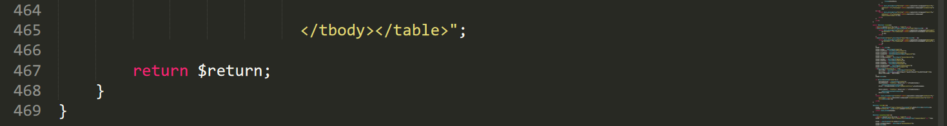

Figure : StudentsController.php18

SubjetcsController.php

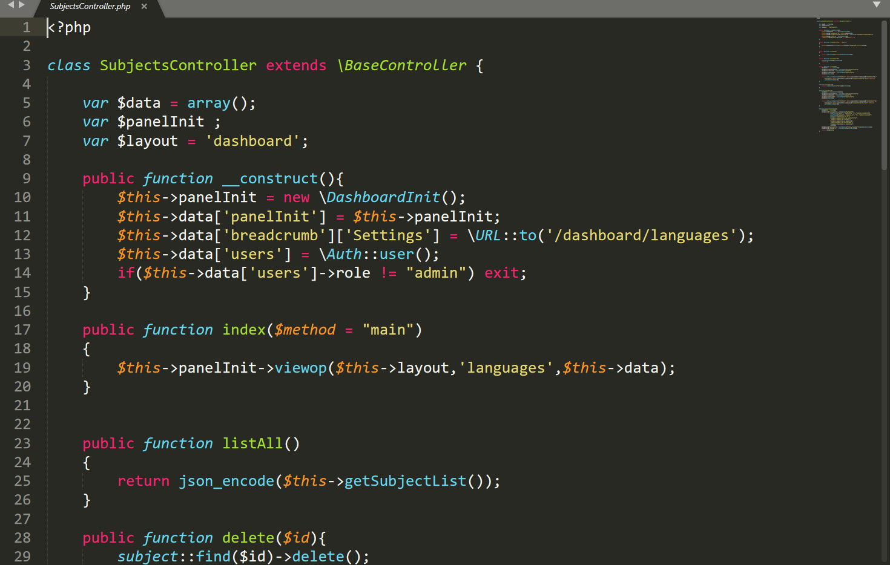

Figure : SubjetcsController.php

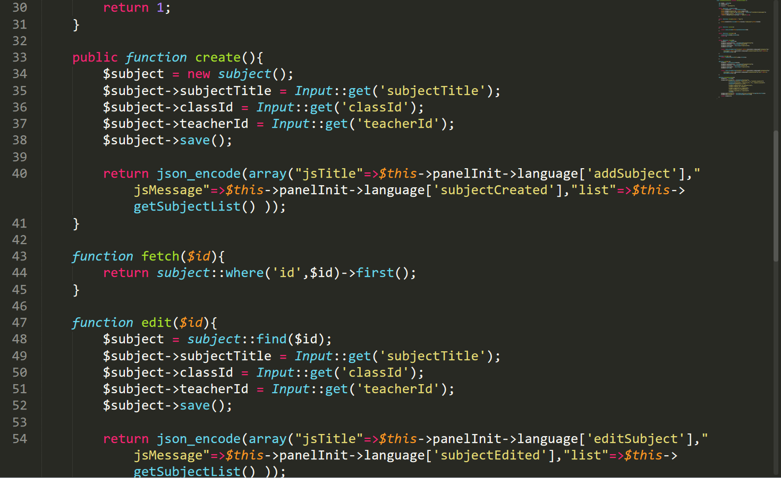

Figure : SubjetcsController.php1

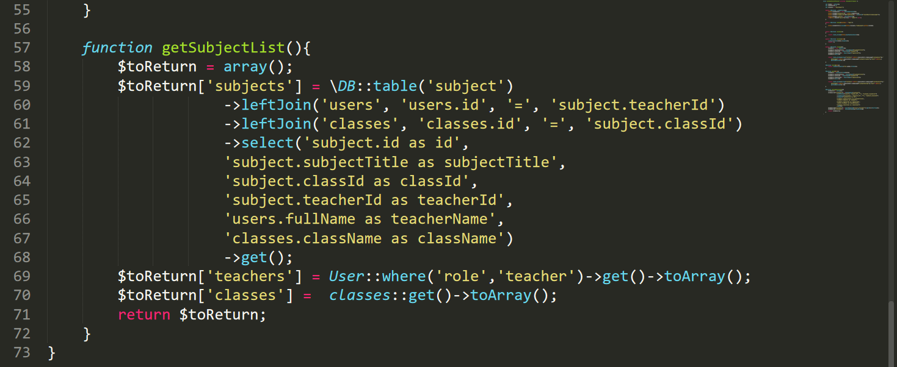

Figure : SubjetcsController.php2

ParentsController.php

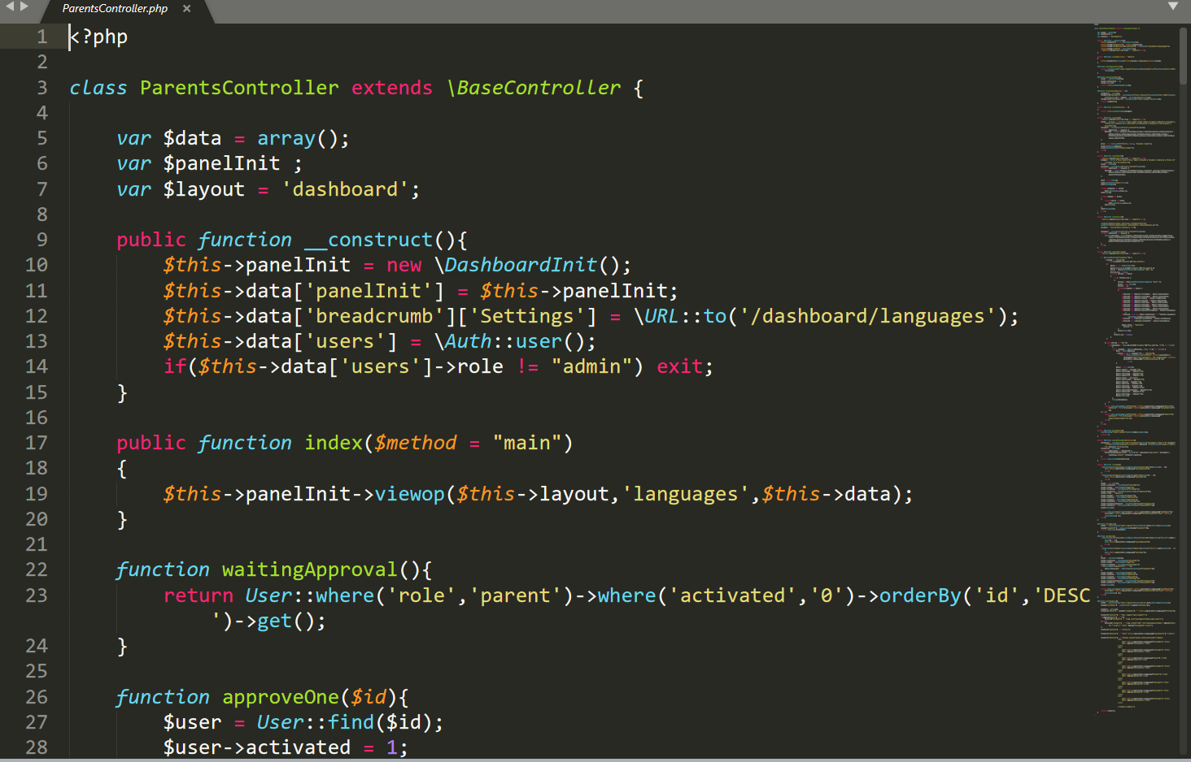

Figure : ParentsController.php

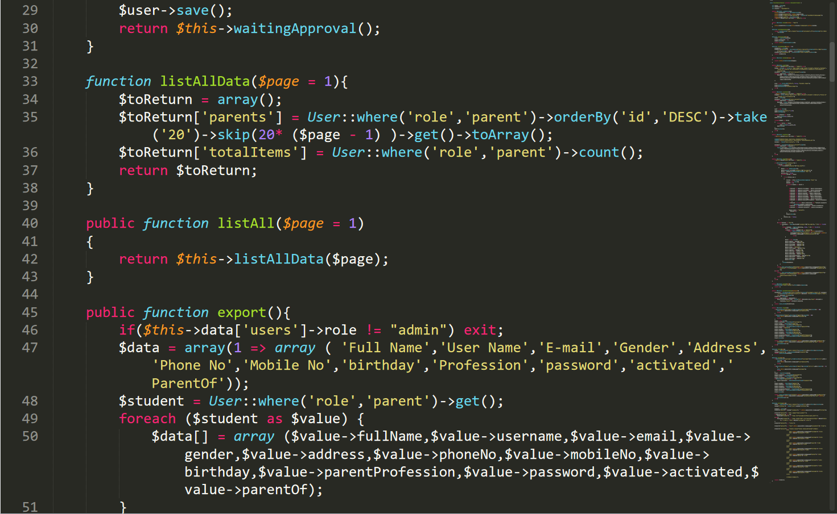

Figure : ParentsController.php1

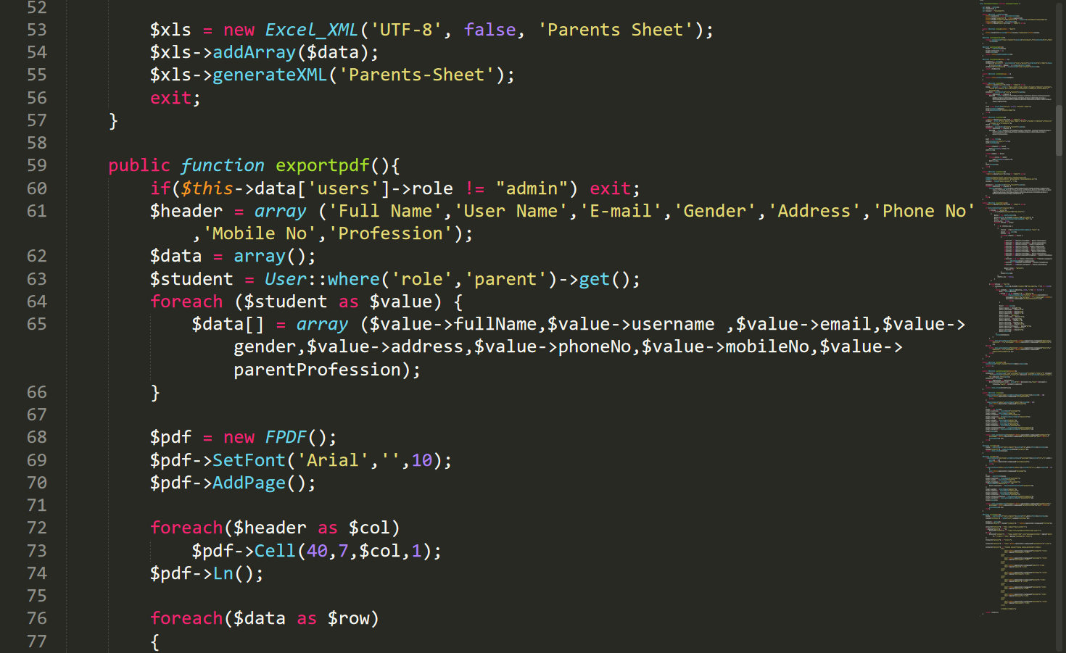

Figure : ParentsController.php2

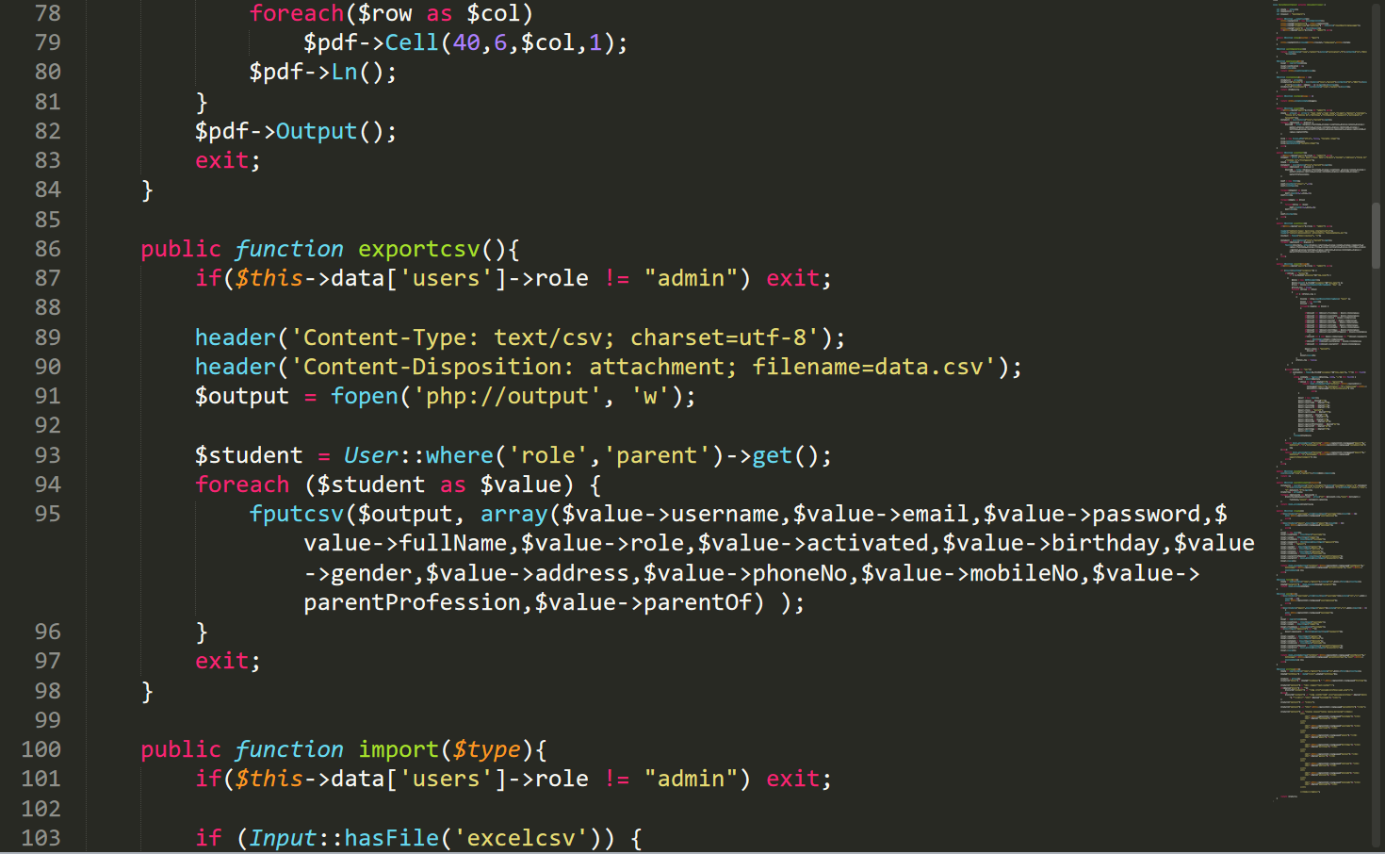

Figure : ParentsController.php3

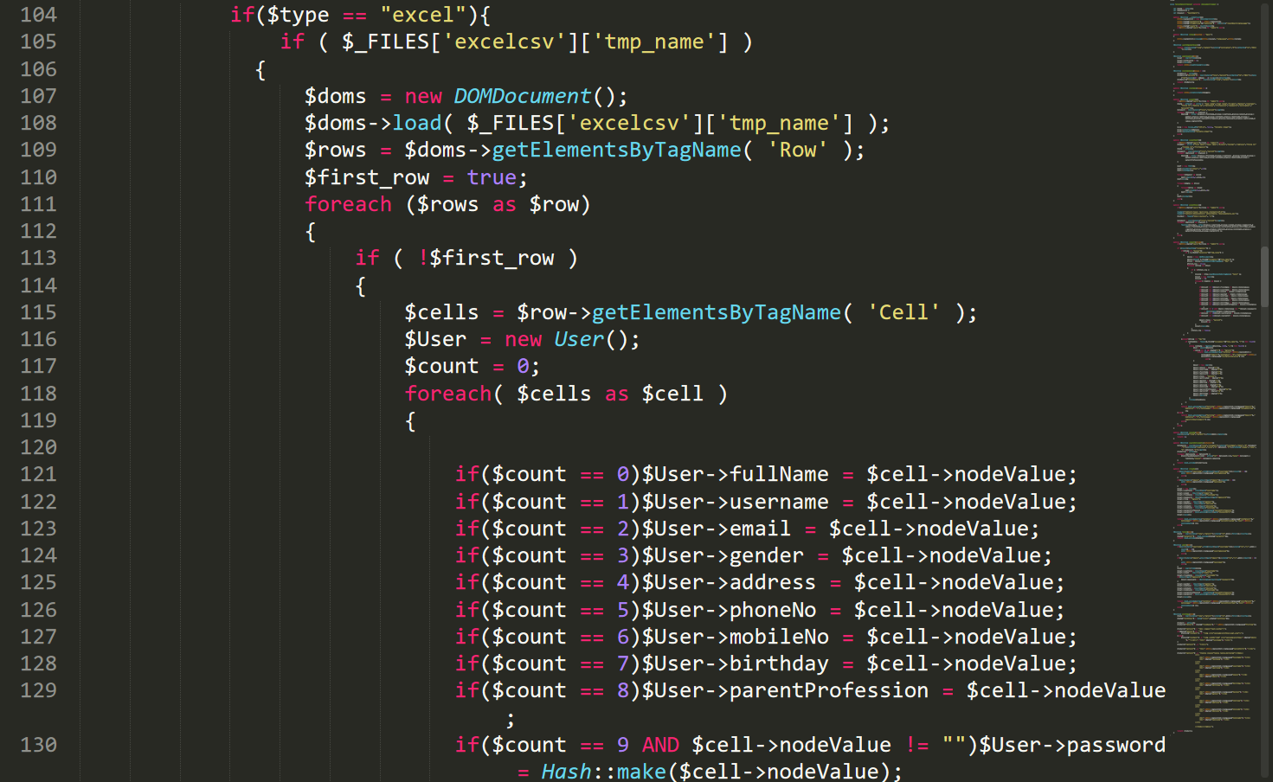

Figure : ParentsController.php4

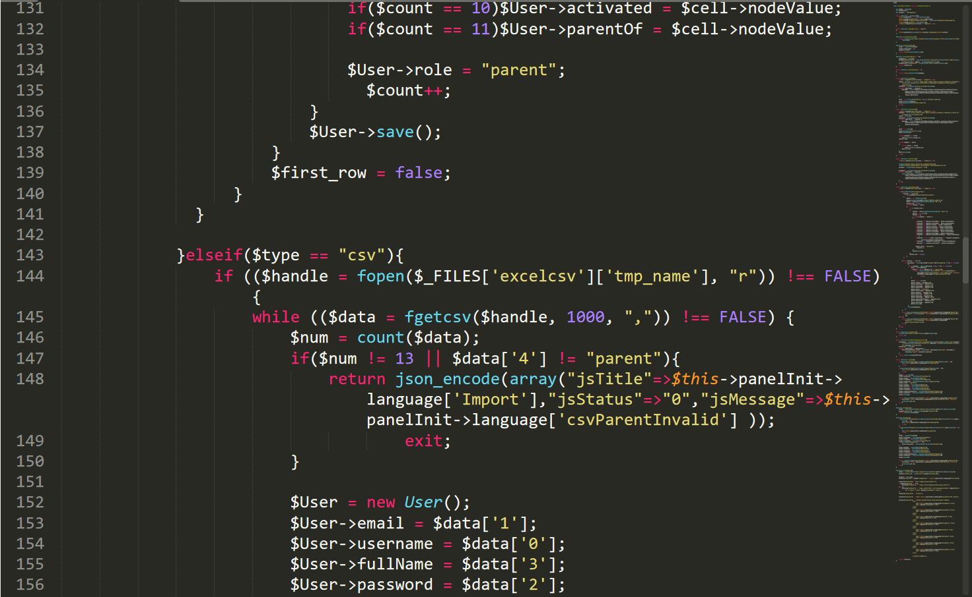

Figure : ParentsController.php5

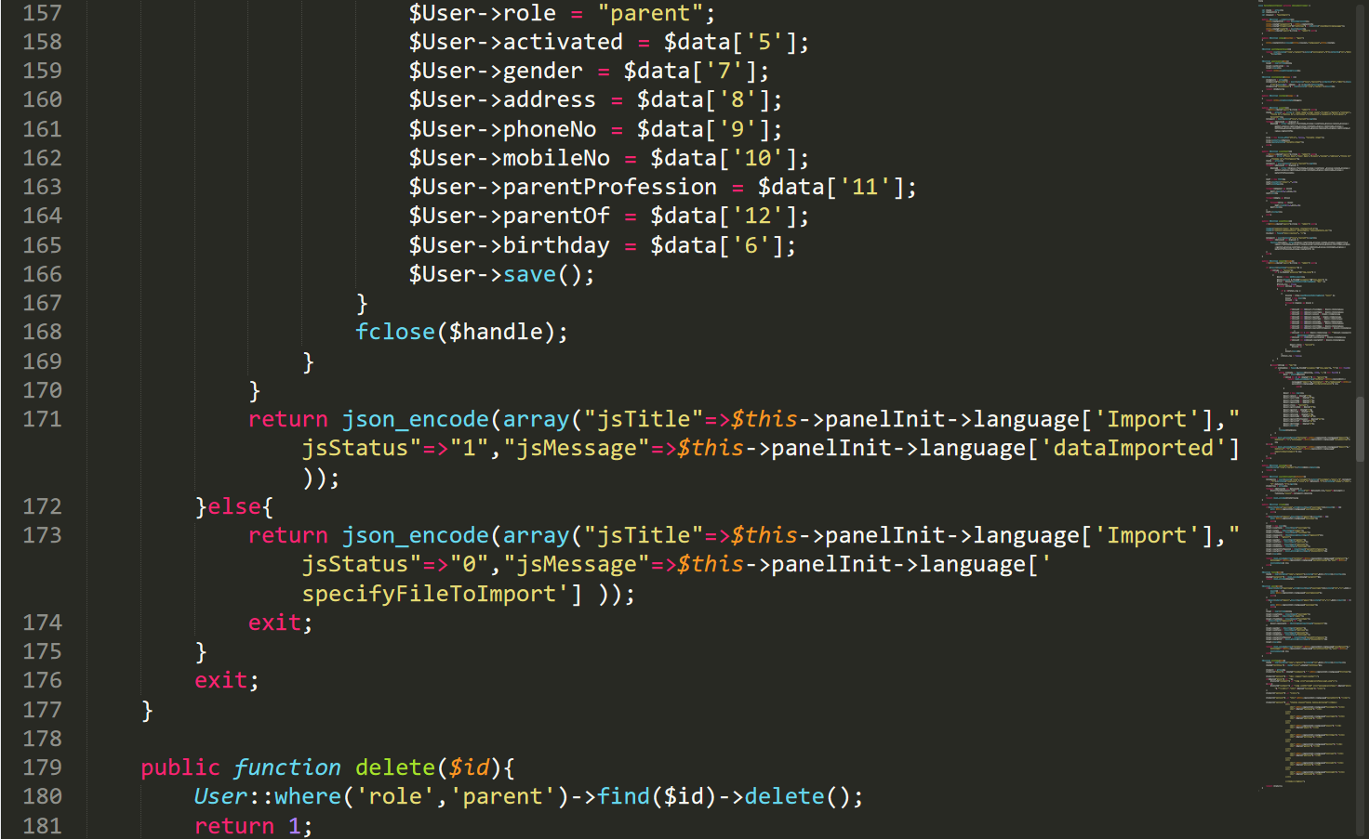

Figure : ParentsController.php6

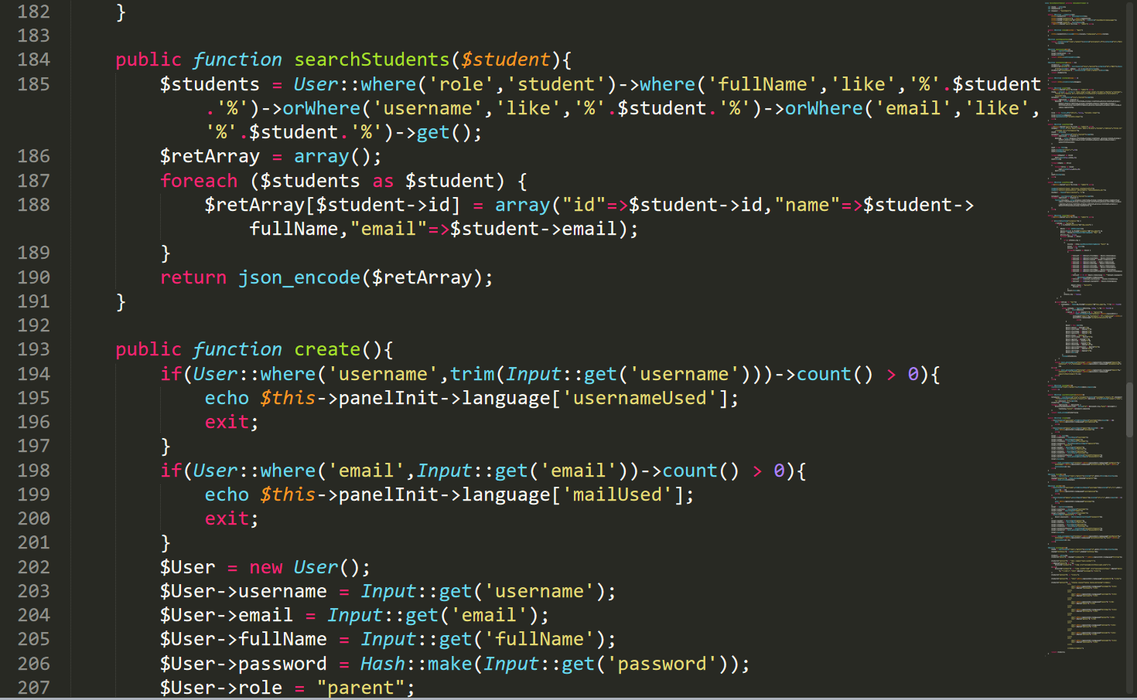

Figure : ParentsController.php6

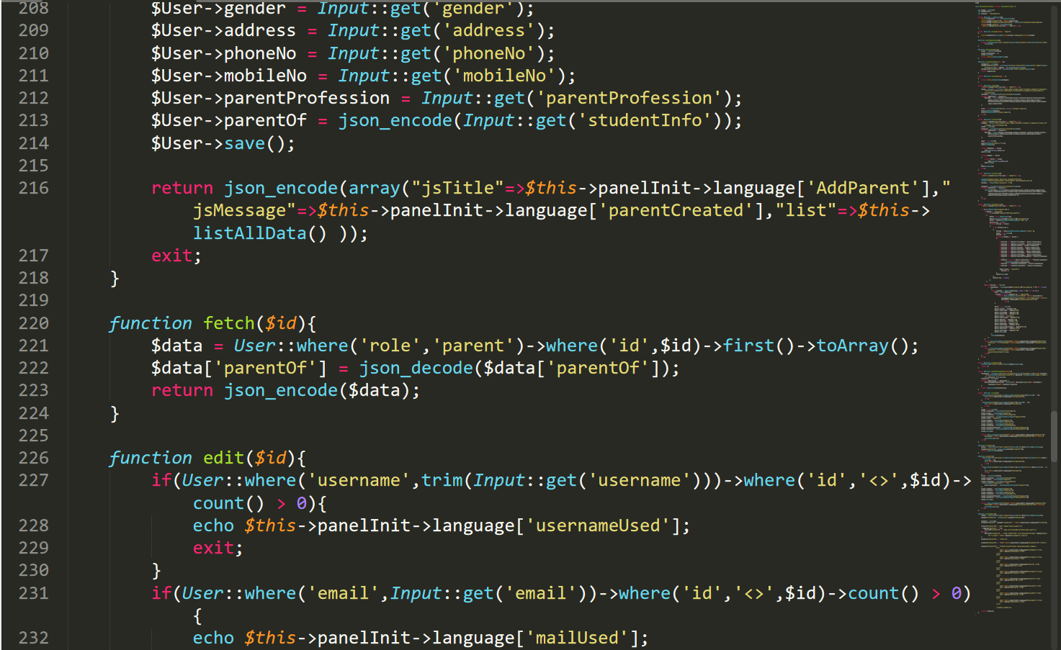

Figure : ParentsController.php7

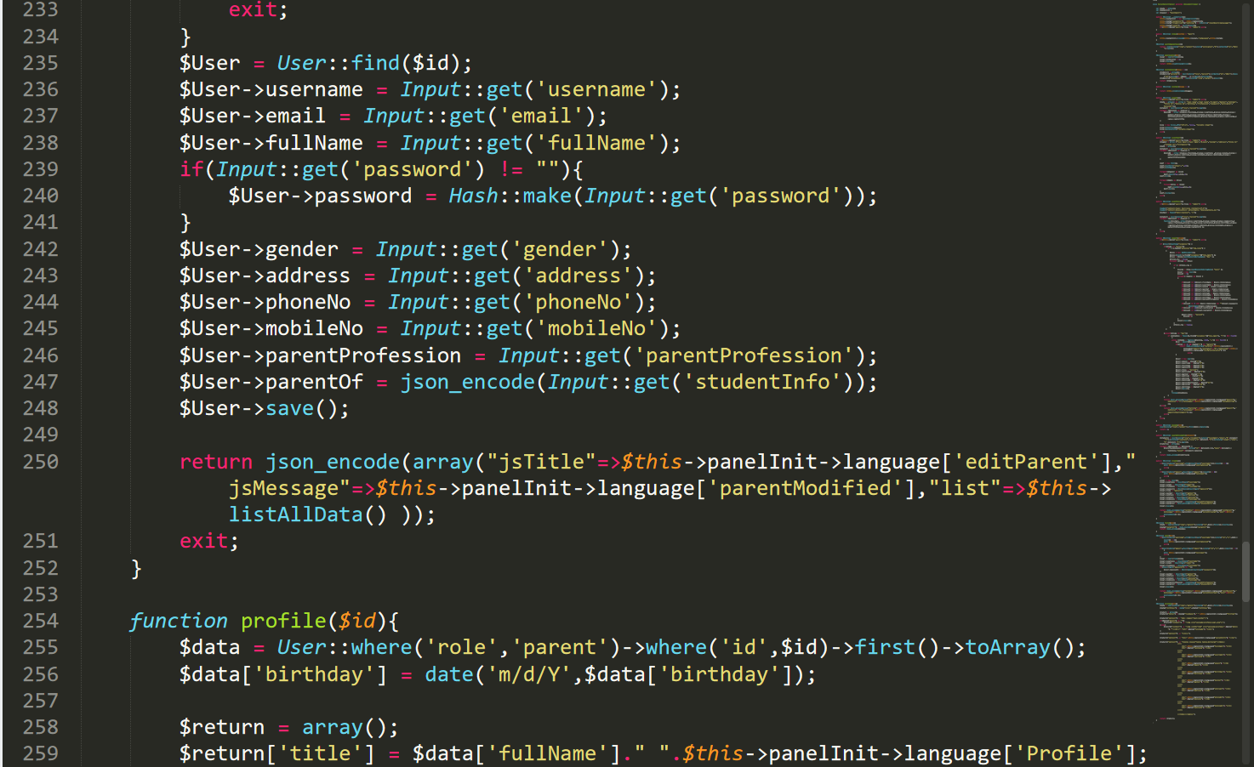

Figure : ParentsController.php8

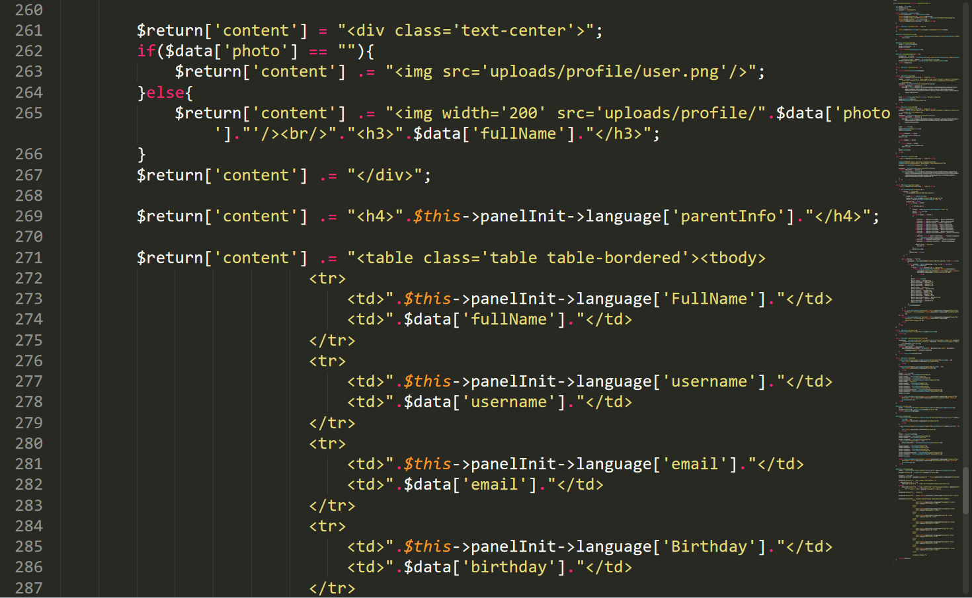

Figure : ParentsController.php9

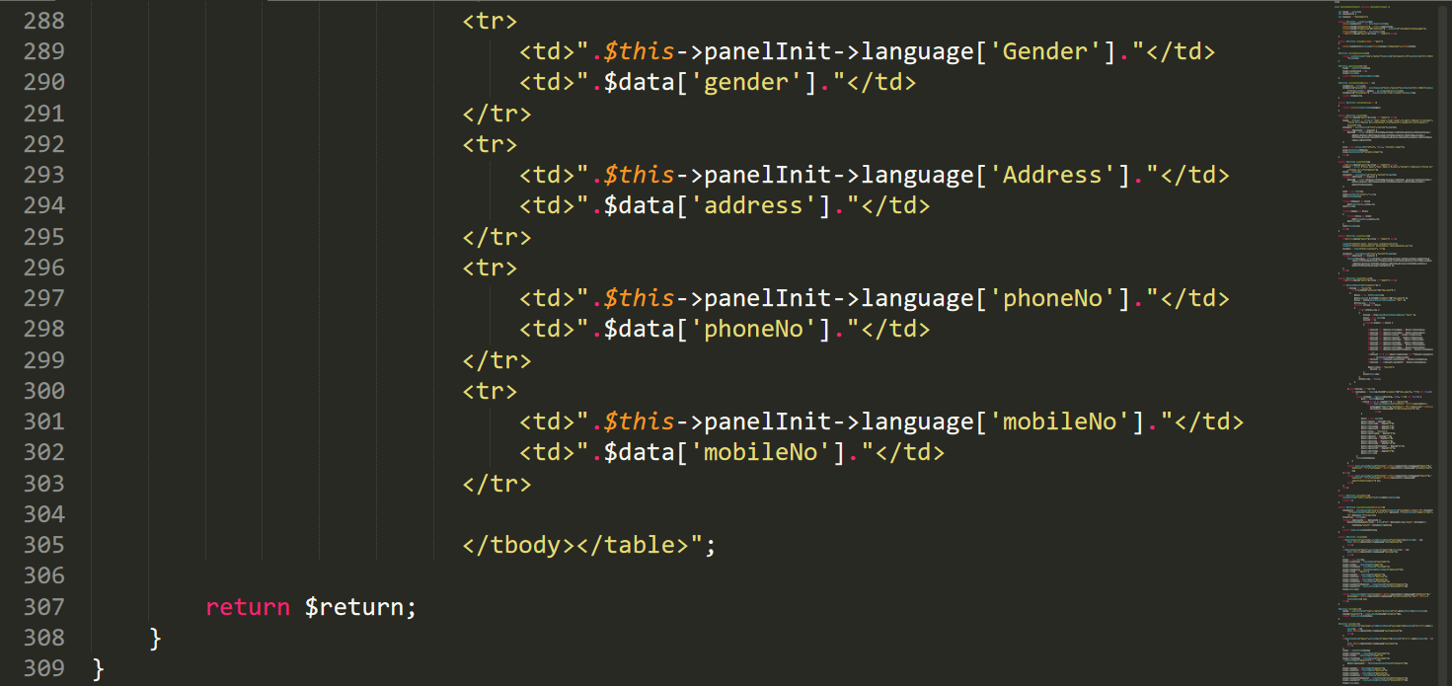

Figure : ParentsController.php10

AssignmnetsControllers.php

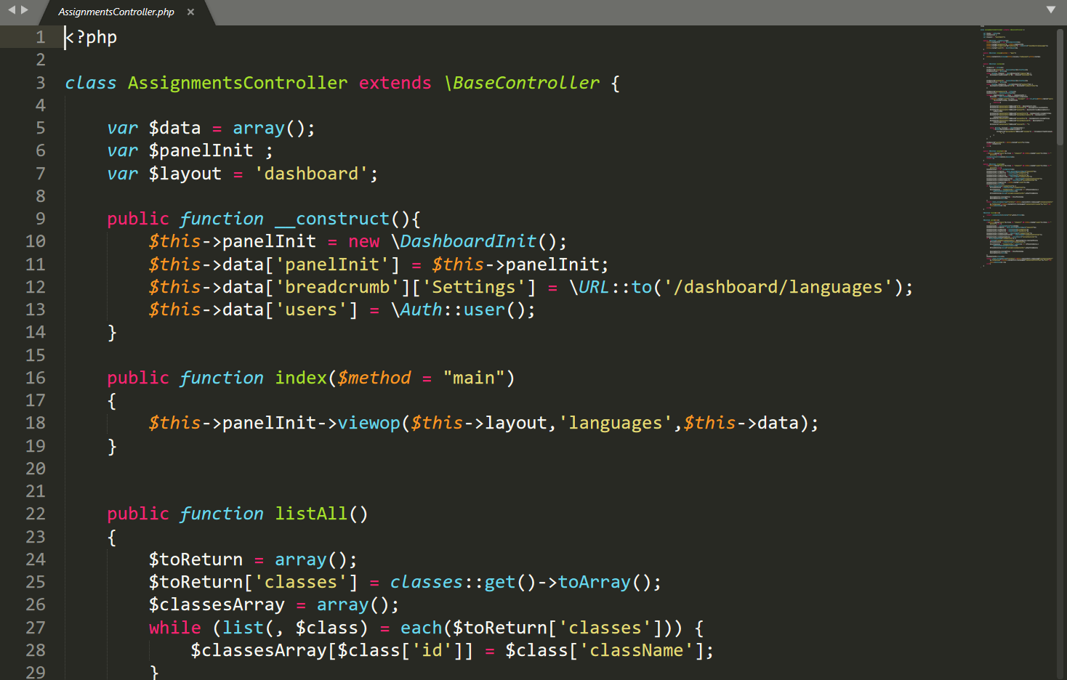

Figure : AssignmnetsController.php

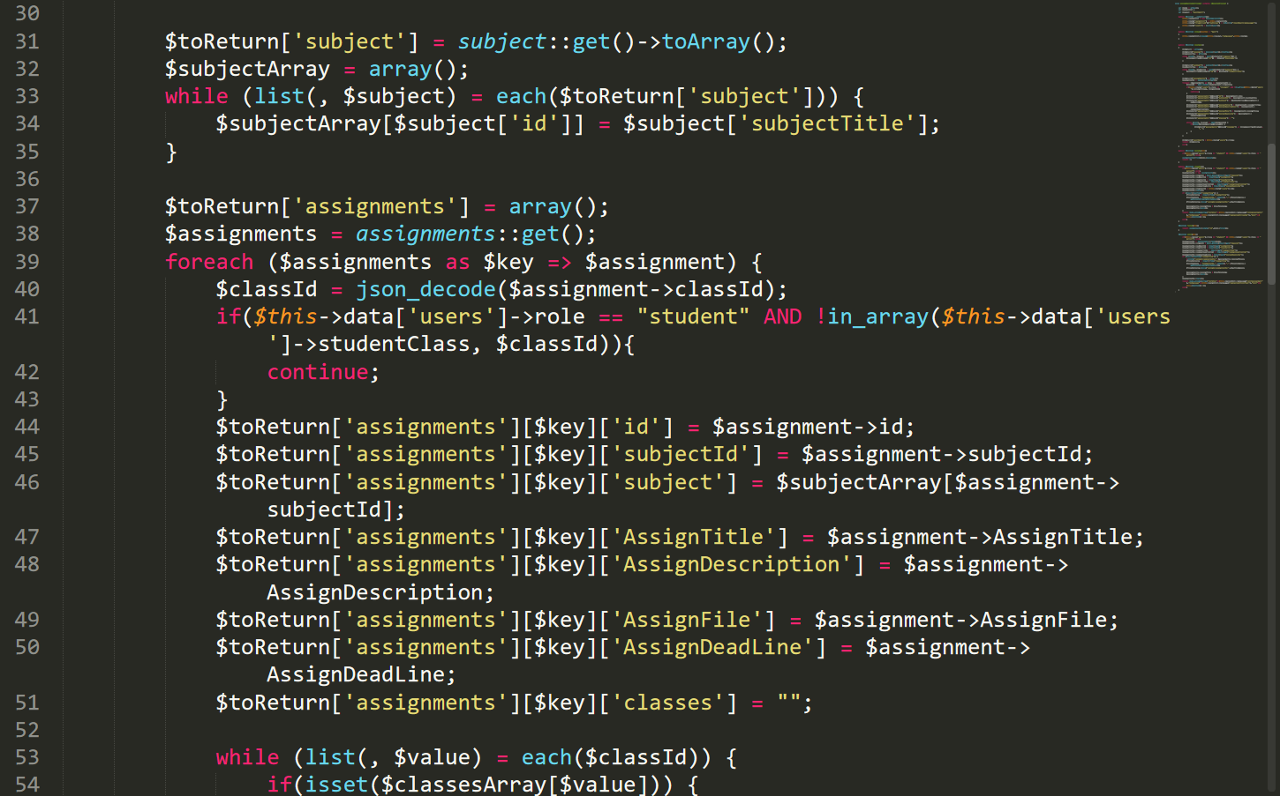

Figure : AssignmnetsController.php 1

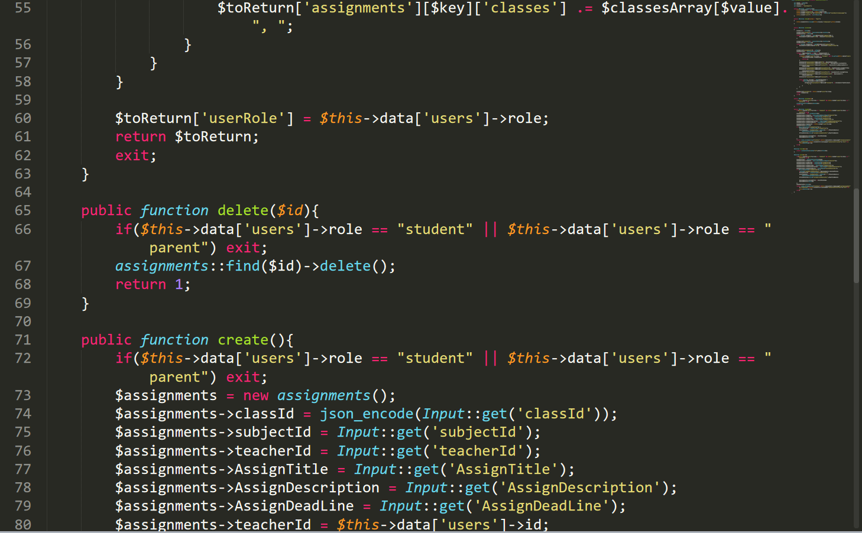

Figure : AssignmnetsController.php2

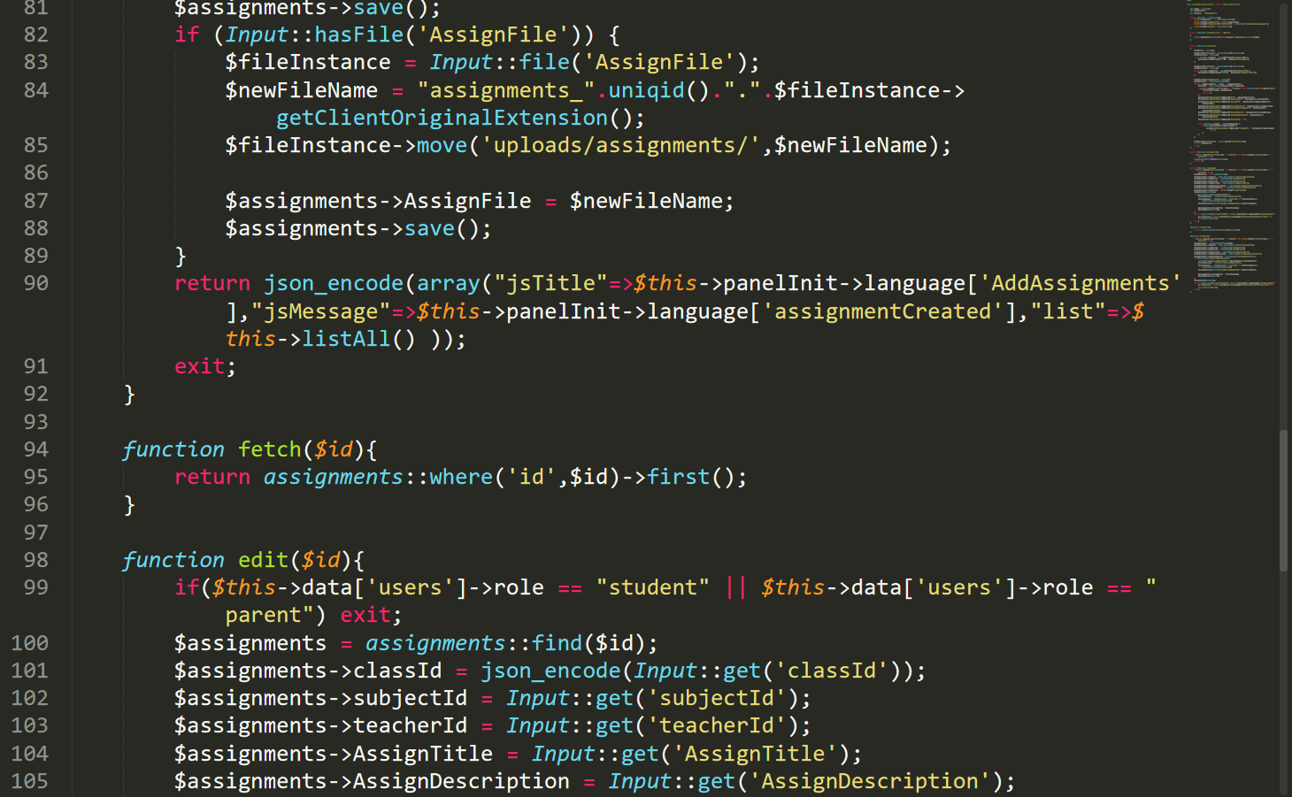

Figure : AssignmnetsController.php3

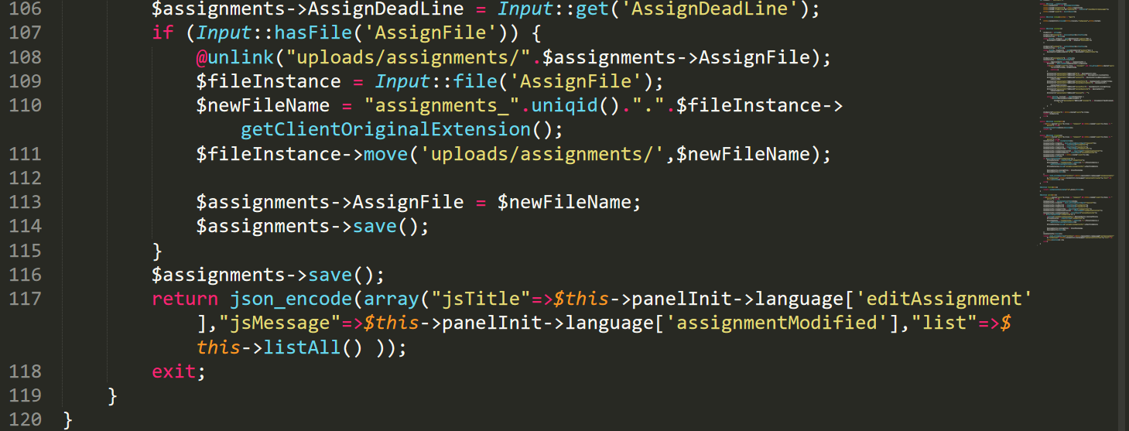

Figure : AssignmnetsController.php4

ClassscheduleControler.php

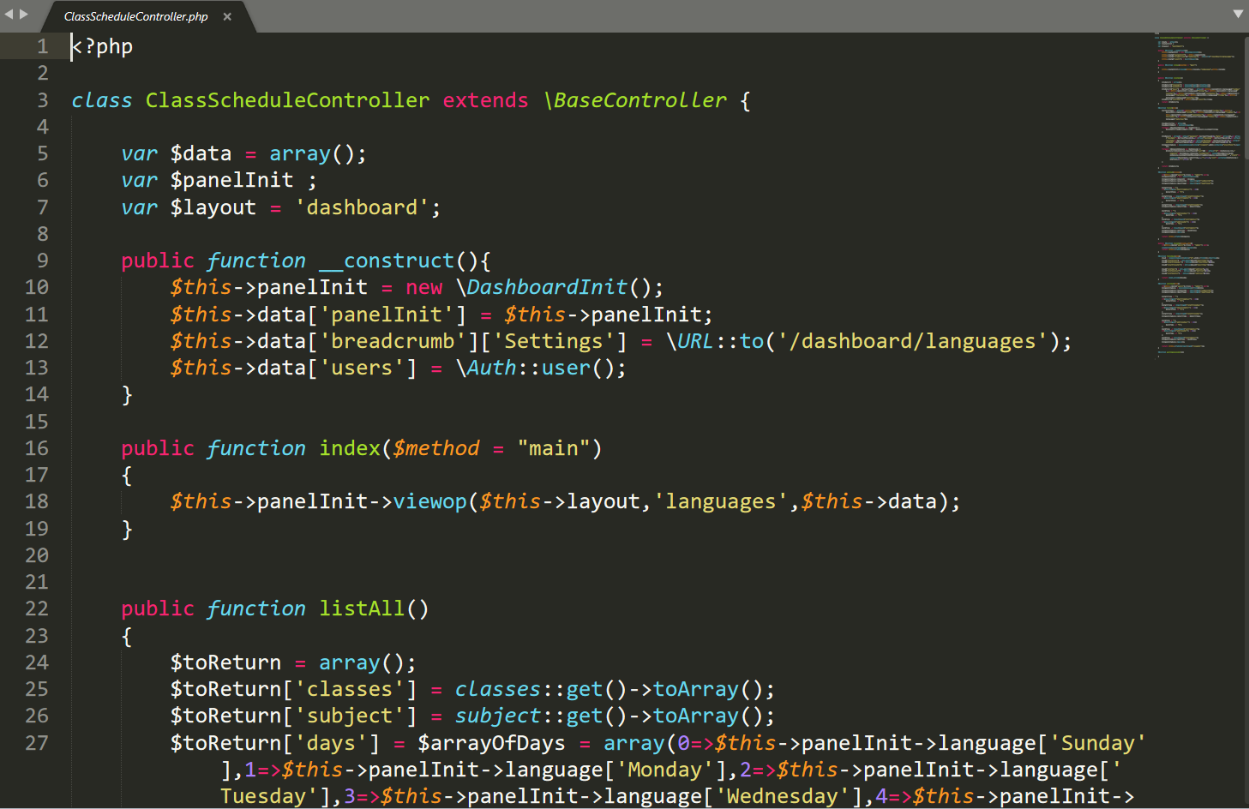

Figure 159: ClassScheduleController.php

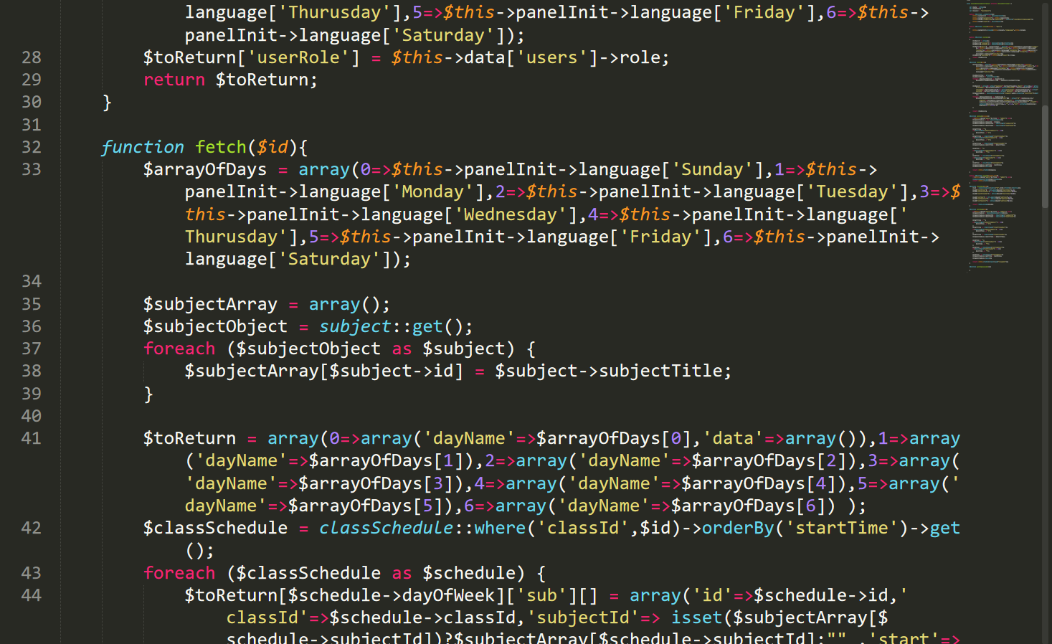

Figure : ClassScheduleController.php1

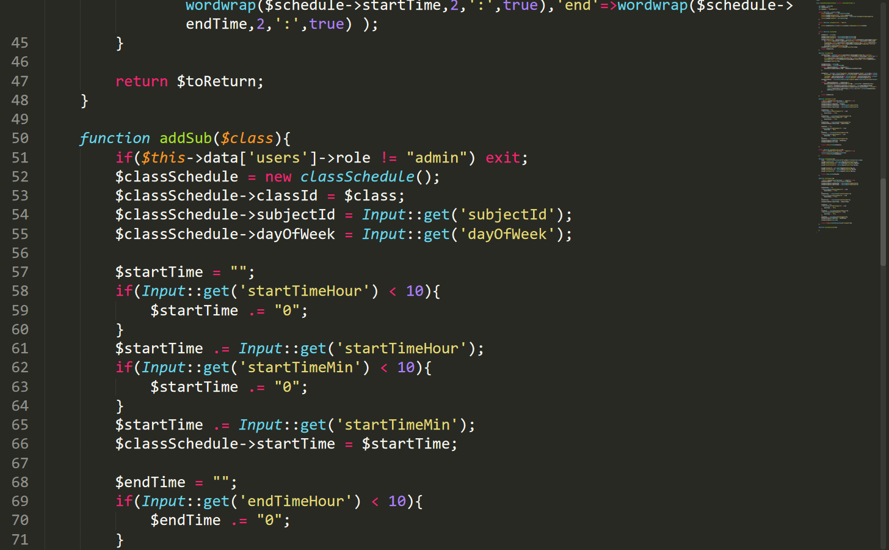

Figure : ClassScheduleController.php2

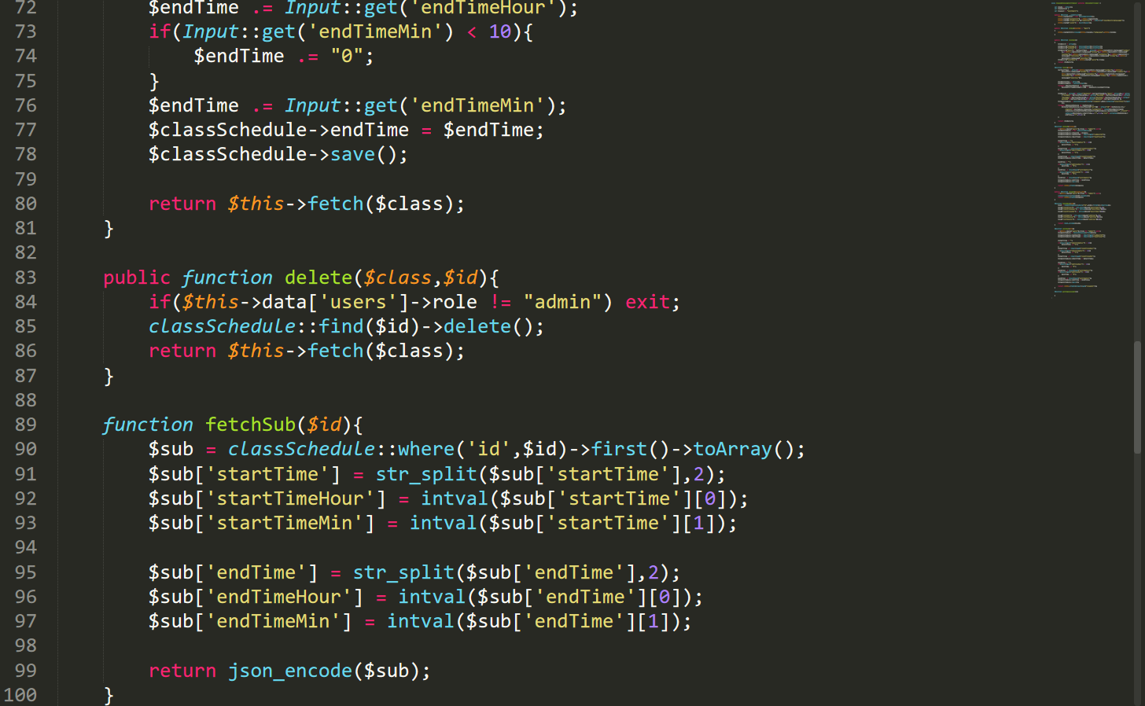

Figure : ClassScheduleController.php4

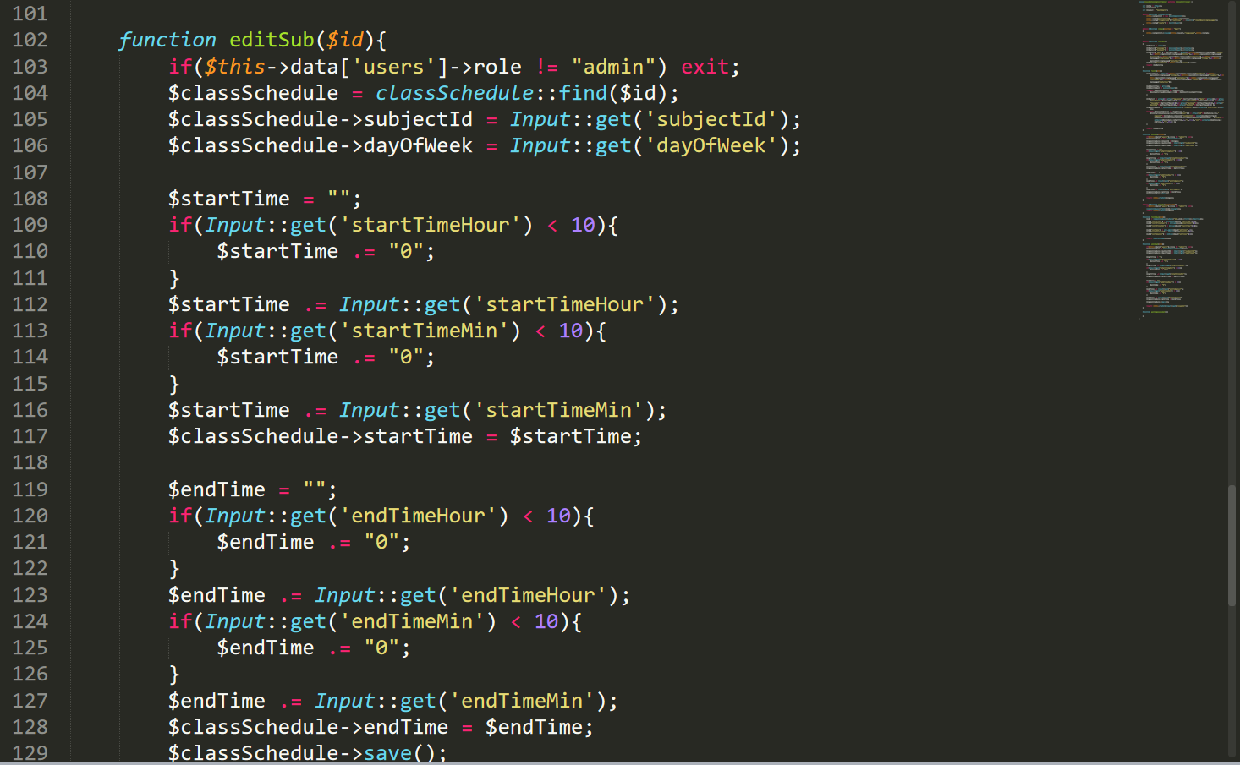

Figure : ClassScheduleController.php5

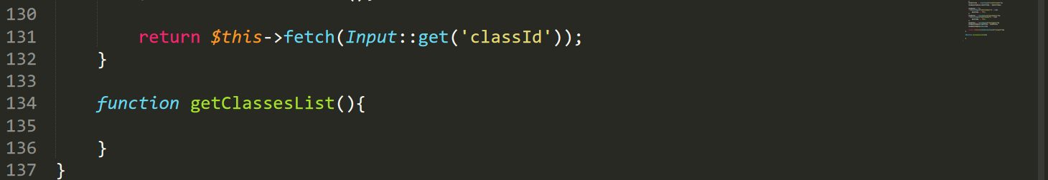

Figure : ClassScheduleController.php6

Model codes

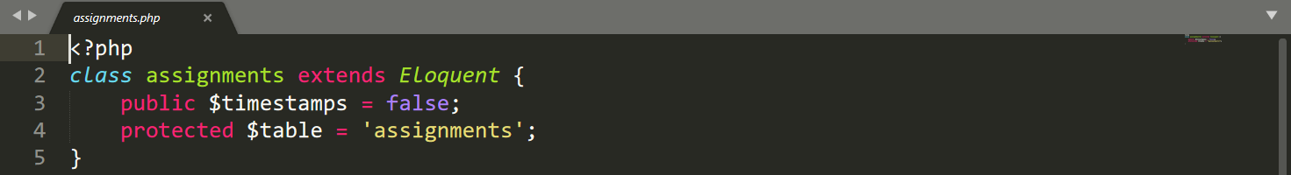

Figure : Assignmnets.php

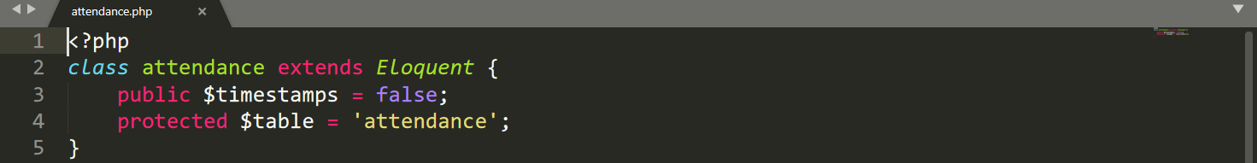

Figure : attendance.php

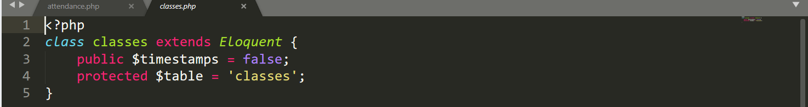

Figure : Classes.php

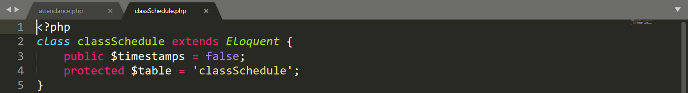

Figure : classSchedule.php

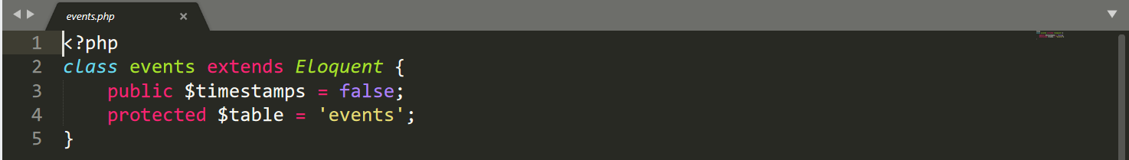

Figure : events.php

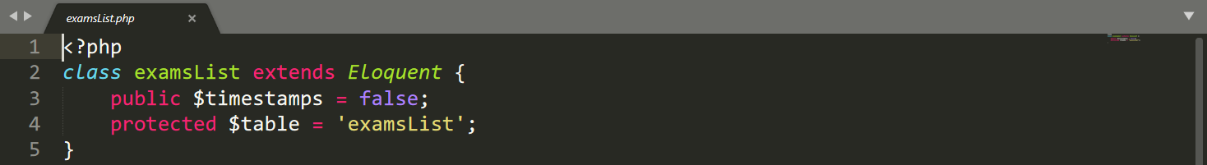

Figure : examlists.php

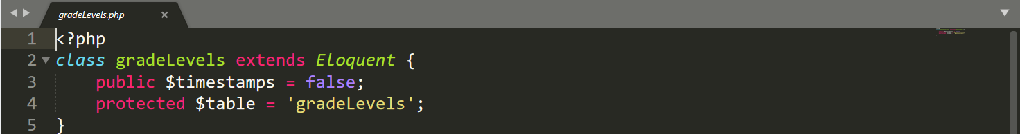

Figure : gradelevels.php

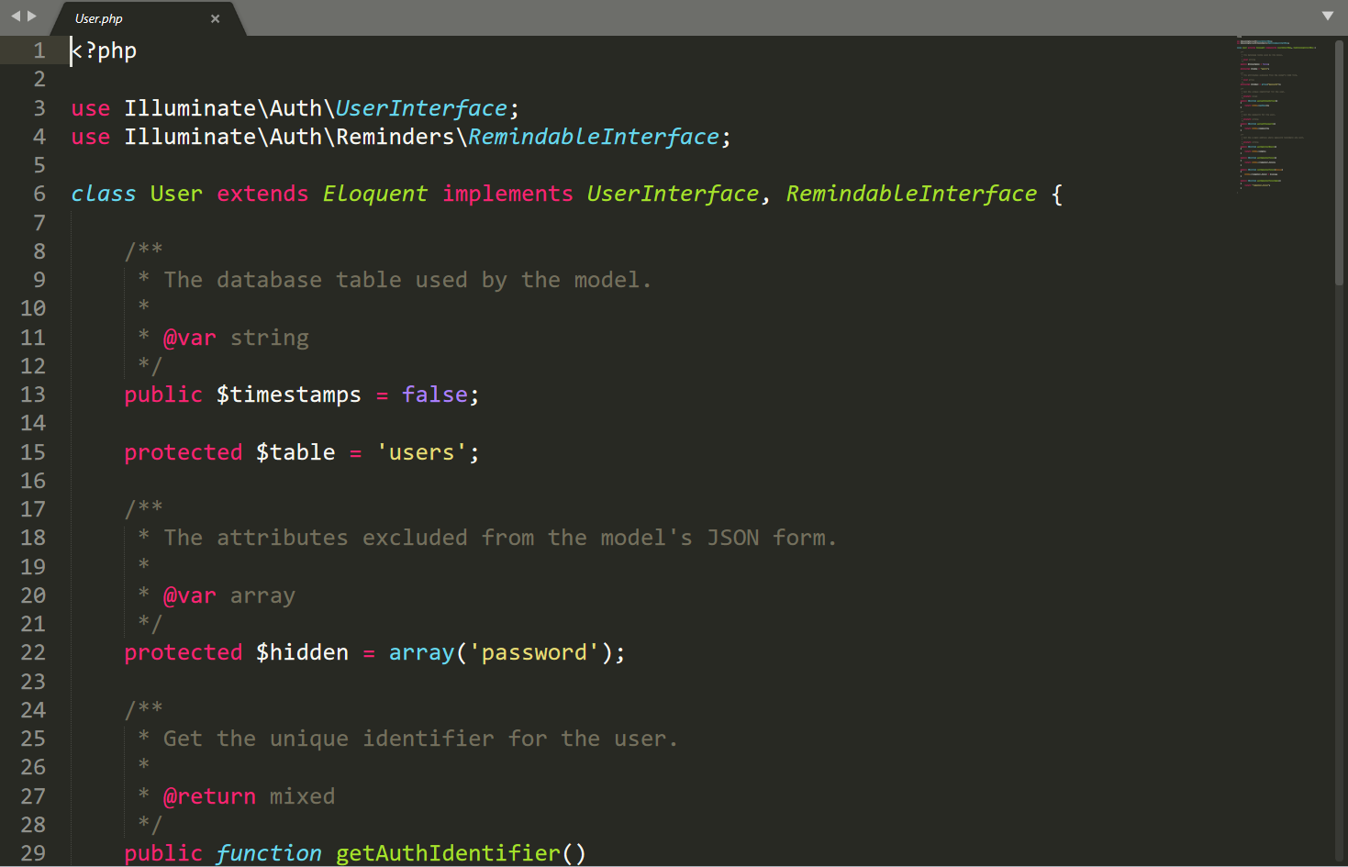

Figure : User.php

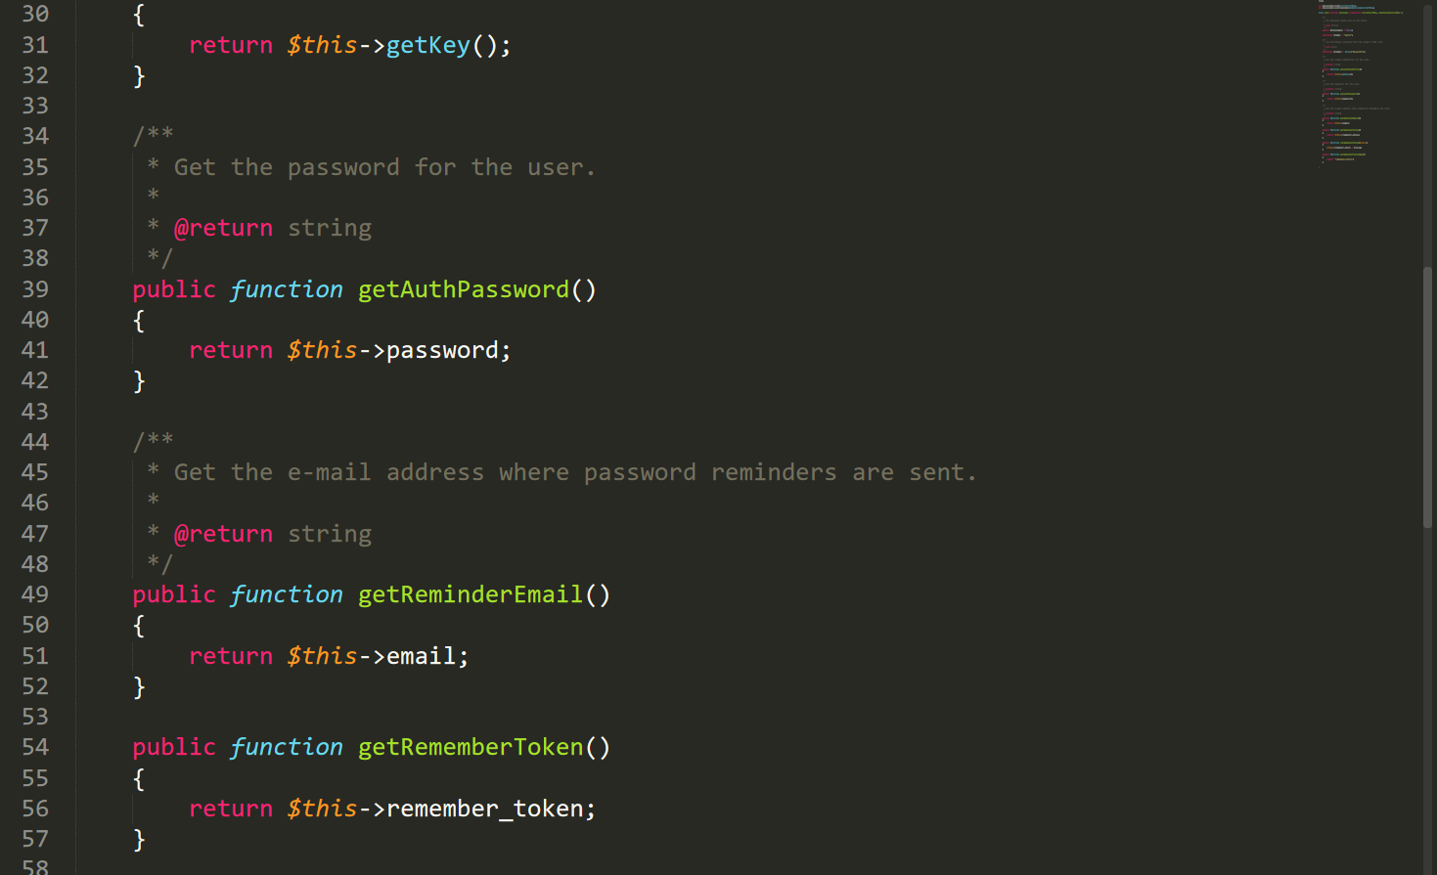

Figure : User.php1

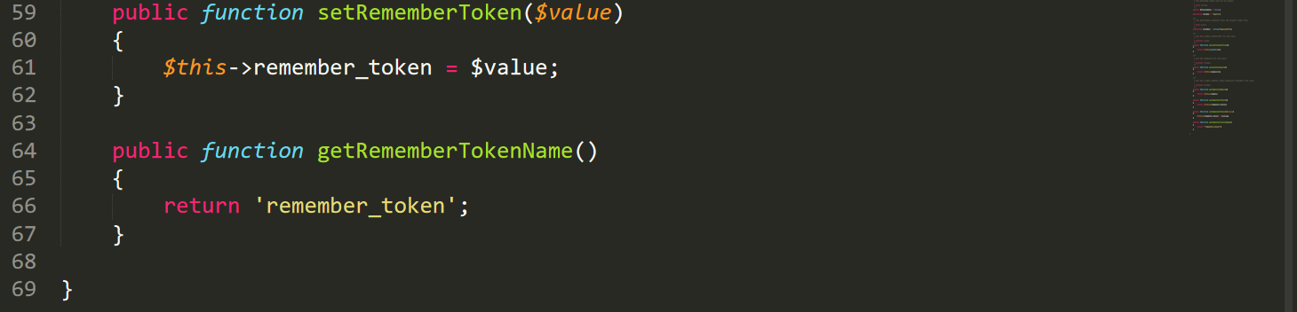

Figure : User.php2

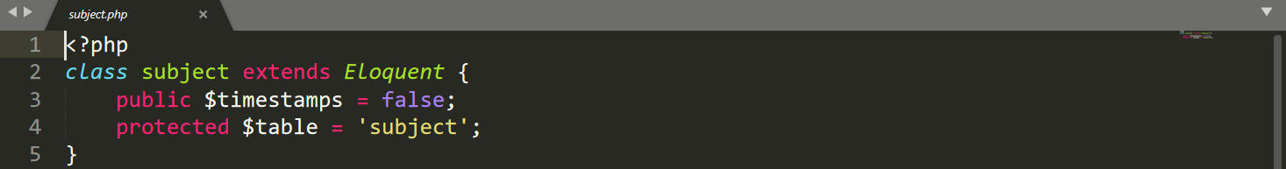

Figure : subject.php

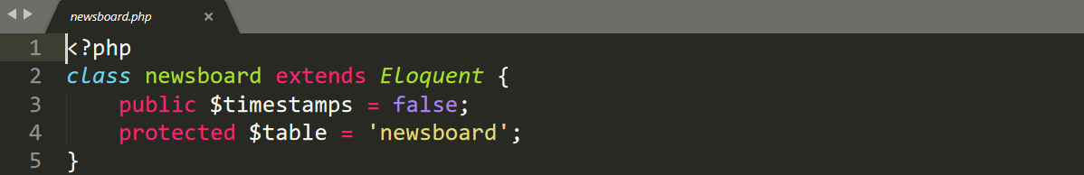

Figure : newsboard

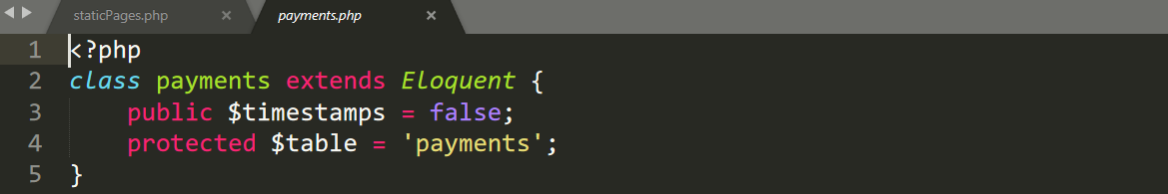

Figure : payments.php

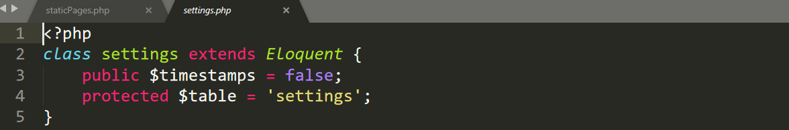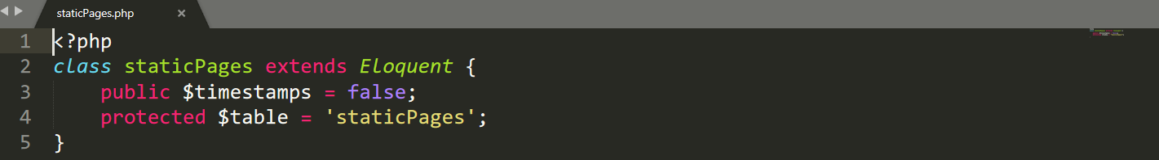

Figure : staticpages.php

Views Code

Register.php

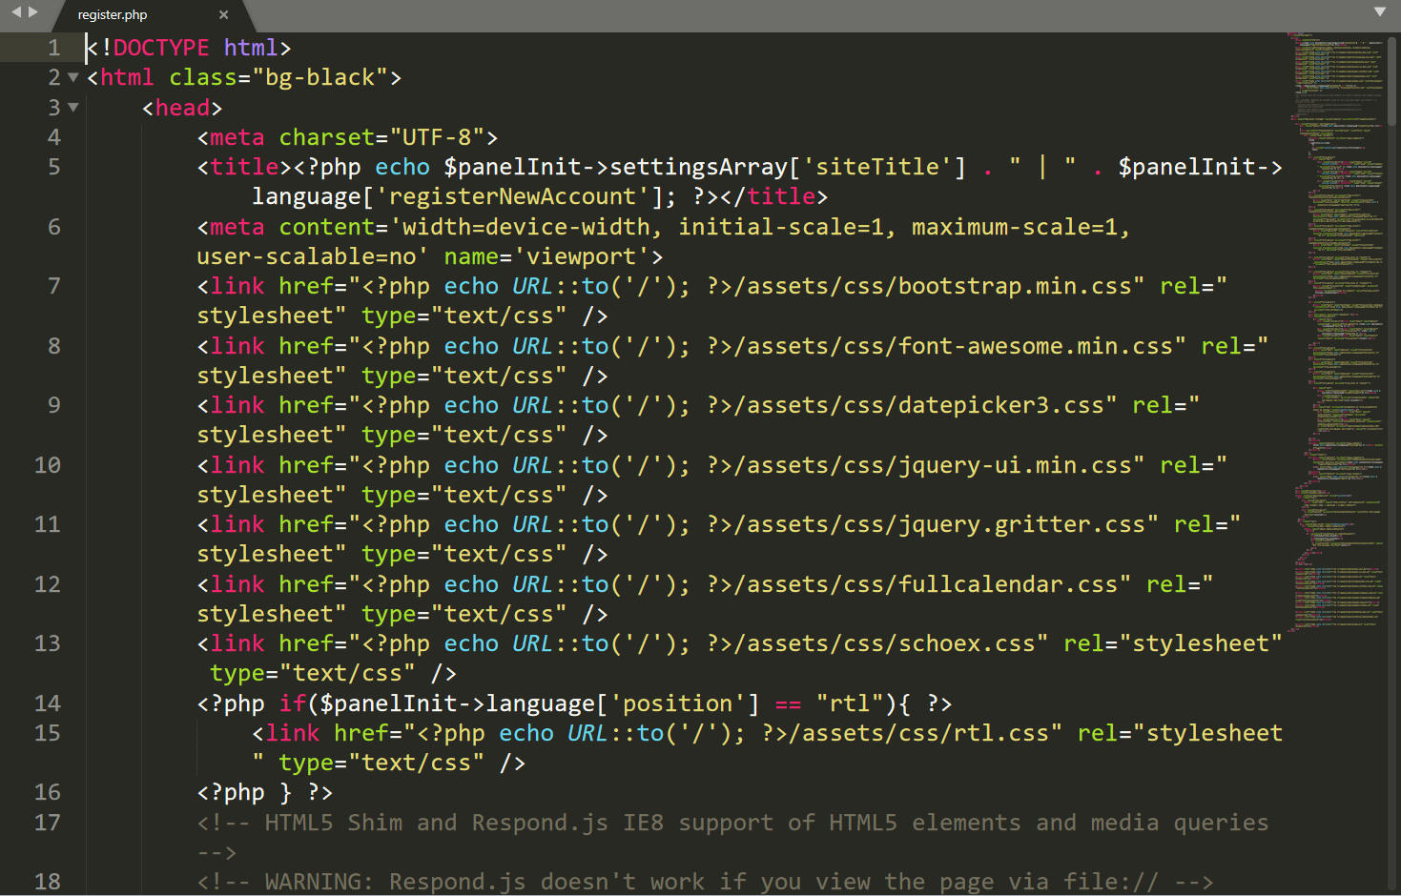

Figure : register.php from view

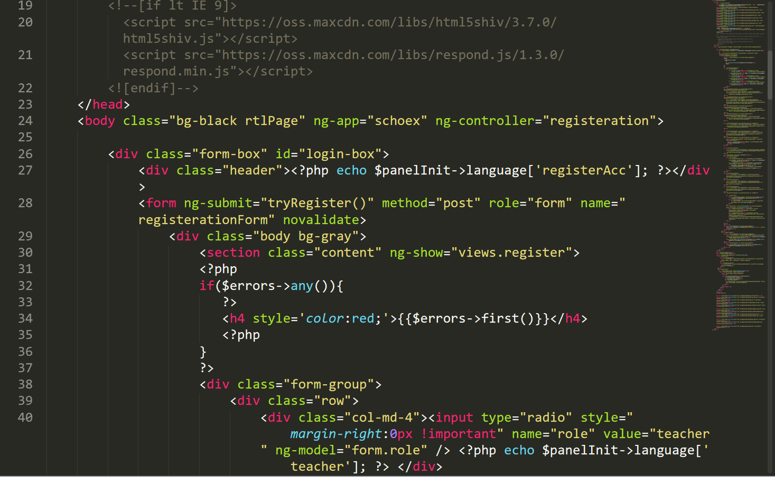

Figure : register.php from view 1

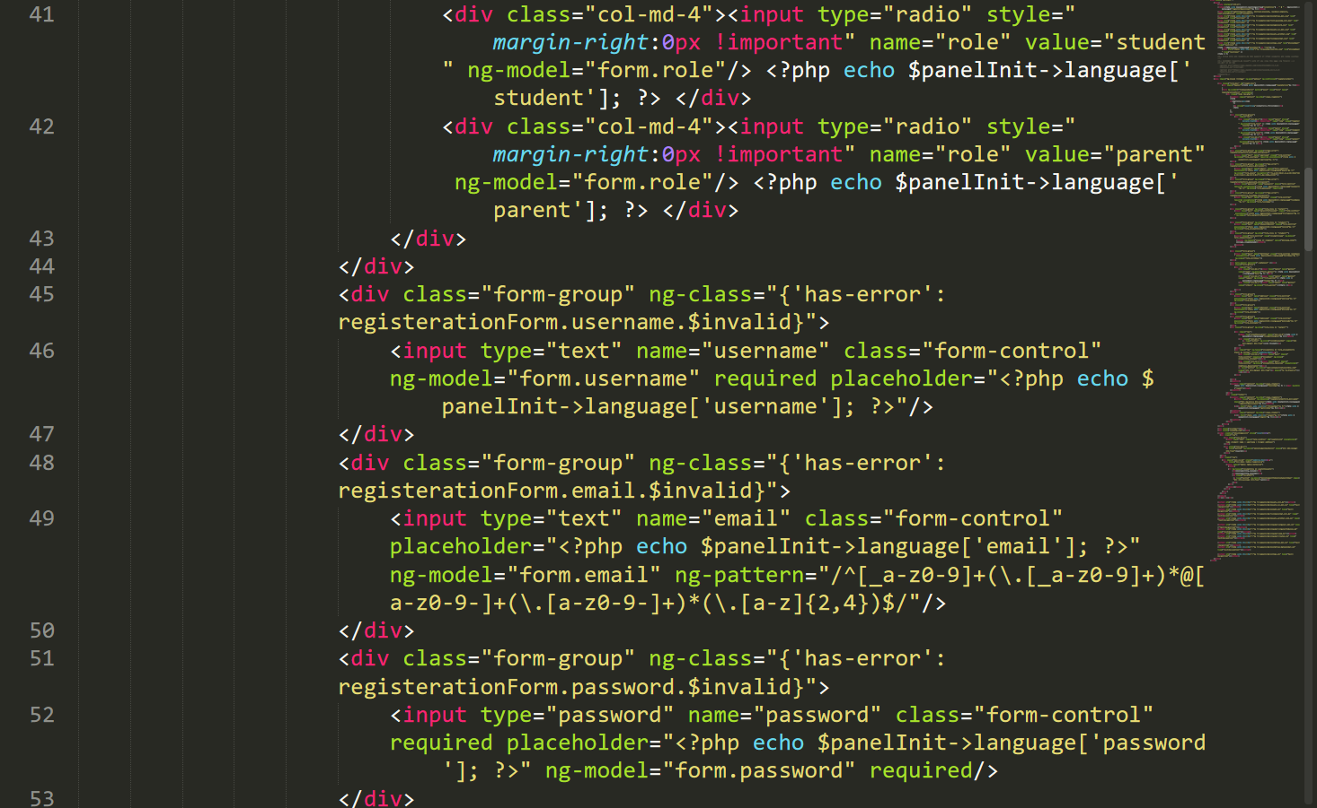

Figure : register.php from view 2

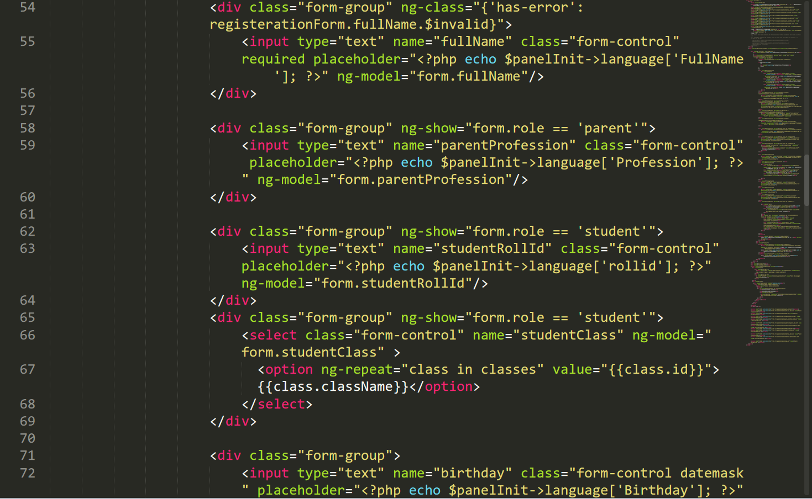

Figure : register.php from view 4

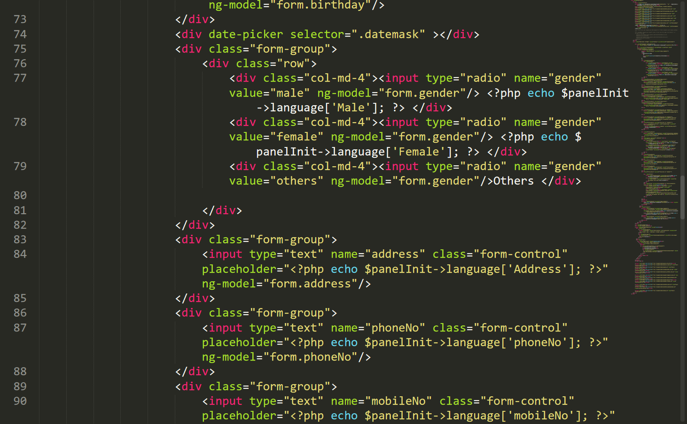

Figure : register.php from view 5

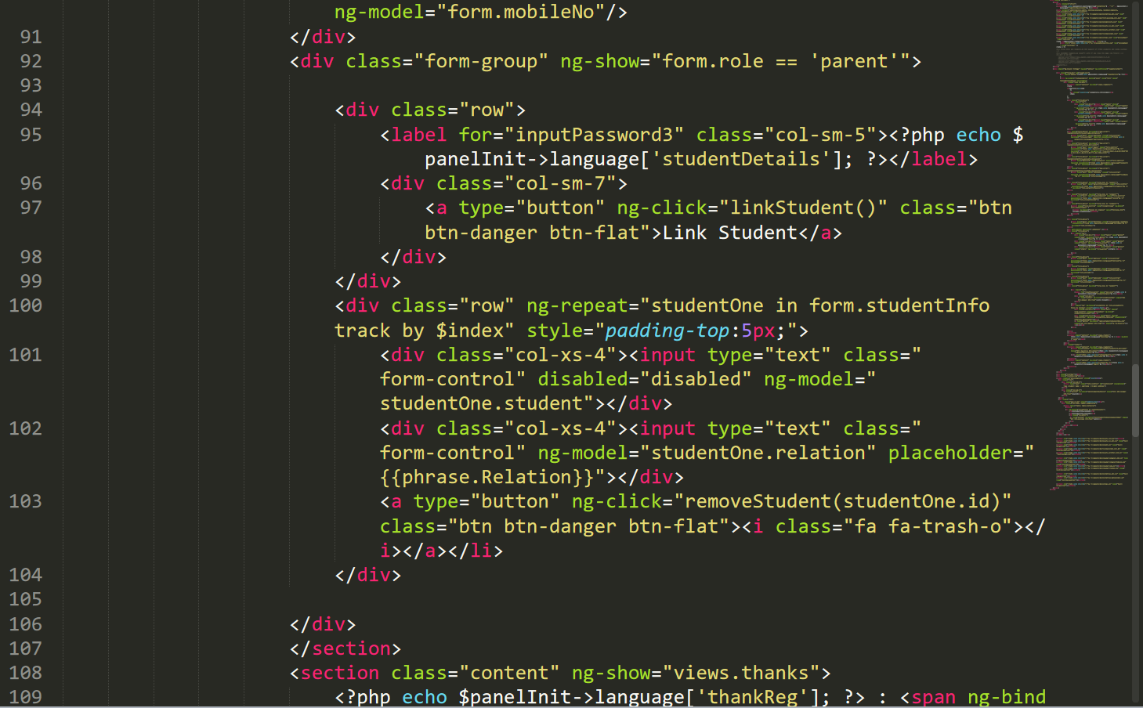

Figure : register.php from view 6

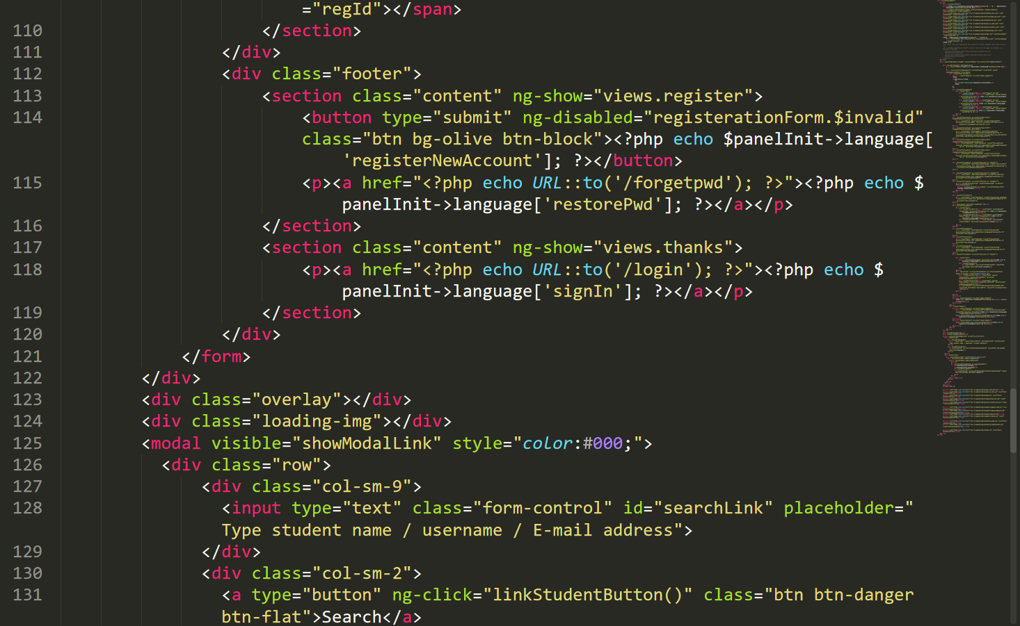

Figure : register.php from view 7

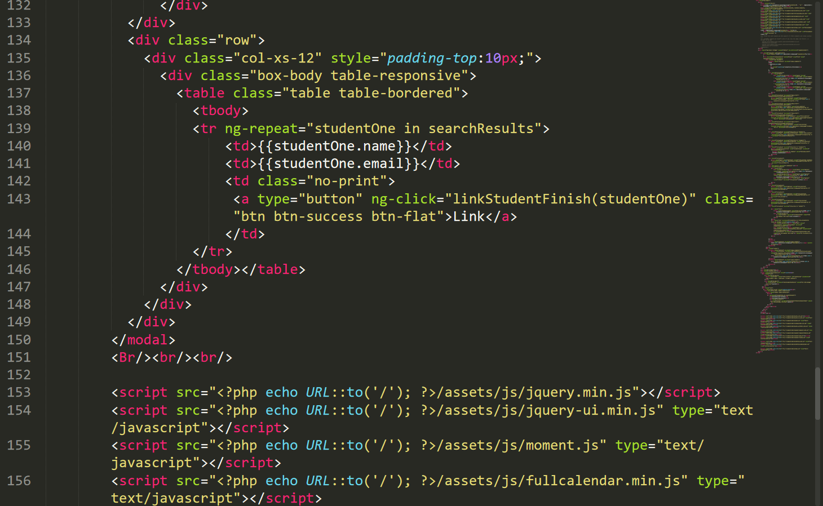

Figure : register.php from view 8

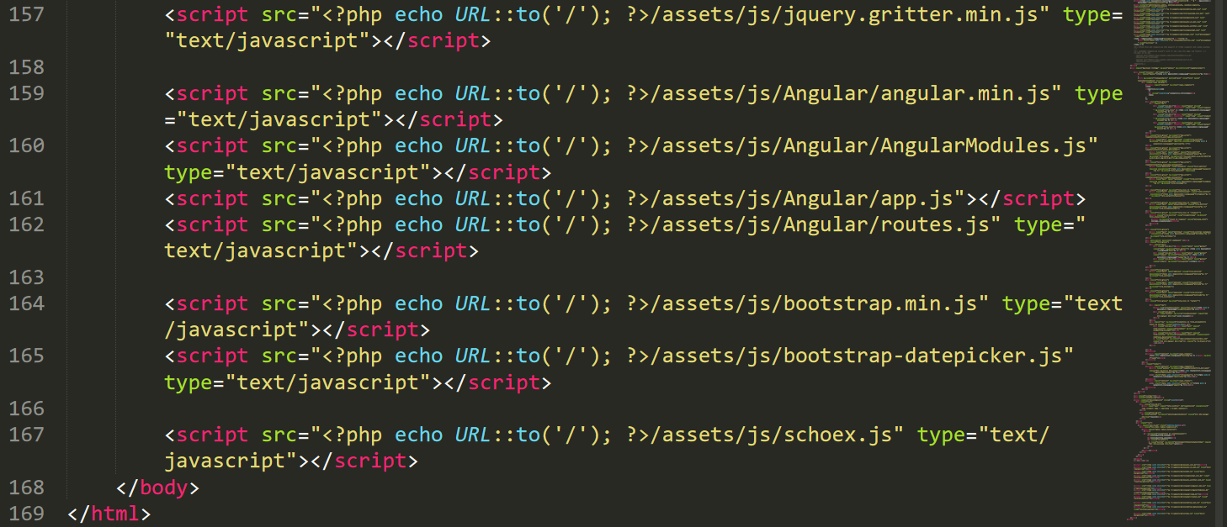

Figure : register.php from view 9

Login code from view

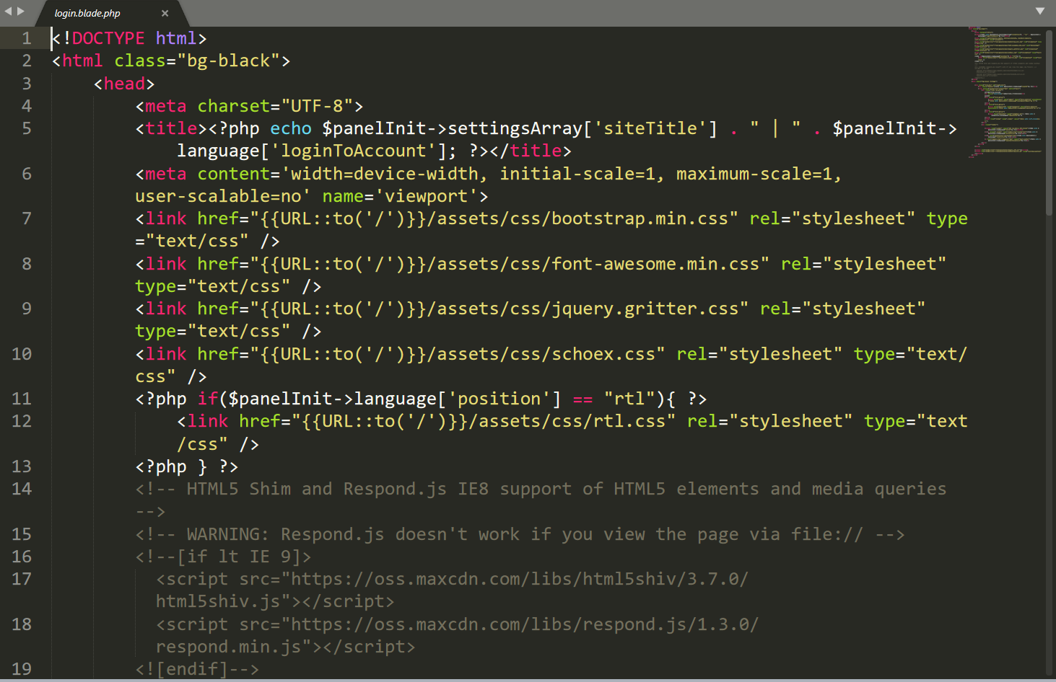

Figure : Login code from view

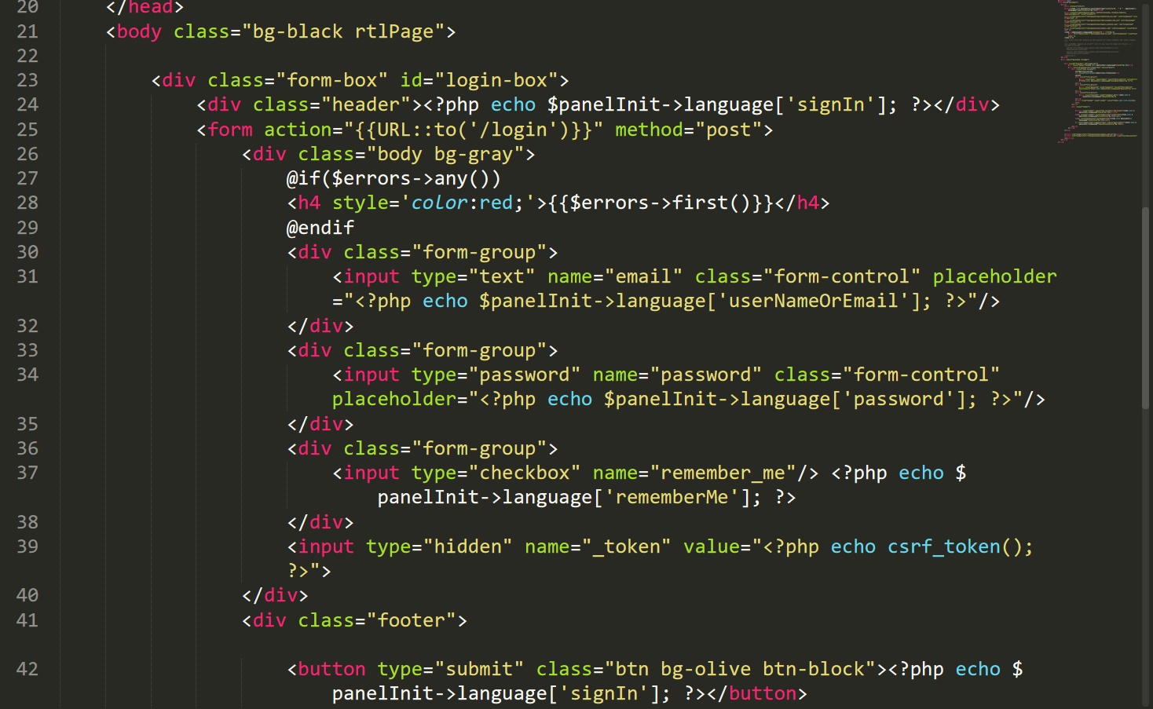

Figure : Login code from view1

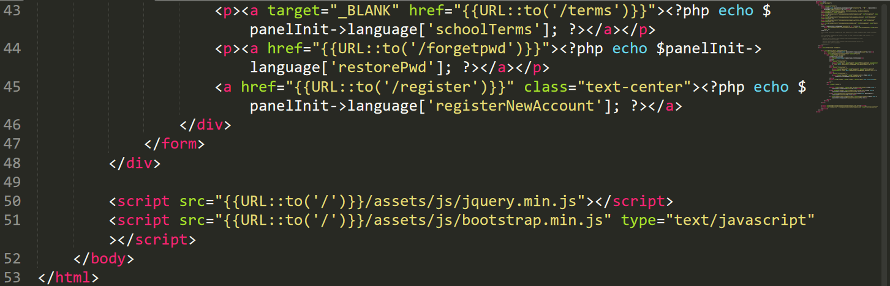

Figure : Login code from view2